Windsor Solutions

Form Design Guide

Updated for Version 4.17
Revision Date: September 28, 2023
Contents
Overview 4
Form Creation Process 5
Step 1: Create and Configure the Form Attributes 5
Step 2: Design the Form Content 25
Step 3: Define the Default Form Submission Workflow 31
Step 4: Test and Publish the Form 37
Refining a Form Design 41
Step 1: Establish a Draft Version of the Form 41
Step 2: Refine the Design of the Form 43
Step 3: Test and Republish the Form 43
Appendix A: Controls 45
Simple Controls 47
Formatted Controls 68
Advanced Controls 87

Version Control

Version | Author | Date | Notes
4.6 | Windsor Solutions | 3/18/2019 | Moved configuration of Internal Data Controls from Design Guide to Advanced Design Guide.
4.6 | Windsor Solutions | 5/3/2019 | Updated Map Control search guidance.
4.7 | Windsor Solutions | 5/3/3019 | Updated document to reflect 4.7 refinements/enhancements.
4.8 | Windsor Solutions | 2/7/2020 | Updated document to reflect 4.8 refinements/enhancements.
4.9 | Windsor Solutions | 7/15/2020 | Updated document to reflect 4.9 refinements/enhancements.
4.10 | Windsor Solutions | 9/4/2020 | Updated document to reflect 4.10 refinements/enhancements. Added ability to enable/disable Today/Now buttons on the Date/Time controls. Also expanded the Instruction Control definition for control value injection.
4.11 | Windsor Solutions | 1/29/2021 | Updated document to reflect 4.11 refinements/enhancements.
4.12 | Windsor Solutions | 7/19/2021 | Updated document to reflect 4.12.
4.12 | Windsor Solutions | 9/16/2021 | Minor refinements to the Single Selection, Multi Selection and Short Text Autocomplete/Data Source sections.
4.13 | Windsor Solutions | 4/13/2022 | Updated the document to include Datagrid control information.
4.14 | Windsor Solutions | 8/31/2022 | Added information about sorting repeaters.
4.15 | Windsor Solutions | 12/19/2022 | Added information regarding form revision notes, no fee toggle, specify intent for internal data controls, number control range.
4.16 | Windsor Solutions | 5/11/2023 | Added information about exporting form properties, diabling clear section button, confidentiality control on attachment controls and deleting forms.
4.17 | Windsor Solutions | 9/28/2023 | Added information regarding the Datagrid column summaries and quick reference to calculated control within the Datagrid.

Overview
The nFORM system supports the ability to design custom forms for submission by the regulated community. These forms are highly configurable and the system provides much flexibility for form designers.
Effectively representing an agency’s forms electronically will often result in a much different presentation than on paper. There are many different approaches and techniques for implementing form elements in nFORM. Designing these forms can sometimes be an artistic expression, requiring implementation, trial, feedback and refinement based on real-world use.
This document covers the primary standard form design activities, including 1) the Form Creation Process and 2) Refining a Form Design.
As with any system, the more flexible the capabilities of a system, the more sophisticated the system will be to support the dynamic nature of the system. Windsor established this document with the standard form design process and features in mind. The more advanced features are described in the Advanced Form Design Guide document.

Form Creation Process
Forms are established in a dynamic manner providing each agency with the flexibility to customize form for their specific needs. This section describes, in detail, the four key steps used to create a new form. These steps include:
- Create and Configure the Form Attributes
- Design the Form Content
- Define the Default Form Submission Workflow
- Test and Publish the Form
This section of the document will describe the process following these steps.

Step 1: Create and Configure the Form Attributes
The first step to form creation is establishing a new draft form and specifying the basic attributes of the form. In this step, a new form is added to nFORM and the high-level properties for the form are defined, including the form name, description, instructions, and the organization that will be responsible for the form. Within the first step at the bottom of the page users have the ability to clone the form which will create a copy based on the targeted form. Next to this button is the export button. Exporting allows the form designer to export the form for re-use and even export it to include all form properties.

Add a New Draft Form to nFORM
This step will create a new nFORM form, in a draft state.
- Select Forms link from the top menu.
- Select the Add Form link in the top right hand of the Forms page.
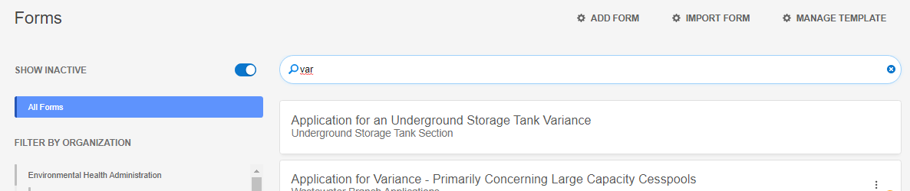
- A new form with the status of “Draft” will be created.

Assign Form to an Organization
This step will assign the parent organization which determines under what organization the form will be listed and enables public users to easily find the forms they need to submit. The setting also determines which internal users have access to maintain the form and process form submissions. Typically, the agency/program that owns the processing of the form is the Responsible Organization.
Note: This setting can be updated later from the Forms Designer Form tab.
Use the following step to assign the parent organization to the form:
- Select the organization that is responsible for and is associated to the form.
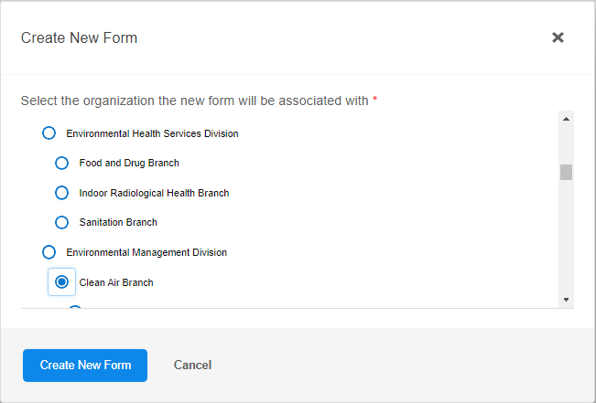

Configure the Form Attributes
This step will allow the user to configure the form details and high-level attributes for the new draft form.
The form designer consists of three main steps; 1) Form Details, 2) Sections and Controls and 3) Processing Steps and Actions. Online applications will require that all three steps be completed. Offline forms will only require Step 1 – Form Details be completed. This section describes what is considered Step 1 of the form design process. This step includes the configuration of all high-level form attributes, or Form Details.
There are many configuration attributes available for use for a form. The Form Details page is separated into a number of tabs. Each tab is organized by similar data points and has information that will need to be filled out before a form can be published and made publicly available. Information that is required for a form to be published will be marked with a red asterisk.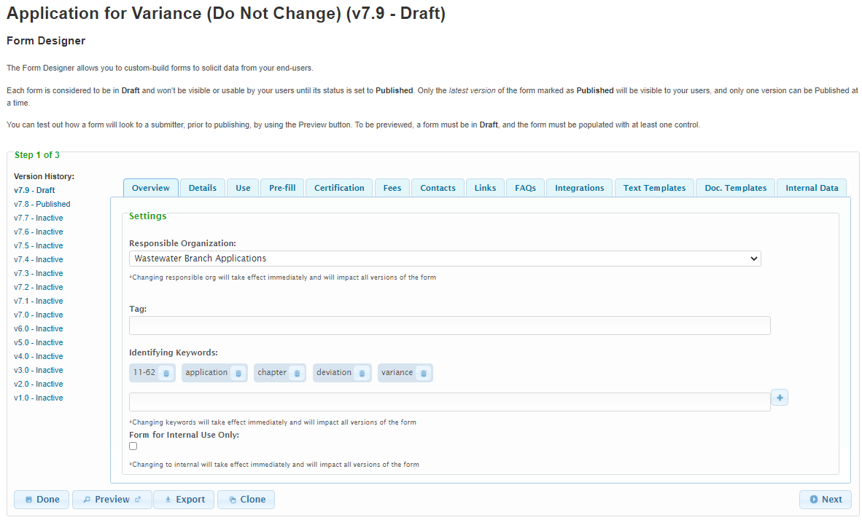
Many useful settings for form setup are listed below.
- Overview – For configuring the form information that is shared across all versions of the form.
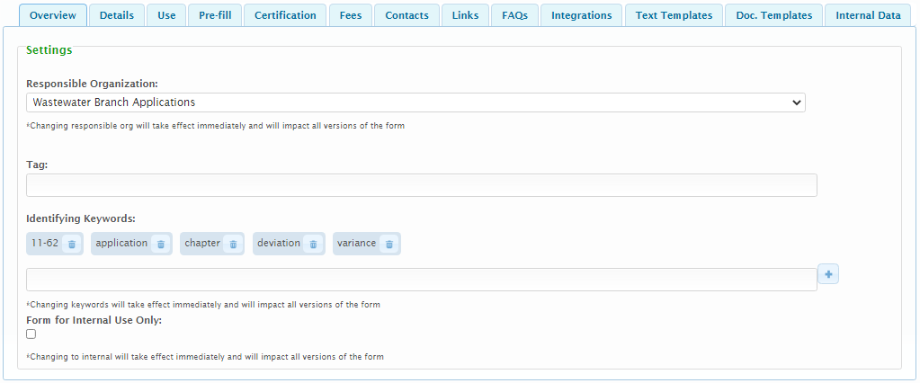
  - Responsible Organization (described above)
  - Tag – uniquely identifies the form. Form tags must be unique across the entire application. Used to map any exporting/importing or use of data back to the original form. Important when an external system or database needs to access submission data outside of the nFORM system (i.e. for data integration). See the TAGging Fundamentals topic in the Integration Guide for additional details on tagging.
  - Identifying Keywords - for the Finder search capability. List of words that users can enter in the Finder that would result in this form being included among the matching results. Matching on identifying keywords is in addition to matching on the form name, form reference number, and form short description, all of which are already automatically searched when using the Finder.
  - Form for Internal Use Only - Identifies if the form will be available for selecting and viewing by the public. If this attribute is checked, the public will not have the ability to find this form.
  - Form revision notes can be added to a form via the Form Revision Notes section in the form design overview tab. Revision notes are helpful when form designers want to communicate the changes that they have made on specific versions.
To add a note simply click on the add note… button. This will give you a prompt to enter the pertinent data. Once a revision note has been created you can edit or delete your own note. The revision notes automatically indicate what version they were added to in the list of revision notes.
- Details – For configuring the main form information.
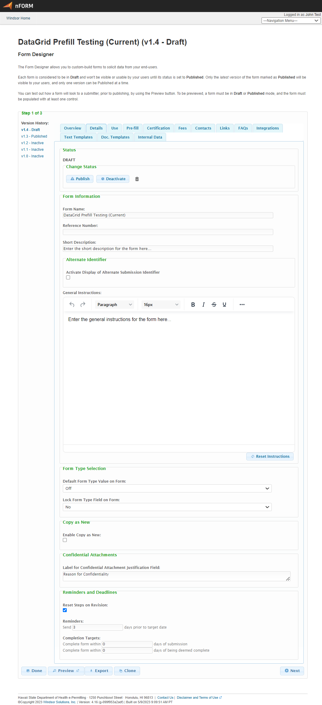
  - Status
    - Statuses
      - Published: Current version of the form is available to be submitted and is not editable.
      - Draft: Current working version of the form is not yet available to be submitted. The most recent published version (if one was available) will continue to be available to be submitted. New forms are initially set to Draft.
      - Inactive: Inactive version of the form, is not editable and is no longer available to be used for new submissions. Used for reference only. Forms with this status can later be updated.
    - Change Status Buttons
      - Publish: Publishes the current version of the form for use by users of the system. Note: Only Draft versions of the form can be published.
      - Deactivate: Deactivates a version of the form. Note: Only Draft or Published versions of a form can be inactivated.
      - Draft: Establishes an editable, draft version of the form that can be used to adjust the configuration of a form. Note: Only Published or Inactive version of a form can be made to draft and only one version of a form can be a draft.
      - Tip: When an existing, published form needs to be edited, you will need to press the Draft button to create a new draft version of the form which can support modifications to that form. If there is already a draft version of the form, that version must be used, or it can be inactivated and then a new draft can be established based on the current master published version. There may only be one draft version of a form at a time.
  - Delete Form- Simply click the trash bin icon in the status section. You can delete your form if there are no open submissions. If there are you will be prompted to delete those first before being able to delete the form.
  - Form Information:
    - Form Name – Public name/title of the form that is displayed throughout the system.
    - Reference Number – A reference number used to identify the form. This is often used to reference an old paper form number.
    - Short Description - Text displayed to support the user in understanding the purpose of the form and its intended audience. Helpful to the public user when deciding if this form is applicable for the user’s situation.
  - Alternative Identifier – Activate Display of Alternative Submission Identifier – If checked, an Alternate Identifier will be enabled allowing the form designer to collect data from the submitter, which will then be displayed on the Processing Dashboard, and submission headers as a way to associate a meaningful name that the application can remember and search on. See Alternative Identifier section of the Advanced Form Design Guide for details on this feature.
  - General Instructions – Text displayed on the form’s home page intended to provide initial instruction for using and completing the form.
  - Form Type Selection:
    - Default Form Type Value on Form – The default form type (e.g. New, Renewal, Modification, etc.) for this form type. When the submitter/user submits a form, the first step is referred to as the “Processing Info” step and the user is prompted to select the reason for submission. This setting determines the default reason for this form type. Note: “Off” can be used when this attribute is not used.
    - Lock Form Type Field on Form – Selecting “Yes” for this attribute will lock the Reason field value based on the configured default value, forcing this value to be consistent for the form.
  - Copy as New – Enable Copy as New – If checked, specifies that the submitter will have the ability to copy existing submissions for this form, as a new submission, from the Submission View page.
  - Confidential Attachments – Label for Confidential Attachment Justification Field (if enabled): The label that will be displayed above the confidential attachment justification field to inform the user to provide a reason if they wish to keep an attachment confidential. Note: this will only be utilized if the submitter identifies an attachment to be confidential.
  - Reminders and Deadlines – Reminders and deadlines allow agency staff to assign target benchmarks for processing submissions as well as to support configurable notifications. Once configured, these benchmarks can be utilized in custom reports, as desired.
    - Reset Steps on Revision: If checked, the timelines and benchmarks for processing the submission will be reset following a revision of a submission.
    - Reminders: Specifies when notifications will be sent and establishes benchmarks for completion of the form.
      - Send NN days prior to target date: Specifies the number of days prior to a given process steps target date that "Near Target Date" notifications should be distributed. These Notifications are configured in the Trigger Action field (i.e., Action: "Near Target Date") of the Workflow Notifications area of the Form designer. Note: notifications will only be sent to the users who are configured to receive such alerts on the processing step notifications area. See Processing Step Notifications below for further details.
      - Complete form within NN days of submission: Species the number of calendar days the agency is targeting to have completed the form (e.g., assigned a finalizing status such Issued or Denied status).
      - Complete form within NN days of being deemed complete: Specifies the number of calendar days, after a submission is deemed complete (i.e., assigned the "Deemed Complete" status), that the agency has targeted to have completed the form (e.g., assigned a finalizing status such Issued or Denied status). Note: this benchmark is only relevant if the "Deemed Complete" Submission Status is enabled.
  - Date Tracking (read-only) – View recent activity on the form: Last Updated, Published By, and Inactivated By.
- Use – For configuring the manner in which the form will be utilized.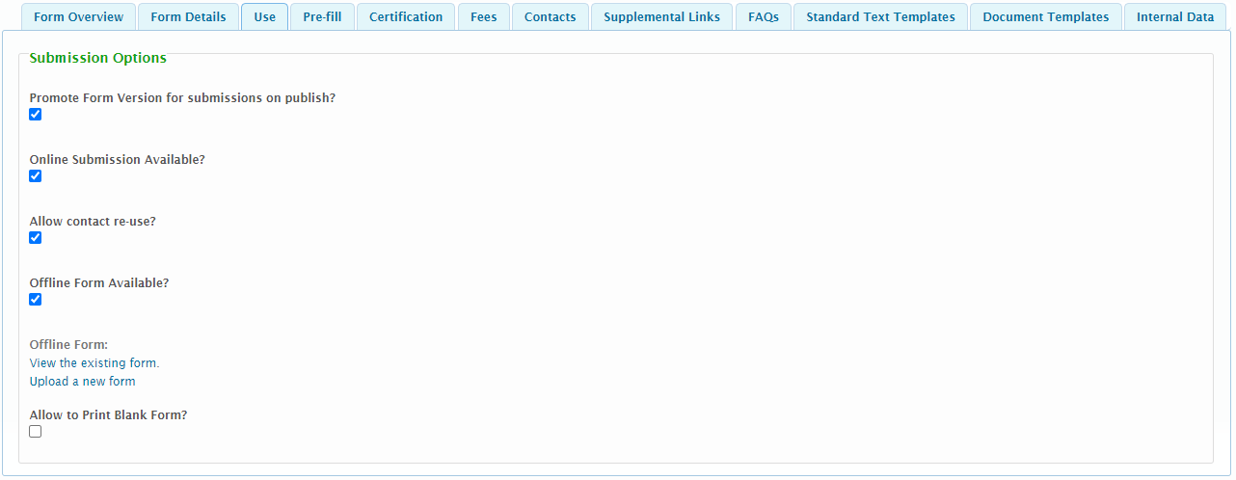
  - Promote Form Version for Submissions on Publish? – If checked, indicates that published updates to a form, should be automatically applied to any previously started draft submissions of the form, when the submitter reopens the submission. If this configuration is enabled, when a user opens their submission, they will be notified that the draft submission will be promoted to the latest form definition in order to continue with the submittal process. Please note that in order to take advantage of this feature, this setting will need to be turned on prior to a submission being started. Essentially, activating this feature enables the "tracking" of any form design changes.
  - Online Submission Available? – If checked, indicates that the form can be completed using the online submission.
  - Allow Contact Re-Use? – If checked, indicates that submitters will have the ability to re-use entered contact information within a form submission.
  - Offline Form Available? – The Offline Form Available? checkbox specifies whether the user can download an electronic copy of the submission and submit this form outside of the system. These can be utilized for forms that are not suitable for online submission or as an offline alternative. If this value is selected, additional fields will be available, and Allow to Print Blank Form? feature will not be available:
    - To view the existing form, click here: If an electronic version of the form was previously uploaded, this document can be viewed and downloaded by clicking on this link.
    - To upload a new form, please click here: This link allows the user to select and upload an electronic version of the form. Files will be virus scanned on upload.
  - Allow to Print Blank Form?: If checked, users will have the ability to print a blank version of the form for reference purposes. If checked, Offline Form Available? feature will not be available.
Note: this value will only be available if configured to be enabled in the system.
- Pre-Fill – For configuring the data importing processes, if and when utilized. See the Data Integration section of the Integration Guide for details on this feature. 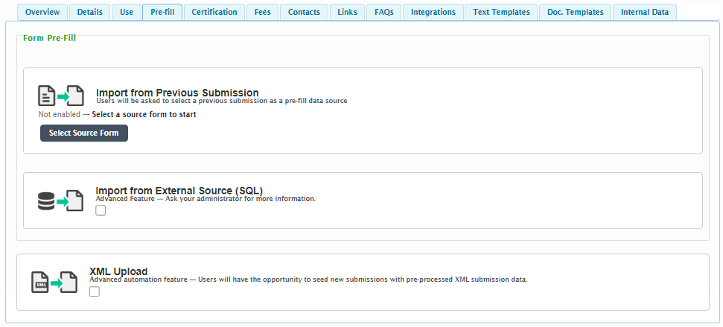
- Certification – For configuring what will be presented to the user during the certification and signature process. 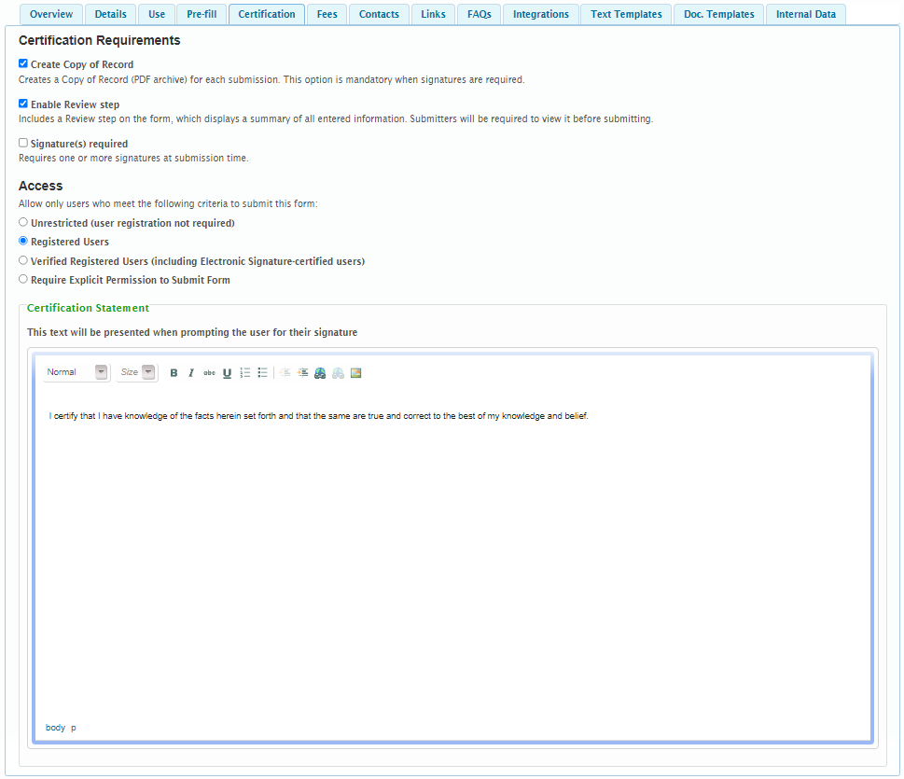
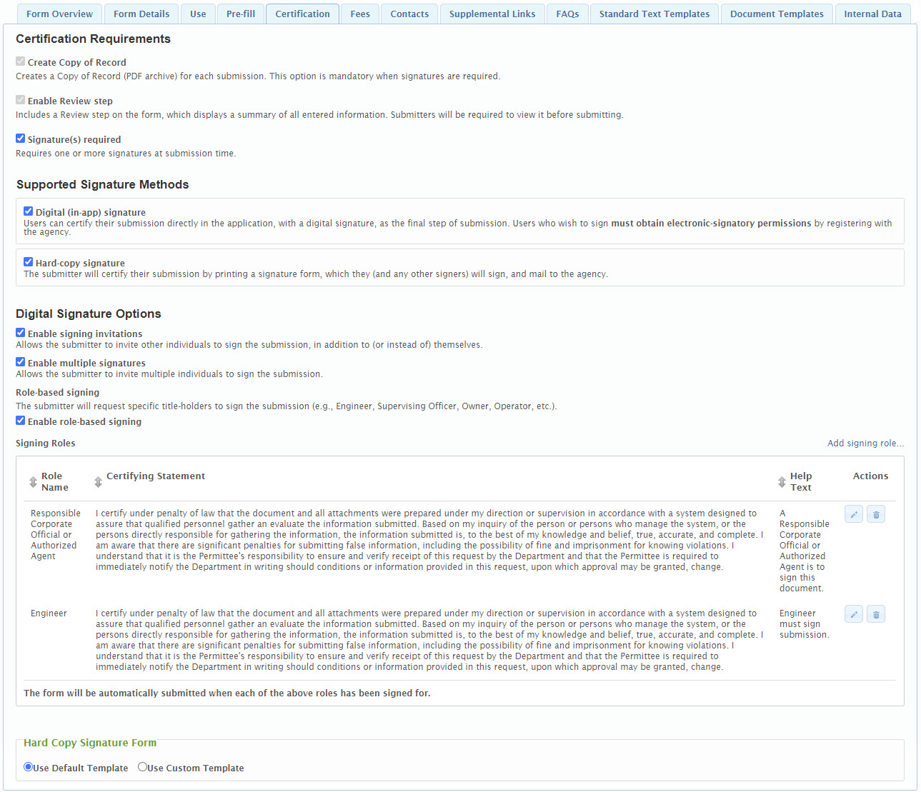
  - Create Copy of Record: If checked, a Copy of Record (PDF archive) will be created for each submission. This option is mandatory when signatures are required.
  - Enable Review Step: If checked, the form will include a Review step on the form, which displays a summary of all entered information. Submitters will be required to view it before submitting. This option is mandatory when signatures are required.
  - Signature(s) Required: Requires one or more signatures at submission time.
    - Digital (in-app) Signature: If checked, users can certify their submission directly in the application, with a digital signature, as the final step of submission. Users who wish to sign must obtain electronic-signatory permissions by registering with the agency.
      - Digital Signature Options:
        - Enable Signing Invitations: Allows the submitter to invite other individuals to sign the submission, in addition to (or instead of) themselves.
        - Enable Multiple Signatures: Allows the submitter to invite multiple individuals to sign the submission.
        - Role-Based Signing: The submitter will request specific title-holders to sign the submission (e.g., Engineer, Supervising Officer, Owner, Operator, etc.).
        - Enable Role-Based Signing:
          - Signing Roles: Specific signing roles (e.g., Engineer, Supervising Officer, Owner, Operator, etc.) can be requested and configured here. For each signing role, the user can provide the following:
            - Role Name: A name for the signing role (e.g., Engineer, Supervising Officer, Owner, Operator, etc.). This role will be presented to the external users.
            - Certifying Statement: The certification text will be presented when prompting the user for the signature for this role. This text can describe what the user is certifying and agreements the submitter are making by signing the form. Each role can have a unique certification statement.
            - Help Text: Any supporting text that should be presented with the signing role to give users further direction as to the role being requested for signing (e.g., "At least one owner must sign this form.").
      - Certification Statement: The certification text will be presented when prompting the user for certification or signature. This text can describe what the user is certifying and agreements the submitter are making when certifying/signing the form. Note: this configuration field will be presented with individual roles if Enable Role-Based Signing is checked.
    - Hard-Copy Signature: If checked, users can certify their submission by printing a signature form, which they (and any other signers) will sign, and mail to the agency. If this option is selected, the form designer will need to select the default template or can upload a custom hard-copy signature form using the "Use Custom Template" option in the Hard Copy Signature Form area.
  - Access: Allow only users who meet the following criteria to submit this form: Note: these options are only available is Signature(s) Required is disabled.
    - Unrestricted (user registration not required): If this option is selected, anyone can submit the form.
    - Registered Users: If this option is selected, any person that has self-registered an account can submit the form.
    - Verified Registered Users (including Electronic Signature users): If this option is selected, any person that has self-registered an account, who's user information has been verified to be correct by the agency (i.e., user is assigned the Verified User or Electronic Signature role for the parent organization) can submit the form.
    - Require Explicit Permission to Submit Form: If this option is selected, individuals must receive explicit authorization to submit the form based on the assignment of the Authorized Submitter role for the parent organization for the form.
- Fees – For configuring any fees that are associated with submitting this form online. 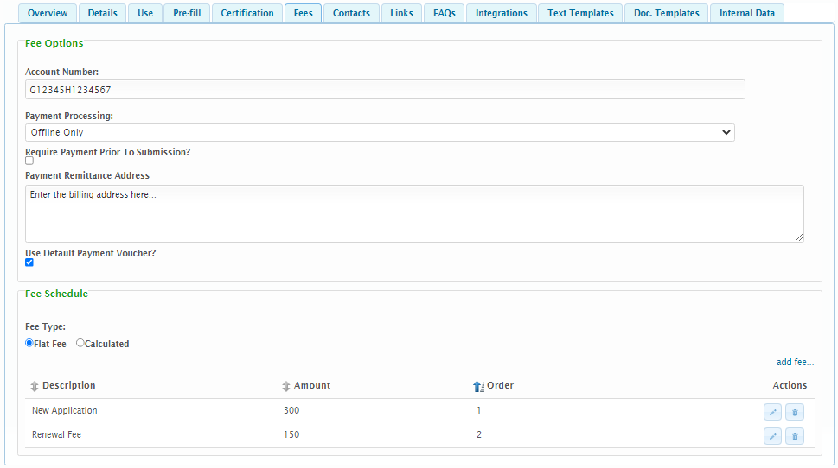
  - Fee Options
    - Account Number – The primary account number for where the processing fee will be distributed within the agency's accounts. This is for reference and reporting purposes only.
    - Payment Processing – There are multiple options for allowable payment methods for a form. These options include:
      - No Fee: If selected the form will have no fees associated and the tab will then be limited with configuration options.
      - Online Only: If this option is selected, online payments will be enabled for this form. Online payments allow the submitter to pay any fees via a 3rd party payment processor, if feature is enabled and configured.
      - Offline Only: If this option is selected, offline payments will be enabled for this form. Offline payments allow the submitter to print a remittance slip, write a check and send a payment to the agency, for any fees due.
      - Online or Offline: If this option is selected, both online or offline payment methods are supported. The user can decide which method best suits their needs.
    - Require Payment Prior to Submission? – If checked, the system will require full payment prior to considering the form as submitted. The submission will be assigned to a "Payment Due" submission status after certification/signing until full payment is received. Once paid, the submission will be assigned a submission status of "Submitted". If unchecked, payment will occur following submission.
    - Payment Remittance Address – The address where form fee payments should be remitted.
    - Use Default Payment Voucher? – If checked, the system default payment voucher will be presented to the submitter. If unchecked, a customized payment voucher template can be uploaded (on the setting following this option) and utilized for submissions of this form and additional fields will be available under the Payment Voucher Template heading. See Payment Voucher Design Guide for details on this feature.
  - Fee Schedule
    - Fee Type – There are multiple options for allowable fee types for a form. These options include:
      - Flat Fee: The initial fee assessed for the submission will be a standard amount.
Tip If your form does not require a fee, edit the Default Fee Description to change the Fee Description to “No Fee Required” and verify that the Fee Amount is set to $0.
      - Calculated: The fee will be calculated based on the properties of the submission.
    - Flat Fees – Any flat fee(s) specific to the form can be configured here. For each flat fee, the user must provide the following:
      - Fee Description: Describes the fee. This value will be presented to the submitter
      - Fee Amount: Specifies the amount of the flat fee.
      - Display After/Order: Specifies a custom sort order for the list of values.
Note: If "Flat Fee" is selected as the Fee Type, at least one fee must be provided.
Note: One or more flat fees can be established, allowing the user to select the appropriate flat fee (e.g., Small Quantity Generator or Large Quantity Generator), when appropriate.
    - Calculation Based Fees – The details of the calculated fee that will be charged to process the form. See the Calculated Fee section of the Advanced Form Design Guide for details on this feature.
- Contacts – For configuring contact information for the form. This contact information will display to the submitter on the Form View page as well as the Submission View page. 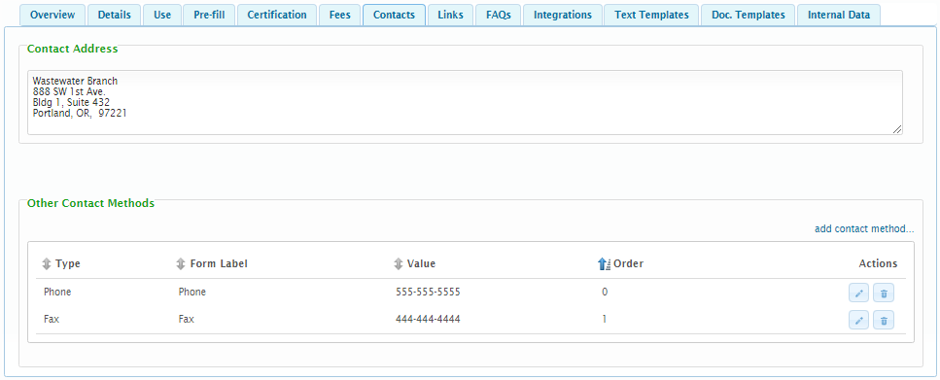
  - Contact Address – The contact address associated to the form.
  - Other Contact Methods – Other contact methods for the form (e.g., phone, mobile, email, etc.). When adding/editing an Other Contact Method, the following attributes are available:
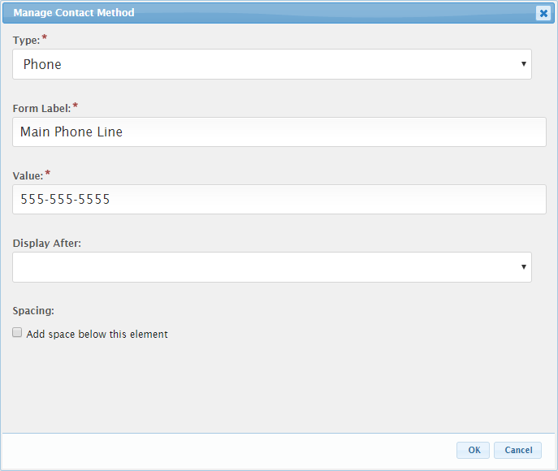
    - A Type can be selected to identify the type of contact method being described.
    - A Form Label can be provided to provide a custom name for the Other Contact Method.
    - The Display After value is used to specify a custom sort order for the list of values.
    - To support regional offices and grouping of other contact methods, space can be added between other contact methods checking the Add space below this element.
- Links – For configuring links related to a form (e.g., statutes, regulations, user guides, organization websites, etc.). These links will display to the submitter on the Form View page. 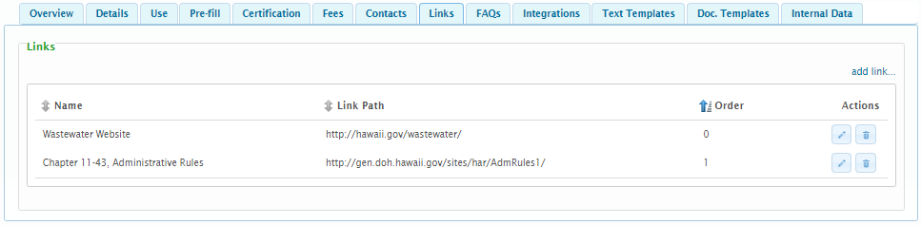
  - Add/Edit Link – When adding/editing an additional link, the following attributes are available:
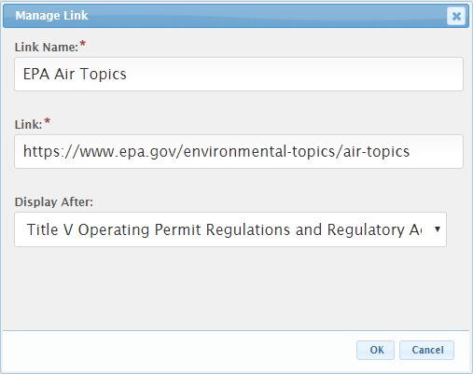
    - A Form Label can be provided to control the way the link will be presented to the user. This label will function as the hyperlink on the organization.
    - The Link field will specific the web address of the web resource (e.g., document or web site).
    - The Display After value is used to specify a custom sort order for the list of values.
Note: The Link value must be a fully qualified web address (e.g., http://... for a website).
- FAQs – Frequently asked questions for the form can be configured here. These Frequently asked questions will be presented to the public on the Form View page.
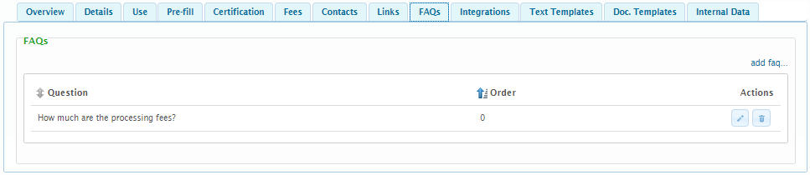
  - Add/Edit FAQ – When adding/editing an additional FAQ, the following attributes are available:
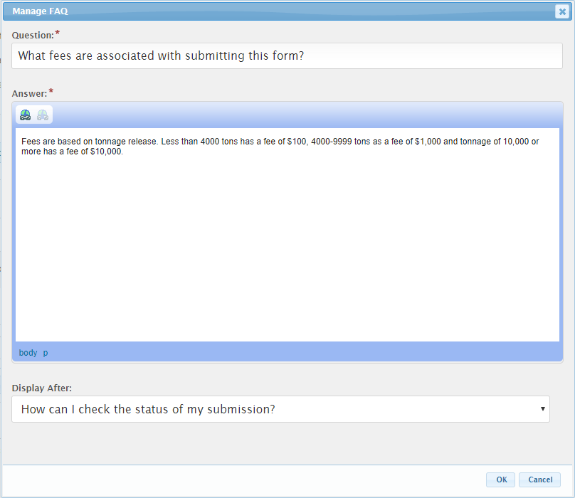
    - A Question is the FAQ question that will be presented.
    - The Answer is the answer to the question that will be presented to the user for the question is selected.
    - Display After value is used to specify a custom sort order for the list of values.
- Integrations - Custom data integrations can be configured from this area. In particular, this area allows a user to customize where on the file system a copy of the submission package will be archived.
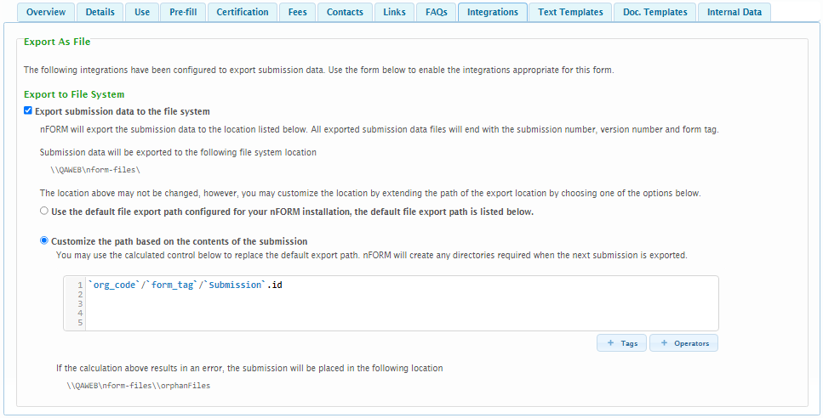
  - Check the “Export submission data to the file system” checkbox to enable this option.
    - The “Submission data will be exported to the following file system location” represents the base file location where submissions will be exported. This setting is configured at the system level in the configuration settings.
    - Custom File Location:
      - Select the “Use the default file export path configured for your nFORM installation” to allow submissions to copied to the location specified in the “Submission data will be exported to the following file system location” attribute.
      - Select the “Customize the path based on the contents of the submission” option to allow submissions to be copied to sub-folders within the “Submission data will be exported to the following file system location” file path. This setting allows users to group like submissions (e.g., by program area, division, permit type, etc.), when appropriate.
        - Sub-Folder Location Formula: The formula used to determine the sub-folder where the submission package will be stored. See Formula Builder topic for additional details on use of this field.
- Text Templates – Text templates can be established for a form to enable an organization to provide consistent communication with the submitter. These text templates will be available for selection by the processing staff when processing a submission (e.g., Correction Requests, Informational Messages, etc.). 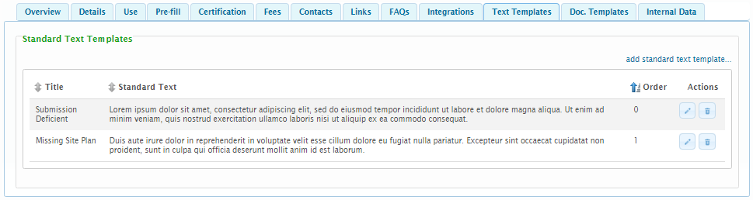
  - Add/Edit Standard Text Template – When adding/editing a Standard Text Template, the following attributes are available:
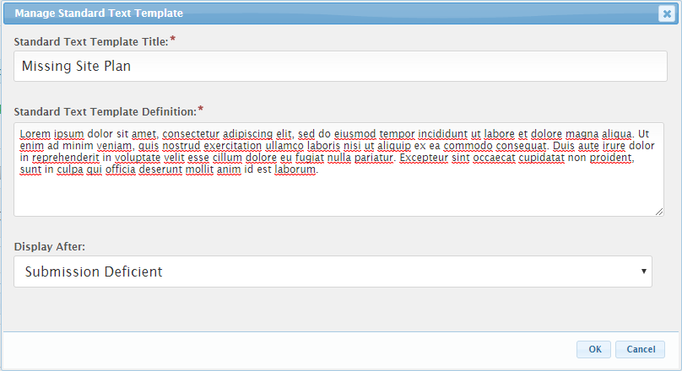
    - A Standard Text Template Title will describe the standard text template in simple terms. This will be the value that is presented to a user when selecting the standard text template.
    - The Standard Text Template Definition is the standardized text that will be imported in to the note when selected.
    - The Display After value is used to specify a custom sort order for the list of values.
- Document Templates – Templates that can be utilized within the form (e.g., Step Actions) to generate documents to support the submission process. See Document Generation Design Guide for details on this feature. 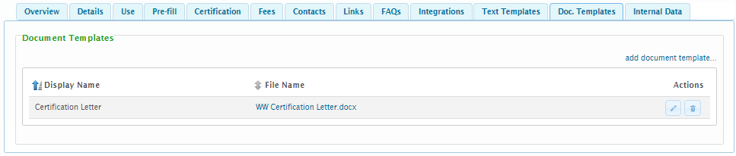
- Internal Data - Internal data controls/fields are available to allow additional internal only data points to be added to a form to support the submission process. This area is for the setup of these internal data controls (for collecting additional information, by internal staff). See the Internal Data Controls section of the Advanced Design Guide for additional details on this feature.

Continue to Step 2
When satisfied with the initial property settings and details for the form, click Next in the lower right hand of the Form Designer to proceed to Step 2, the Form Sections and Controls designer in the Form Designer, where the form content can be configured. 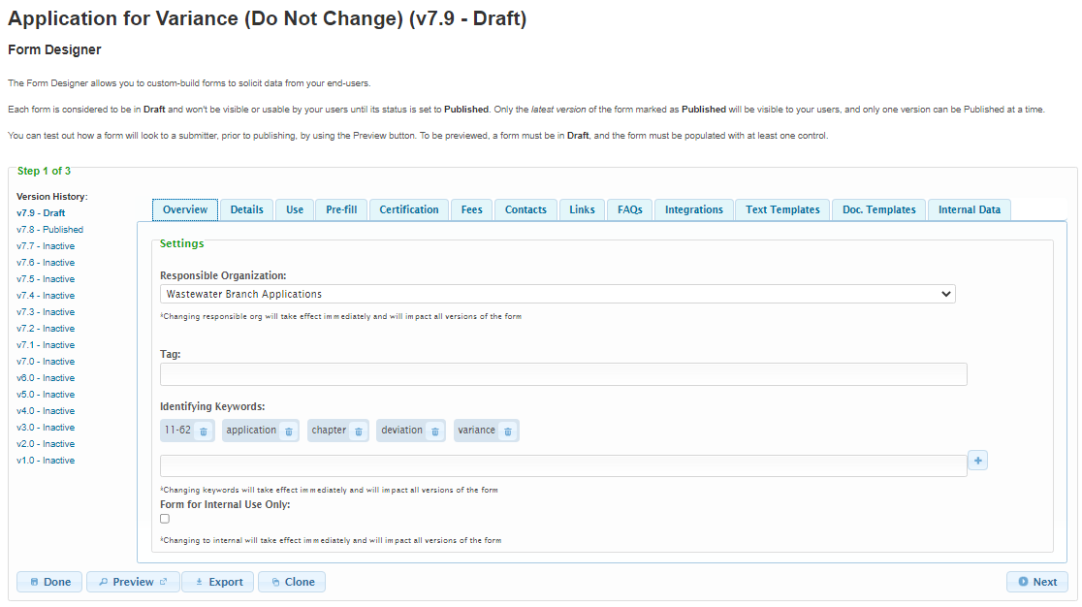
Navigation Tip: Clicking the tabs on Step 1 of the Form Designer allows you to navigate to the different form attribute tabs. Clicking the Next button advances the Form Designer to Step 2 where Form Sections and Controls will be managed.

Step 2: Design the Form Content
The second step to form creation is to design the sections and controls that will be presented to the submitter on the form. This step is used to view and manage the logical sections of a form as well as the controls included in each section and includes the configuration to define logical sections of an on-line form as well as instructions and input controls to each section. Forms can include multiple sections to allow the information on a form to be distributed in logical and consumable groupings of questions and answers.

Plan Your Form Layout
Consider the design of your online form and how form fields should be grouped in to sections and the order in which these sections should be displayed. The organization of an online form should enable users to easily understand and quickly fill out the form.
Many online forms are initially based off existing paper-based forms. While some sections from the paper-based forms may be appropriate to model in your online form, others may no longer be necessary or helpful. Keep in mind that online controls have the additional capabilities to display helpful text to the end user and validate what the user types and selects.
See Appendix A: Controls for additional details on available controls types and configuration options.
Once a determination has been made as to how the form will be organized, sections and controls can be added to the form. This is done in Step 2 of the Form Designer.
Note: If you had previously exited out of nFORM, you will need to return to the Form Designer: Click Forms in the top menu bar, locate your form in the list, and click the Edit Action button to edit the form. Click Next in the lower right hand of the Form Designer to proceed to Step 2. The form must be in Draft mode in order to update the form.

Add Sections
This portion of the document describes how logical sections are viewed and managed on a form. These sections provide a means to break a form into smaller, more consumable components. This is the second of a three-step process to design a form. The Sections allow the user to identify the name of each Section as well as an introduction for the Section.
To add a section to a form:
- Continue from Step 1: Create and Configure Form Attributes step described above.
- From Step 2 of the Form Designer, click Add section +
Note: To edit an existing Section, click on the Edit icon to the right of the Section in question.
- The Section dialog box will be displayed. 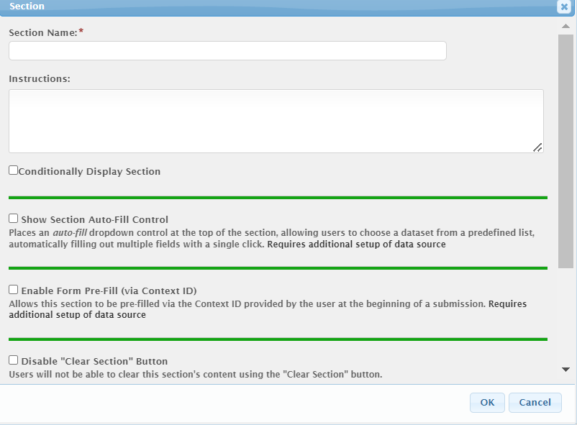
- Provide the properties of the section:
  - In the Section Name field, type a name that will help the users understand the purpose/organization of the section. The name will appear as a header at the top of the section on the form. For example, “Applicant Information” or “Owner Identification”.
Other optional settings include:
  - Instructions - type instructions or information that will be helpful to users filling out the form section. The Instructions text will appear immediately below the Section Name and above any controls within the section.
  - Conditionally Display Section – If the section will be allowed to display conditionally, during submission process, check the Section is conditionally displayed checkbox. When checked, the Display Formula text field will be enabled for configuration. See Conditional Display section of the Advanced Form Design Guide for details on this feature.
  - Show Section Auto-Fill Control – if the section will support automatically populating data fields, during submission process, check the Show Section Auto-Fill Control checkbox. See the Data Integration of the Integration Guide for details on this feature.
Note: The Auto-Fill option on the Contract Control works independently of this setting.
  - Enable Form Pre-Fill (via Context ID) – if section data will be prefill upon creation of the submission, this Enable Form Pre-Fill (via Context ID) will need to be checked. In addition, the pre-fill data will need to be configured appropriately. See the nFORM Data Integration Guide for details.
  - Disable ‘Clear Section’ Button: When selected the clear section button does not appear on the form for the applicant to clear that section.
  - Enable Repeater for this Section – check if the section requires the submitter to have the ability to repeat the questions in this section for multiple items. For example, the same information asked in this section needs to be supplied for each tank onsite, or for each panel installed.
    - Disable Repeater-Item Add/Duplicate – If the Repeater should not allow the ability to add/duplicate the section, check the Disable Repeater-Item Add/Duplicate checkbox. This feature is helpful when a Repeater is automatically prepopulated with data.
    - Disable Repeater-Item Delete – If the Repeater should not allow the ability to delete sections, check the Disable Repeater-Item Delete checkbox. This feature is helpful when a Repeater is automatically prepopulated with data.
    - Dynamically Name Repeater Items – If the Repeater should be dynamically assigned a name based on a value on form, check the Dynamically Name Repeater Items checkbox. The Repeater-Item Name Formula field will be enabled. See the Display a Dynamically Assigned Name to a Section Repeater in the Advanced Form Design Guide for additional details on this feature.
    - Repeater-Item Name Formula – Enter the formula for deriving the repeating section name in the Repeater-Item Name Formula field. This formula field allows for specifying the text to display for each item in the list. A great deal of flexibility has been provided with this formula which supports very simple and very complex derivations. See the Fee Calculation section of the Advanced Form Design Guide for details on format of formulas used in this area.
    - Sort - The system supports the ability to dynamically sort Repeaters based on various properties in the Repeater. You can sort Repeaters based on one or more attributes (e.g., Repeater Title, Field 1, Field 2, etc.) within the Repeater and to define the direction (Ascending/Descending) of each sort attributes. New attributes can be added by clicking the ‘Add sort criteria…’ button.
  - This Section is Optional – check if the section will be considered optional (e.g., validation only applied if values are entered on the section).
  - Tag - uniquely identifies the section within the form. Used to map any exporting/importing or use of data back to the original form field. Important when an external system or database needs to access submission data outside of the nFORM system i.e. for data integration. See the TAGging Fundamentals topic in the Integration Guide for additional details on tagging.
- Click the OK button to continue. If an error is presented, resolve the issue presented and click the OK button to continue. Repeat step as necessary.
- Continue to add sections as needed by repeating these steps.
- Drag the section boxes up or down to adjust the order in which the sections will be displayed on the form.
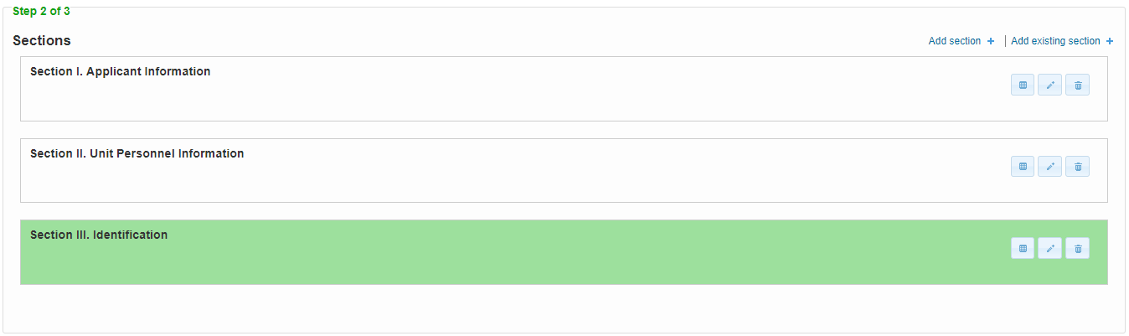
Tip: To save time, use Add existing section + link to copy an entire section and its controls from an existing form. The existing section must be in “Published” form in order for it to appear in the list of available forms for copying. The existing section (the original form section from which the copy was created) will not be affected by any changes made to the section in the new form.

Add Controls
Once the form has at least one section, individual controls can be placed on the form to capture the user’s input. Controls allow form designers to configure the questions and information that will be presented and captured within each section.
To enter the Controls component where you will add and view controls,
- Click the Controls button in the Section where you wish to add controls.
To add a control to the form:
- In the Available Controls area, click the tab names to navigate between the different Control Types: Simple, Formatted and Advanced.
- Locate the appropriate control type for the user input/question on your form.
- Click on the control type to add it to the section container. The control will automatically be added to the bottom of the current section.
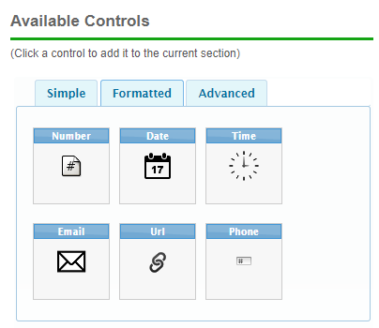
Note: To edit an existing Control, click on the Edit icon to the right of the Control in question.

- In the Control dialog displayed, fill in the information for the particular control type, as appropriate. Fields with a red asterisk are required.
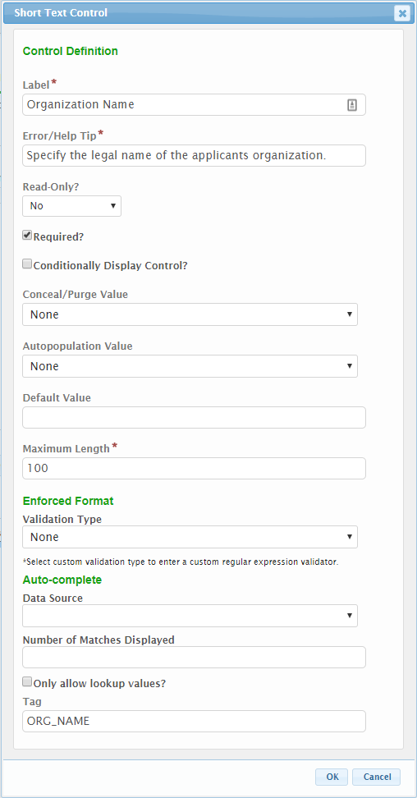
- Some of the fields that are common across control types include :
  - Label: Field name/question that will be presented to the submitter.
  - Error/Help Tip: Text that is displayed when a user hovers the mouse over the user input field. Also used to provide additional information in the case of an incompliant value being entered for a field e.g. a character is entered in a number-only field.
  - Read-Only?: If the control will be considered read-only, this attribute will be set to “Yes”. If the control will be considered read-only, only if prepopulated, this attribute will be set to “If prepopulated”. If the control will not be considered read-only, this attribute will be set to “No”.
  - Conditionally Display Control?: If the control will be allowed to display conditionally, during submission process, check the Conditionally Display Control checkbox. When checked, the Display Formula field will be enabled for configuration. See the Conditional Display section of the Advanced Form Design Guide for details on this feature.
  - Autopopulation Value: When appropriate, some information can be auto-populated in based on information found in a user’s profile (e.g., user’s name, email address, etc.).
  - Default Value: As needed, a control's value can be defaulted to a particular value using this attribute.
  - Maximum Value: The maximum number of characters that a user can enter in this field.
  - Required?: Check this if the user is required to fill in this field.
  - Tag: A tag value is a unique name assigned to a control to allow the control to be identified. This attribute is essential for facilitating the data importing and exporting processes. Used to map submission data back to its originating control element within the form. Referenced in formulas (e.g. fees) and when exporting/importing submission data. Only form fields that are "tagged" will be exported. See the TAGging Fundamentals topic in the Integration Guide for additional details on tagging.
Tip: See Appendix A: Controls for a completed list of available controls types and configuration options.
- Continue to add controls as needed by repeating these steps.
- Click and drag a control up or down within the section container to adjust the order in which the controls will be displayed within the section.
When satisfied with the controls and layout of this section, click Next Section in the lower right hand of the Form Designer to proceed with adding controls to the next section of the form.
Below is an example of section container with Short Text, Instruction and Contact Controls added to the form:
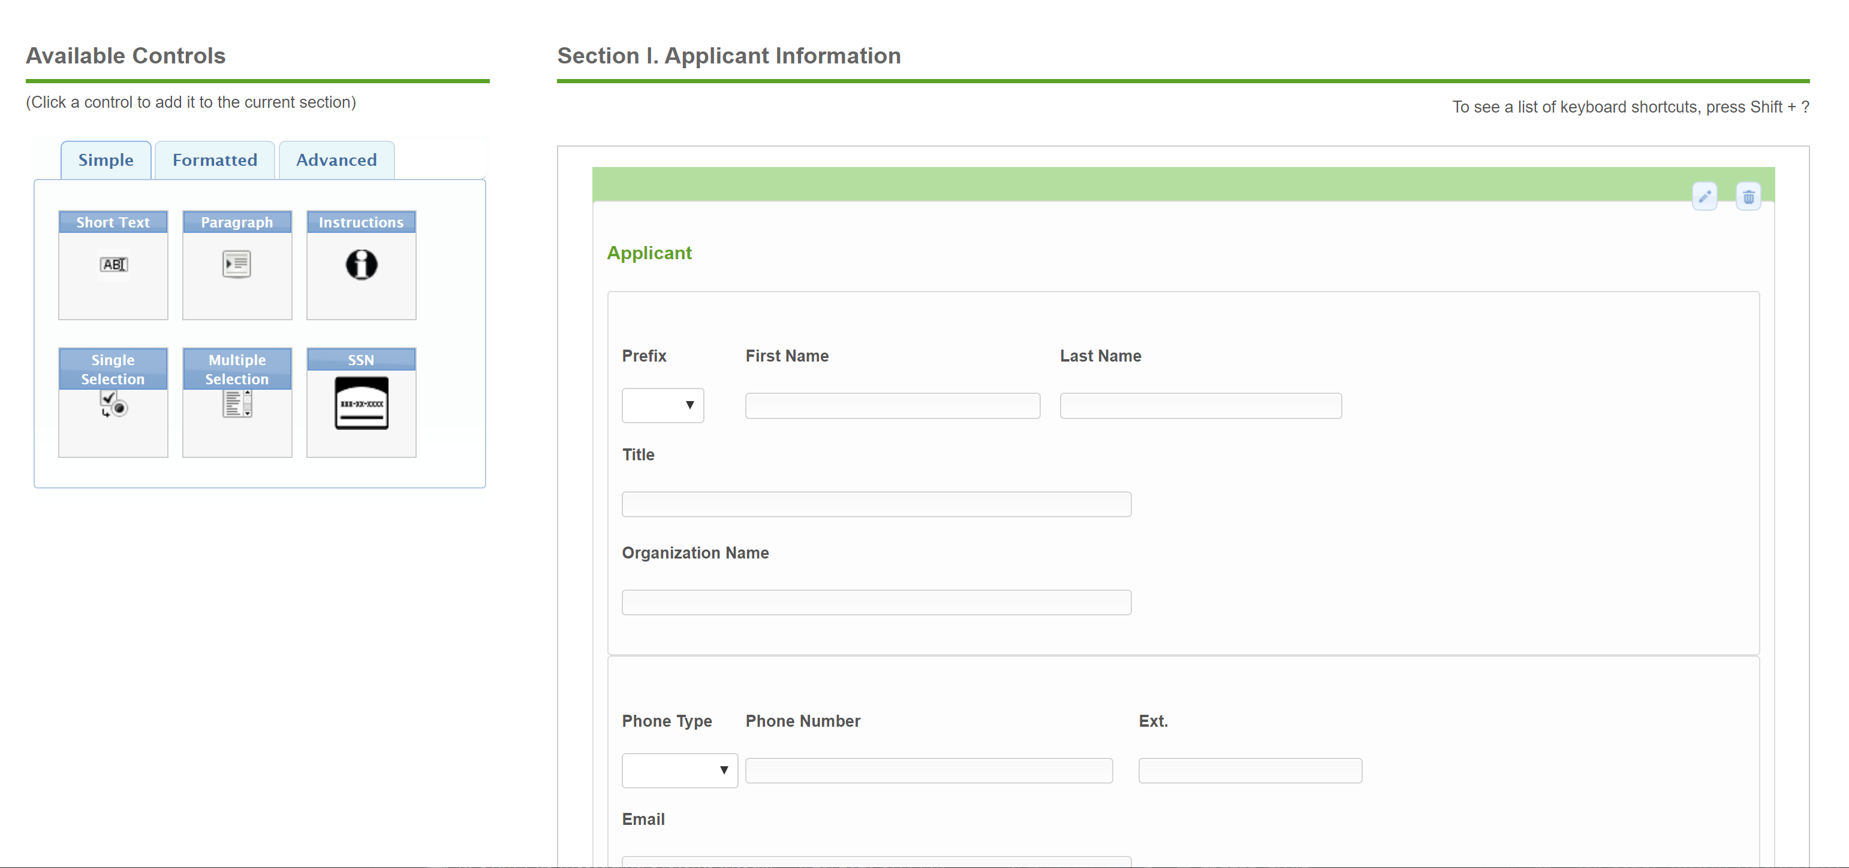

Continue to Step 3
When satisfied with all sections and their controls, click Return to Section List button.
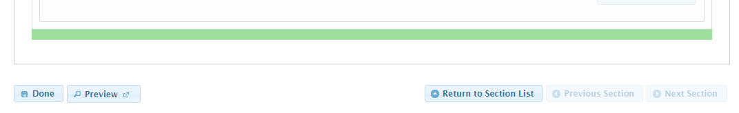
When satisfied with the configuration of the form content, click Next in the lower right hand of the Form Designer to proceed to Step 3, Default Form Submission Workflow, in the Form Designer.
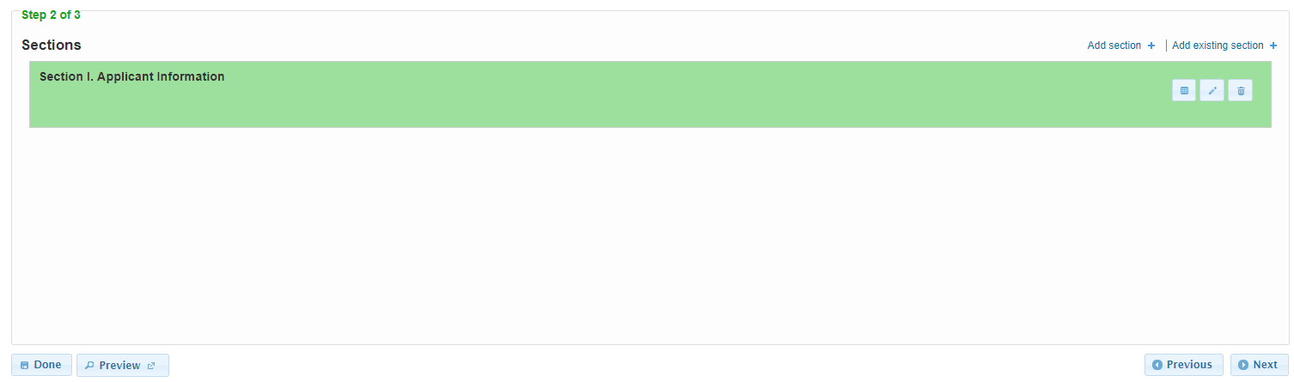

Step 3: Define the Default Form Submission Workflow
The third step to form creation is to define the default form submission workflow that the form will facilitate the processing of a form submission. This step includes the configuration of the form workflow steps and any associated step actions (e.g., notifications sent, documents generated, etc.), or Processing Steps and Actions.
Note: this default workflow can be adjusted after submission, to meet the unique needs of each form submission.

Determine Processing Procedures/Steps
Workflow Processing steps in nFORM typically follow an organization’s operating procedures for processing an application/form submission.
Below is an example of an agency’s operating procedure for processing an application as reflected in nFORM.
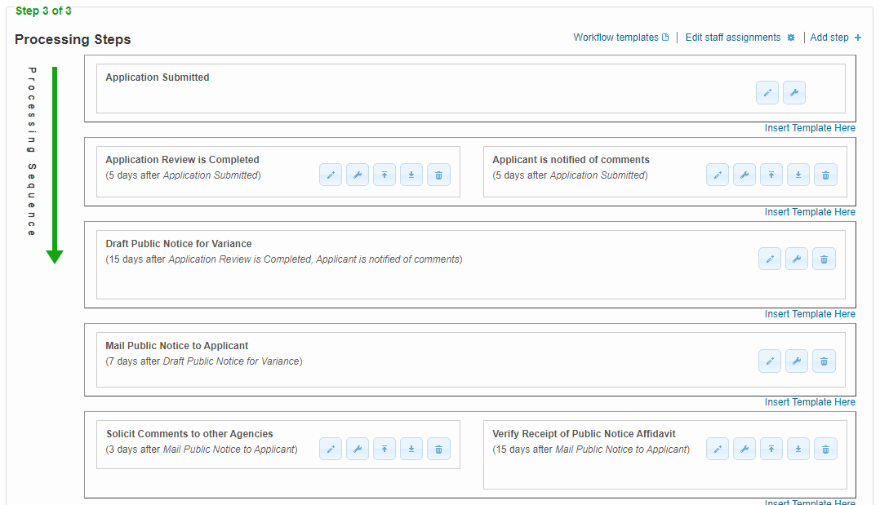
Note: If the user previously exited out of nFORM, then will need to return to the Form Designer: Click Forms in the top menu bar, locate the form in question from the list, and click the Edit Action button to edit the form. Click Next in the lower right hand of the Form Designer until you reach Step.

Configure Processing Steps
This section describes how the designer views and manages the default processing steps that a form will follow. These processing steps can be adjusted as required to meet the needs of the specific form. Processing steps can be assigned to Processing levels. Levels are used to represent steps that can be done in parallel. When two or more processing steps are set at the same level, the next level of steps will not be started until the final processing step on the level is completed.
Note: an initial “Form Submitted” workflow step will automatically be established for each form to support the recording of the initial submission in the workflow process.
To add a new processing step to a form:
- Continue from Step 2: Configure Form Content step above.
- Click Add step + in the top right hand of Step 3 of the Form Designer wizard. The Step dialog box will be displayed.
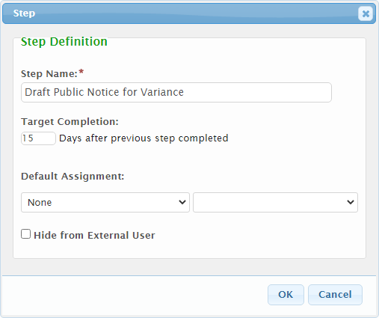
Note: To edit an existing Step, click on the Edit icon to the right of the Step in question.
- Enter a name for the Step in the Step Name field. This will represent the name of the processing step as it will appear in the process and in any notifications. For example, “Administrative Review”.
- Configure the optional step settings if applicable to this step in the workflow:
  - Target Completion NN Days After Previous Step Completed – targeted number of calendar days to complete this Processing Step once it is activated (i.e. the previous step is completed). Used to determine if alert notifications should be sent. To learn more about notifications, see the next topic, Configure Actions.
  - Default Assignment – Role or person the step will be automatically assigned when a form submission reaches this step in the processing of the form. Note: roles must be defined for the parent organization.
  - Hide From External User – the progress of processing the submission is visible to the submitter, by default that includes current and completed Processing Steps. Check this box if the step should not be listed in the submitter’s view of the Processing Steps history.
- Click OK
- If an error is presented, resolve the issue presented and click the OK button to continue. Repeat step as necessary.
- Continue to add Processing Steps that reflect your workflow by repeating these steps. Typically, forms will have a Processing Step each time the processing of the form requires another individual or team to perform a business activity.
- Click and drag a step level up or down to a new position to adjust the default order in which the steps will be activated and completed during submission processing.
- Click and drag a step up or down to a new position in a different step level (next to another step) to allow for parallel step processing.

Configure Actions
Each Processing Step supports actions for a step to inform staff, submitters or other interested parties of developments in processing as well as to automate processing. Each processing step can support custom step actions based on a step’s activation, completion, nearing of a target date, passing of a target date, or fees being satisfied. Examples of these actions include sending an email notification, marking a step as complete, automatically changing submission status, or generating a document.
To add a new step action to a form:
- On an existing processing step, click the Step Actions button to open the Step Actions dialog. All step actions that are currently configured for that step are listed.
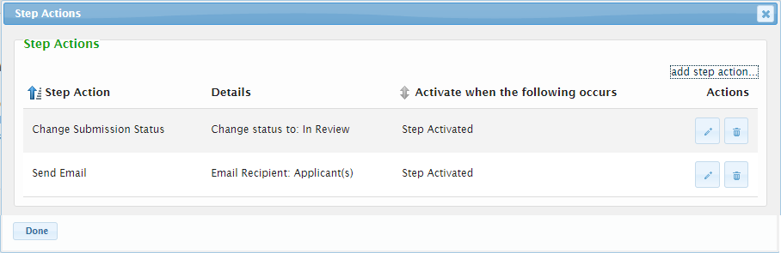
Note: To edit an existing Section, click on the Edit icon to the right of the section in question.
- Click add step action link to open the Manage Step Actions dialog.
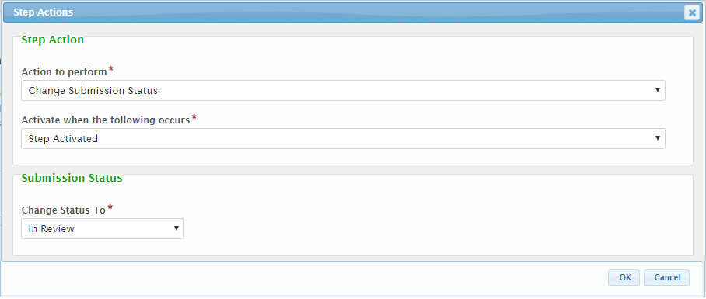
- Select the Action to Perform value. Based on the selected value, the fields presented on the form will change based on the attributes necessary to support the selected action type. Available Action Types and associated attributes include:
  - Autocomplete this Step – Automatically marks the current processing step as completed based on the occurrence of the selected Activate when the following Occurs value.
    - Activate when the following Occurs – Used to determine the activation trigger for this action. See Shared Attributes below for more details on this field.
  - Change Submission Status – Automatically changes the status of the submission to the selected Change Status To value based on the occurrence of the selected Activate when the following Occurs value.
    - Activate when the following Occurs – Used to determine the activation trigger for this action. See Shared Attributes below for more details on this field.
    - Change Status To – The status that will be assigned to the Submission.
  - Generate Document – Automatically generates a document based on the selected Document Template based on the occurrence of selected Activate when the following Occurs value and notifies the interested parties.
    - Activate when the following Occurs – Used to determine the activation trigger for this action. See Shared Attributes below for more details on this field.
    - Document Template: The template that will be used to generate the document. Note: this must be established and uploaded to the Form on Step 1 of the Form Designer. See Document Generation Design Guide for details on this feature.
    - Share document with applicant: If checked, the submitter will have the ability to view and download the generated document.
    - Email Attributes – Used to support the shipment of an email notifying the appropriate audience to the generation of the document. See field description below.
  - Send Email – Sends an email to interested parties of the action having been performed.
    - Activate when the following occurs - Used to determine the activation trigger for this action. See Shared Attributes below for more details on this field.
    - Email Attributes – Used to support the shipment of an email notifying the appropriate audience to the action. See field description below.
  - Send Submission File – If configured and enabled, activates the transmission of submission files to an external document storage system.
    - Activate when the following occurs – Used to determine the activation trigger for this action. See Share Attributes below for more details on this field.
  - Validate Internal Data – Allows for the validation and even requirement of internal data controls before processing step completion.
    - Activate when the following occurs - Used to determine the activation trigger for this action. Before step completed is the only option available.
    - When those values are selected the user is presented with a list of available internal data controls and then given the option to make them required before step completion. This is helpful in requiring important data for form completion.
  - Shared Attributes
    - Activate when the Following Occurs: Perform the selected step action when,
      - Fee(s) Satisfied: The fee status for the submission is changed to None, Paid or Waived.
      - Completed: Send notification when the processing step is marked as completed.
      - Activated: Send notification when the processing step is activated and available for processing.
      - Past Due: Send notification when the processing step is past its target completion date.
      - Near Target Date: Send notification when the processing step is nearing the target completion date.
Note: The “near” distinction is derived based on the value that is specific for the form Reminder – Send NN Days Prior to Target Date field.
    - Email Attributes (Generate Document and Send Email Only):
      - Recipient: The party who will receive the notification. These parties can include:
        - Applicants: All users who have access to manage the submission.
        - Submitter: The user who submitted the form.
        - Staff Step Assignment: The internal staff person who is assigned to the associated processing step.
        - Responsible Staff: The internal staff person who is assigned to the submission.
        - Internal User: The specific system user chosen from the drop-down list.
        - Custom Email Address: Any valid email address.
      - Custom text to append to email: The text entered in this area will be included in the email sent to the submitter.
  - The Usage section allows an internal data control to be marked for intent. The current options for this feature are File Transfer and payment processing. Both options allow the user to configure internal data controls with a third party integration. An override tag can be used if the integration will look for a specific tag when retrieving for the controls value.
- Click OK. The new action will appear in the Step Actions list.
- Continue to add step actions by repeating the above for each Processing Step where step actions are desired.
- Click Done to return to the Processing Steps list.
Tip: It is recommended that step actions be added on the Processing Step where user action is to be taken. For example, if the user is to be notified once a submission is in Management Review which follows Compliance Review step in the workflow, there is technically a choice to add a step action on either Compliance Review Completed or Management Review Activated. We recommend adding the step action on the step where the interested party needs to act upon the information.

Configure Staff Assignments
nFORM provides Form Designers with the ability to establish staff processing assignment based on the designation of roles, workgroups and workgroup route maps. These processing assignments are used to assign individuals to Submissions and Submission Processing Steps, either automatically based on a value in a submission or based on explicit assignment by a Submission Processor.
For additional details on this Staff Assignment feature as well as the details of how to configure and implement the feature, please reference the Staff Assignment section of the Advanced Design Guide document.

Continue to Step 4
Once all workflow Processing Steps and Actions have been configured, the form can be previewed, tested and published, the last step in adding a new form.

Step 4: Test and Publish the Form
The final step to form creation is to test and publish the form for use by system users. This step includes reviewing the form layout and testing the user interactions to ensure the form presents and behaves as intended. In addition, this step includes the publishing process, once the form is ready for selection and use in the system.

Preview and Test the Form
Use these steps to preview the form:
- Click Preview button in the lower left hand of the Form Designer (from any major Step in the Form Designer). The form will be opened (in a preview mode) in a new browser window/tab.
Note: Only forms that are assigned a “Draft” or “Published” status and have sections and controls configured can be previewed.
- Click Begin Form Entry button to start the submission process to fill out and submit the online form using a similar process to the end user.
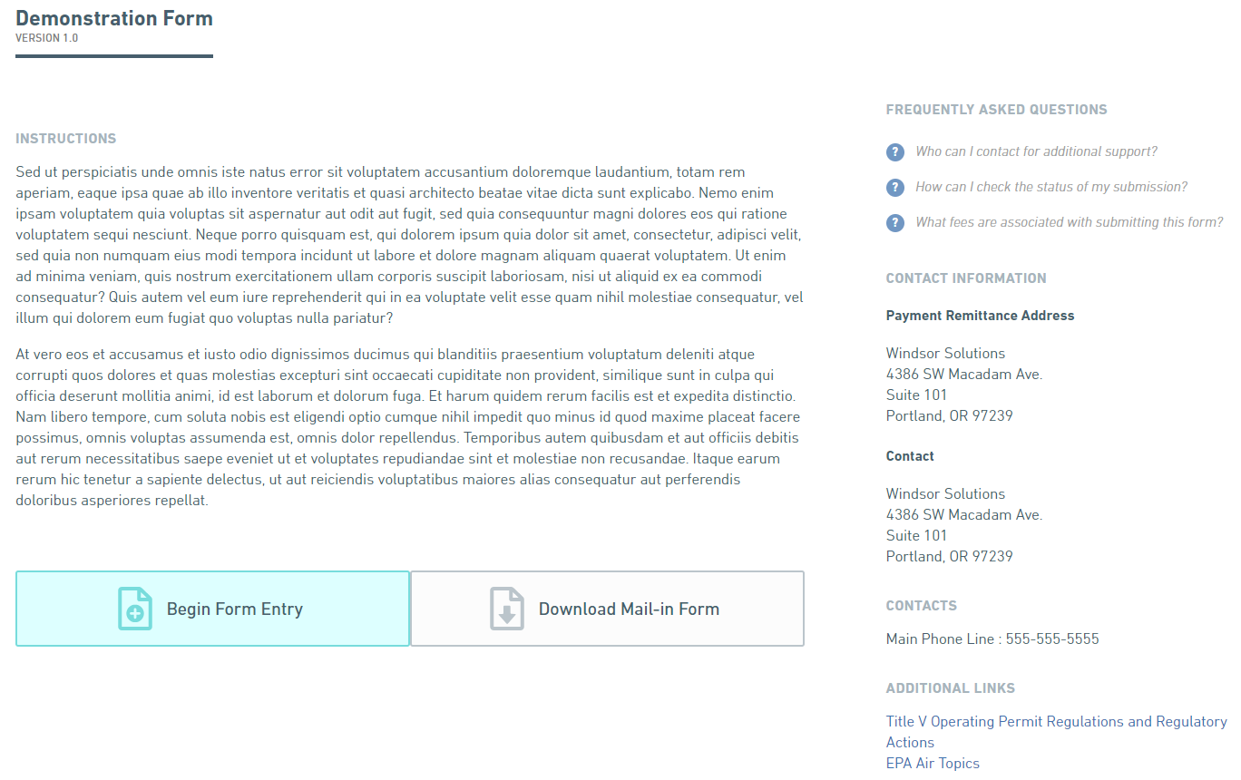
- Review the layout and organization of the sections and controls.
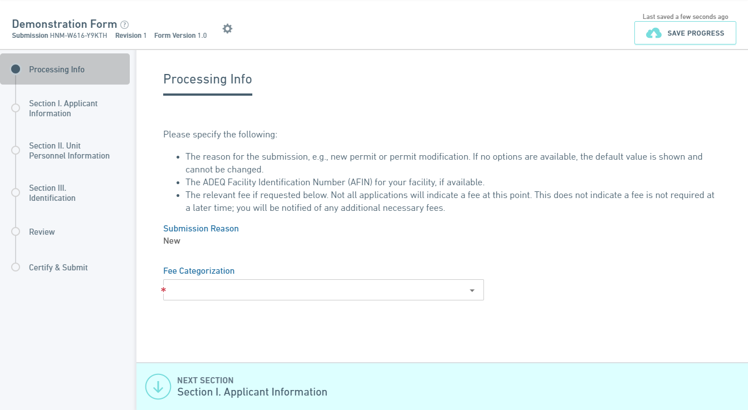
- Enter data in the form and test the form interaction and form features to ensure the form is working as intended.
- Proceed through all the form data entry sections (entering any required information) using the Next Section button in each section, to the Review section.
- Once on the Review section, review the entered information for accuracy and completeness.
- Click Next Section to proceed to the Certify & Submit screen. Review any certification text and the certification method that was configured as part of the Form Details.
- Click Submit Form to complete the preview.
- Adjust the form design, using the directions for Steps 1 and 2 above, as needed/desired.
Tip: While a final preview of the form is recommended, for a more iterative approach to form layout and design, preview any draft form as soon as controls added to all sections.

Publish the Form
Once satisfied with the layout and the user interactions of the new form, return to the Step 1: Form Details of the Form Designer to publish the form.
Note: The organization may have its own business procedures for reviewing, testing and publishing forms. See the nFORM System Administrator to determine if such policies apply to the organization.
Use these steps to publish a form:
- Return to the browser window where the form preview was launched.
- Return to Step 1 (Form Details) in the Form Designer.
Note: One or two clicks of the Previous button may be needed to get back to Step 1, depending on where in the form designer the Preview was initiated.
- From the From Details tab of the Form Designer, click the Publish button.
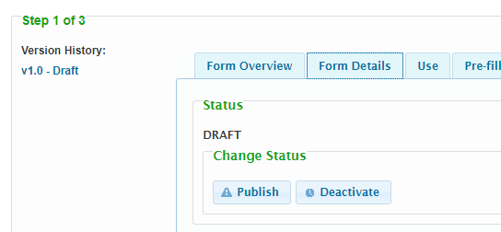
- If the form was previously published, you will be prompted to select whether the new version should be considered a minor or major version change. If this is a new form, the minor and major version change selector will not be presented and the form will be assigned a version number of v1.0.
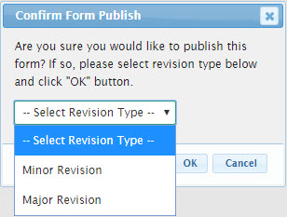
Note: A Minor Revision will increment the secondary version number (e.g., 1.2 to 1.3) where a major revision will increment the primary version number (e.g., 1.2 to 2.0). When a Major Revision is published, where the form does not have the Promote Form Version for Submission to Publish? option checked on the Use tab, any submitters that have an in process submission for the old version of the form, will be warned (when they open or submit the form) that it will be at the agency's discretion as to whether submission of the old form format will be accepted, due to the significance of the changes.
- Confirm the form publish by clicking on the OK button on the confirmation dialog.
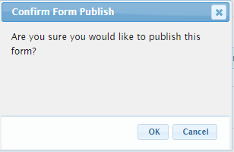
- Assuming all business validation rules are passed, the form will be published and ready for selection and use.
- If this is a new form, v1.0 – Published version will be displayed under Version History. If updating an existing version, you will see an incremented version (e.g. v2.4).

Form Ready for Use
Congratulations! At this time, the form is published and ready for selection and use within the system!
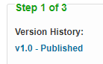

Refining a Form Design
Form design changes are needed from time to time, especially when a form is initially established online. This is anticipated and healthy for the maintaining the strength and usefulness of a form design. This section describes, the key steps used to refine the design of an existing form. These steps include:
- Establish a Draft Version of the Form
- Refine the Design of the Form
- Test and Republish the Form
While similar to the Form Creation process, this section of the document describes where these processes differ.

Step 1: Establish a Draft Version of the Form
The first step to refining the design of a form is selecting and opening the form in question.

Open the Form Needing Refinement
This step will open the form in question.
- Select Forms link from the top menu to open the Forms page.
- From the Forms page, enter a portion of the form name in the Filter field to instantly narrow down the list of potential forms for selection.
- Double click on the form in question to open the form.
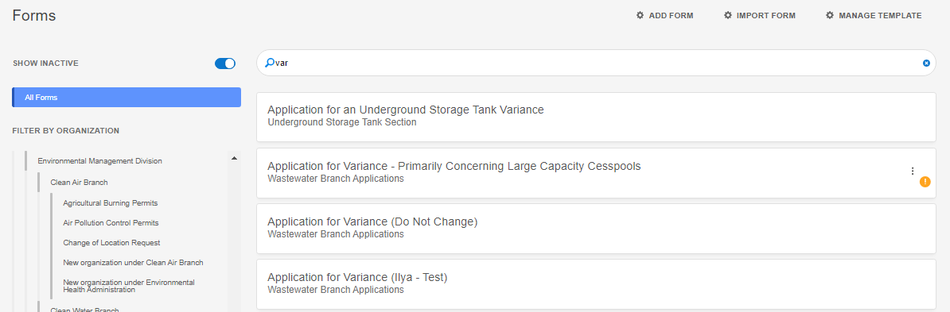
- The form in question will be opened in the form designer.
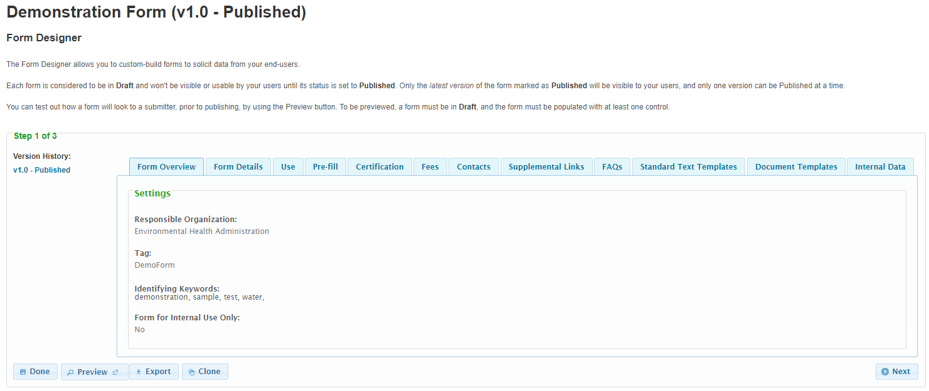

Establish a Draft Version of the Form
When working with form designs, the published version of the form is always locked and can’t be changed. In order to make changes to the design, a working version, or draft version of the form must be established.
Use these steps to establish a draft version of the form:
- In the Form Designer, click on the Details tab to navigate to the Form Details information.
- Click on the Change to Draft button.
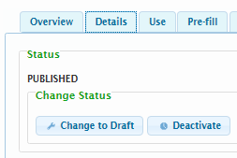
- Confirm the draft version of the form will be created by clicking on the OK button on the confirmation dialog.
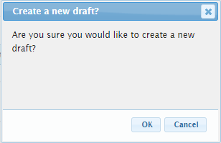
- A draft version of the form will be created and is ready for refinement.
- The version of the form will be incremented by one, if the published version is v1.0, the new draft will be assigned a value of v1.1.
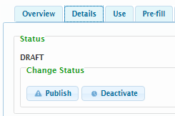
Note: the published version of the form will remain published and available for selection and use.

Step 2: Refine the Design of the Form
The second step to form refinement is to alter and refine the form design, as needed.
The process to refine the existing design of a form (e.g., Form Attributes, Form Content and Workflow Processing Steps and Actions) are closely aligned with what is described in the Configure the Form Attributes, Define the Form Content and Define the Default Form Submission Workflow Steps (Steps 2 and 3) of the Form Creation Process above. Please reference these sections of the document for additional details on adjusting the form design.

Step 3: Test and Republish the Form
The final step to form creation is to test and republish the form for use by system users. This step includes reviewing the form layout and testing the user interactions to ensure the form presents and behaves as intended. In addition, this step includes the publishing process, once the form is ready for selection and use in the system.
The process to test and republish a form is the same as is described in the Test and Publish the Form Step (Step 4) of the Form Creation Process above. Please reference this section of the document for additional details on adjusting the form design.

Appendix A: Controls
This section details each control type which is available to be included in a form as a form element and the typical usage of each. Currently available control types include:
- Simple: The Simple controls allow for support of the more basic data display/capture. Simple controls include:
  - Instructions: The instruction control is used for conveying information to the submitter. This can be used to communicate instructions or to provide context for a particular question, section or the form as a whole. This control also provides the ability to display a horizontal line or a hyperlink, when appropriate.
  - Paragraph: The Paragraph control is used to capture longer text values such as a detailed description or an explanation.
  - Selection: Selection controls allow the submitter to select one or more values from a pre-defined list.
    - Single Selection: The Single Selection control is used to capture an individual value selection from a list (i.e., dropdown list).
    - Multiple Selection: The Multiple Selection control is used to capture one or more values from a list (i.e., dropdown list).
  - Short Text: The Short Text control is used to capture a specific text value such as a name or a short descriptor.
  - SSN: The SSN control is used to capture Social Security Numbers (SSN) and control display (or lack thereof) of the values in this field, as appropriate.
- Formatted: The Formatted controls allow a user to capture data of a particular format. Formatted control types include:
  - Date: Used to enforce an entered value is a valid date (e.g., 1/1/2012). This control provides a date picker utility for eased date selection.
  - Email: Used to enforce an entered value is a valid email address (e.g., me@mydomain.org).
  - Number: Used to enforce an entered value is numeric (e.g., 1001). This control provides up/down buttons for incrementing the numeric value up and down.
  - Phone: Used to enforce an entered value adheres to standard phone number format (e.g., 555-555-5555 x555).
  - Time: Used to enforce an entered value is a valid time (e.g., 12:00 am). This control provides a time picker utility for eased time selection.
  - URL: Used to enforce an entered value adheres to standard URL format (e.g., https://www.mysite.org).
- Advanced: The Advanced controls allow for support of the more advanced data capture capabilities. Advanced controls include:
  - Address: The Address control captures a standard address such as submitters address, work site.
  - Attachment: The Attachment control allows for capture/upload of electronic document(s).
  - Calculated: The Calculated control allows for calculated of a value based on a formula. The calculated value can be derived based on values found in other controls on the form.
  - Contact: The Contact control allows for capture of detailed information for a contact person, including attributes such as a name, title, company, phone numbers, email, and address, etc.
  - Hidden Text: The Hidden Text control allows for data to be included in a form, but hidden, when appropriate, for storing data used by the import/export processes, that may have no meaning to the submitter.
  - Location: The Location control allows for the capture of a latitude and longitude for a particular spatial point/location. Users can search for a location by an address, entry of a latitude and longitude decimal value or use of a Google map to point to and identify a specific location.
  - Message: The Message control presents messages to users based on submission properties, if desired. This includes informational messages, warnings and errors. Users are prevented from submitting forms with error messages presented.
  - Name: The Name control captures a Name and Title value. This can be used to capture the name/title of an owner, operator or project manager.
  - Tables: Table controls allow for the capture of a table of data from the submitter. The Table controls currently supported, include:
    - Advanced Table: The Advanced Table control allows for the capture and/or display of data in a highly formatted table structure. Users can interact with the table (e.g., adding/removing rows), if appropriate, and entered data can be controlled using a number of Simple and Formatted control types.
    - [Bulk Upload] Table: The [Bulk Upload] Table control allows the agency to provide a predefined spreadsheet template to the submitter for download, population, copy and upload back into the system. The Table control is intended to ease data entry for bulk datasets. Users will download a predefined spreadsheet template, populate this template with the appropriate data, and then copy the raw data from the populated spreadsheet and paste the data in to the table control on the form, where the system will capture the data and present it back to the user for review.

Simple Controls
The Simple controls allow for support of the more basic data display/capture. These controls are described here. Simple control types include the following:
- Instructions: The instruction control is used for conveying information to the submitter. This can be used to communicate instructions or to provide context for a particular question, section or the form as a whole. This control also provides the ability to display a horizontal line or a hyperlink, when appropriate.
- Paragraph: The Paragraph control is used to capture longer text values such as a detailed description or an explanation.
- Selection: Selection controls allow the submitter to select one or more values from a pre-defined list.
  - Single Selection: The Single Selection control is used to capture an individual value selection from a list (i.e., dropdown list).
  - Multiple Selection: The Multiple Selection control is used to capture one or more values from a list (i.e., dropdown list).
- Short Text: The Short Text control is used to capture a specific text value such as a name or a short descriptor.
- SSN: The SSN control is used to capture Social Security Numbers (SSN) and control display (or lack thereof) of the values in this field, as appropriate.

Instructions
The instruction control is used for conveying information to the submitter. This can be used to communicate instructions or to provide context for a particular question, section or the form as a whole. This control also provides the ability to display a horizontal line or a hyperlink, when appropriate.
Control Properties in Submission Wizard
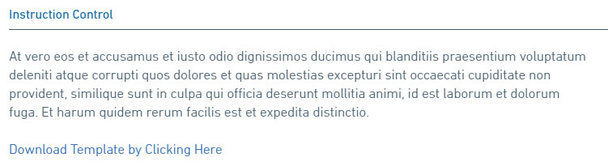
The following properties are available for display/data entry with this control in the Submission Wizard:
- Label: The label for the control will be displayed to the submitter.
- Error/Help Tip: The help tip that will be presented to the submitter when hovering their mouse over the help tip icon () for the control.
- Instruction Text: The instructions that will be presented to the submitter in the body of the Instruction control.
- Separator Line: If checked, a horizontal line will be presented in the Instruction control.
- Link: The text that will be displayed for the web link.
- Control Display: Control may not display depending on Display Formula value configuration.

Control Properties in Form Designer
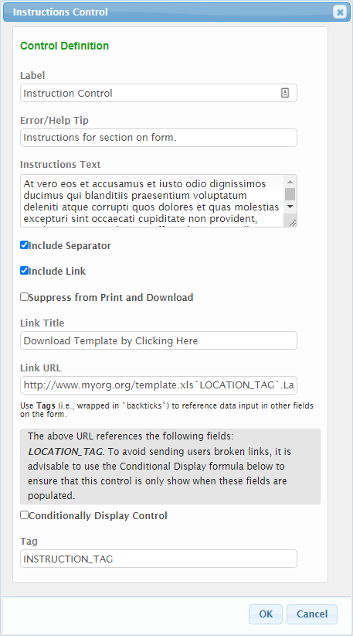
The following configuration properties are available for the Instruction control:
- Label: The label that will be displayed to the submitter.
- Error/Help Tip: The help tip that will be presented to the submitter when hovering their mouse over the help tip icon () for the control.
- Instruction Text: The instructions that will be presented to the submitter in the body of the Instruction control.
- Include Separator: If checked, a horizontal line will be presented in the Instruction control.
- Include Link: If checked the Link Title and Link URL will be enabled for configuration.
  - Link Title: The text that will be displayed for the link.
  - Link URL: The fully qualified URL (e.g., https:www.wikipedia.org) for the link.
  - Note: Values from other fields can be included in the URL by referencing control tags. The tag value must be provided within two tick "`" marks (found in the top left of your keyboard below the escape button). An example is `Location`.Latitude or `Location`.Latitude.
    - To avoid presenting an invalid link while the URL is being formed, it is advisable to use the Conditionally Display Control capability to ensure that the control is only shown when all dependent fields are populated.
- Suppress from Print and Download: Indicates whether the instruction control will be displayed on submission outputs such as print outs or downloads.
- Conditionally Display Control?: If the control will be allowed to display conditionally, during submission process, check the Conditionally Display Control checkbox. When checked, the Display Formula text field will be enabled for configuration. See the Conditional Display section of the Advanced Form Design Guide for details on this feature.
- Tag: The unique name assigned to the control to allow the control to be uniquely identified. This attribute is essential for facilitating the data importing and exporting processes. See the TAGging Fundamentals topic in the Integration Guide for additional details on tagging.

Paragraph
The Paragraph control is used to capture longer text values such as a detailed description or an explanation.
Control Properties in Submission Wizard
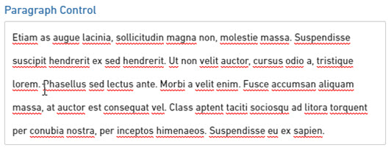
The following properties are available for display/data entry with this control in the Submission Wizard:
- Label: The label for the control will be displayed to the submitter.
- Error/Help Tip: The help tip that will be presented to the submitter when hovering their mouse over the help tip icon () for the control.
- Data Entry: The data entry area for the control. Note: if Read-Only attribute is enabled, the field will be locked and data entry will not be allowed.
- Control Display: Control may not display depending on Display Formula value configuration.

Control Properties in Form Designer
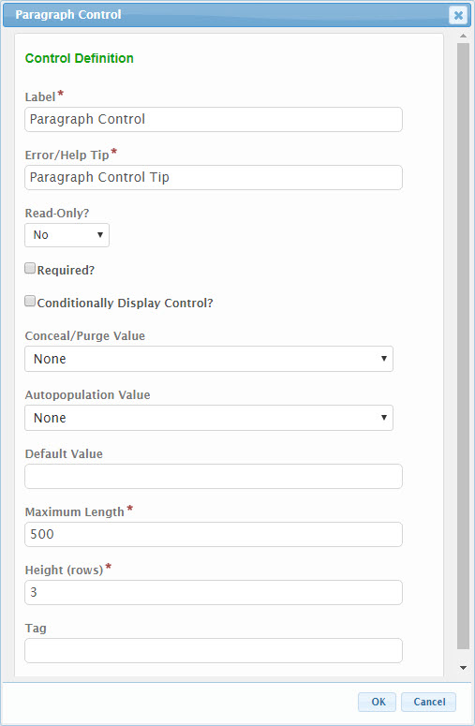
The following configuration properties are available for the Paragraph control:
- Label: The label that will be presented to the submitter for the control.
- Error/Help Tip: The help tip that will be presented to the submitter when hovering their mouse over the help tip icon () for the control. This attribute will also be utilized to provide additional information to the submitter when an invalid value is available for the control.
- Read-Only?: If set to "Yes", the control will be displayed in a read-only mode. If set to "No", the control will be editable. If set to "If Prepopulated", the control will be displayed in read-only mode, if the control is pre-filled with data.
- Required?: Specifies whether the control is required to be entered by the submitter.
- Conditionally Display Control?: If the control will be allowed to display conditionally, during submission process, check the Conditionally Display Control checkbox. When checked, the Display Formula text field will be enabled for configuration. See the Conditional Display section of the Advanced Form Design Guide for details on this feature.
- Conceal/Purge Value: For sensitive information, control value selection can be set the conceal, conceal and purge, or none. If "None" is selected, data will display in standard ways. If "Conceal" is selected, data entered in this control will be concealed from most users. If "Conceal and Purge" is selected, data entered in this control will be concealed from most users and will be purged from the submission, once the submission is finalized. See the Conceal and Purge Data Point topic in the Advanced Form Design Guide for additional details on this feature.
- Autopopulation Value: When a value is selected in this attribute, information will automatically be populated in the control based the respective value found in the submitter’s user profile (e.g., user name, user email address, etc.).
- Default Value: If entered, the controls value will be defaulted to the value entered in this attribute.
- Maximum Length: The maximum number of characters that the submitter will be allowed to enter in the control.
- Height: The height of the control, as a number of rows that the field can span on the form.
- Tag: The unique name assigned to the control to allow the control to be uniquely identified. This attribute is essential for facilitating the data importing and exporting processes. See the TAGging Fundamentals topic in the Integration Guide for additional details on tagging.

Selection
Selection controls allow the submitter to select one or more values from a pre-defined list. Two options for selection controls are available: Single and Multiple Selection.

Single Selection
The Single Selection control is used to capture an individual value selection from a pre-defined list (i.e., dropdown list).
Control Properties in Submission Wizard
Dropdown Format
Radio Buttons Format
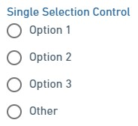
The following properties are available for display/data entry with this control in the Submission Wizard:
- Label: The label for the control will be displayed to the submitter.
- Error/Help Tip: The help tip that will be presented to the submitter when hovering their mouse over the help tip icon () for the control.
- Value List: Clicking in the control will display the list of pre-defined values. Clicking on a row will add the selected item to the selected item list. One item can be selected.
- Delete: The Delete icon ('x') can be used to remove an item from the selected item list.
- Please Describe: If "Other" is selected, the Please Describe field will be displayed and the user will be required to entered a value in this field.
- Control Display: Control may not display depending on Display Formula value configuration.

Control Properties in Form Designer
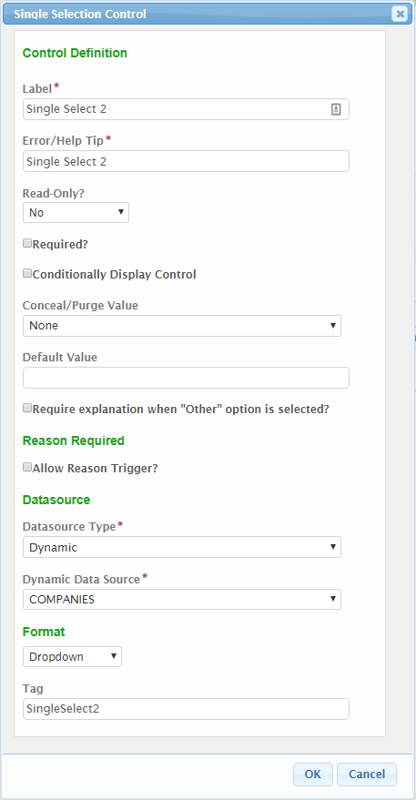
The following configuration properties are available for the Single Selection control:
  - Label: The label that will be presented to the submitter for the control.
  - Error/Help Tip: The help tip that will be presented to the submitter when hovering their mouse over the help tip icon () for the control. This attribute will also be utilized to provide additional information to the submitter when an invalid value is available for the control
  - Read-Only?: If set to "Yes", the control will be displayed in a read-only mode. If set to "No", the control will be editable. If set to "If Prepopulated", the control will be displayed in read-only mode, if the control is pre-filled with data.
  - Required?: Specifies whether the control is required to be entered by the submitter.
  - Conditionally Display Control?: If the control will be allowed to display conditionally, during submission process, check the Conditionally Display Control checkbox. When checked, the Display Formula text field will be enabled for configuration. See the Conditional Display section of the Advanced Form Design Guide for details on this feature.
  - Conceal/Purge Value: For sensitive information, control value selection can be set the conceal, conceal and purge, or none. If "None" is selected, data will display in standard ways. If "Conceal" is selected, data entered in this control will be concealed from most users. If "Conceal and Purge" is selected, data entered in this control will be concealed from most users and will be purged from the submission, once the submission is finalized. See the Conceal and Purge Data Point topic in the Advanced Form Design Guide for additional details on this feature.
  - Default Value: If entered, the controls value will be defaulted to the value entered in this attribute.
  - Require explanation when “Other” option is selected?: If checked, when "Other" is selected by the submitter, a "Please Describe" text field will be activated and required to be entered. Note: "Other" must be an option entered for the data source.
  - Reason Required - Allow Reason Trigger?: If checked, the Trigger Label and Trigger Match Text attributes will be enabled. The Reason Trigger feature is one where if a particular text value is matched, a custom reason field will appear. This is often used in a Yes/No situation, where if the user answer "Yes", the will need to provide a reason as to why they answered Yes.
    - Trigger Label: The label that will displayed as the "reason" field.
    - Trigger Match Text: The text value that will be matched in order to enable/disable the reason field.
  - Data Source: Specifies the Data Source to be used for the list in the control.
    - Typed In: Allows user to enter the list of values to present to the submitter. If selected, an Options text field will be displayed and allowing the user to 'Type In' the list of values to be available for the control. Each item in the list will be separated by a carriage return. See the Binding Data Sources to Form Controls – Typed In section of the Advanced Form Design Guide for details on this feature.
    - Dynamic: Allows user to select a pre-configured data source to populate the controls list of values. These data sources are stored in the LOOKUP and LOOKUP_VALUE tables in the database.
      - If selected, Dynamic Data Source dropdown field displays allowing for selection of desired list of values. See system administrator for assistance. See the Binding Data Sources to Form Controls - Dynamic section of the Advanced Form Design Guide for details on this feature.
      - If the data source selected is considered a child of another data source, the If this data source is a child of another control, select the parent control tag property will be enabled. See system administrator for assistance. See the Binding Data Sources to Form Controls - Dynamic – Cascading Lists section of the Advanced Form Design Guide for details on this feature.
    - Repeating Section or Advanced Table: Allows user to select a Repeating Section or Advanced Table as the data source. The user will be able to specify the unique control to link to for linking purposes (not necessarily displayed to the user) and then a formula can be entered to specify the text to display to the user in the selectable list. If selected, the Control tag for Selected Value (saved value) and Display Formula for Selection attributes will display for configuration. See the Binding Data Sources to Form Controls – Repeating Section and Advanced Table and Cascading Lists section of the Advanced Form Design Guide for details on this feature.
- Format: The format in which the control selections will display (e.g., Dropdown or Radio Buttons).
- Tag: The unique name assigned to the control to allow the control to be uniquely identified. This attribute is essential for facilitating the data importing and exporting processes. See the TAGging Fundamentals topic in the Integration Guide for additional details on tagging.

Multiple Selection
The Multiple Selection control is used to capture one or more values from a pre-defined list (i.e., dropdown list).
Control Properties in Submission Wizard
Dropdown Multi-Select List Format
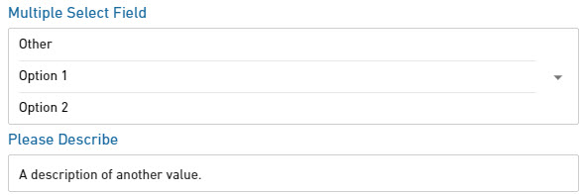
Checkbox Format
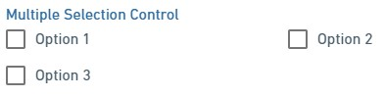
The following properties are available for display/data entry with this control in the Submission Wizard:
- Label: The label for the control will be displayed to the submitter.
- Error/Help Tip: The help tip that will be presented to the submitter when hovering their mouse over the help tip icon () for the control.
- Value List: Clicking in the control will display the list of pre-defined values. Clicking on a row will add the selected item to the selected item list. Many items can be selected.
- Delete: The Delete icon ('x') can be used to remove an item from the selected item list.
- Please Describe: If "Other" is selected, the Please Describe field will be displayed and the user will be required to entered a value in this field.
- Control Display: Control may not display depending on Display Formula value configuration.

Control Properties in Form Designer
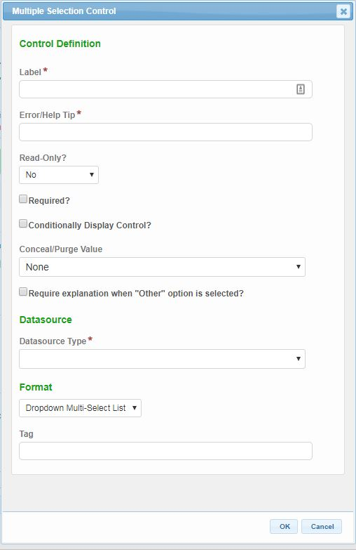
The following configuration properties are available for the Multiple Selection control:
- Label: The label that will be presented to the submitter for the control.
- Error/Help Tip: The help tip that will be presented to the submitter when hovering their mouse over the help tip icon () for the control. This attribute will also be utilized to provide additional information to the submitter when an invalid value is available for the control.
- Read-Only?: If set to "No", the control will be editable. If set to "Yes", the control will be displayed in a read-only mode. If set to "If Prepopulated", the control will be displayed in read-only mode, if the control is pre-filled with data.
- Required?: Specifies whether the control is required to be entered by the submitter.
- Conditionally Display Control?: If the control will be allowed to display conditionally, during submission process, check the Conditionally Display Control checkbox. When checked, the Display Formula text field will be enabled for configuration. See the Conditional Display section of the Advanced Form Design Guide for details on this feature.
- Conceal/Purge Value: For sensitive information, control value selection can be set the conceal, conceal and purge, or none. If "None" is selected, data will display in standard ways. If "Conceal" is selected, data entered in this control will be concealed from most users. If "Conceal and Purge" is selected, data entered in this control will be concealed from most users and will be purged from the submission, once the submission is finalized. See the Conceal and Purge Data Point topic in the Advanced Form Design Guide for additional details on this feature.
- Allow Other: If checked, an "Other" value will be added to the end of the list. When "Other" is selected by the submitter, an "Other" text field will be activated and required to be entered.
- Data Source: Specifies the Data Source to be used for the list in the control.
  - Typed In: Allows user to enter the list of values to present to the submitter. If selected, an Options text field will be displayed and allowing the user to 'Type In' the list of values to be available for the control. Each item in the list will be separated by a carriage return. See the Binding Data Sources to Form Controls - Dynamic section of the Advanced Form Design Guide for details on this feature.
  - Dynamic: Allows user to select a pre-configured data source to populate the controls list of values. These data sources are stored in the LOOKUP and LOOKUP_VALUE tables in the database. If selected, Dynamic Data Source dropdown field displays allowing for selection of desired list of values. See system administrator for additional details. See the Binding Data Sources to Form Controls - Dynamic section of the Advanced Form Design Guide for details on this feature.
  - Repeating Section or Advanced Table: Allows user to select a Repeating Section or Advanced Table as the data source. The user will be able to specify the unique control to link to for linking purposes (not necessarily displayed to the user) and then a formula can be entered to specify the text to display to the user in the selectable list. If selected, the Control tag for Selected Value (saved value) and Display Formula for Selection attributes will display for configuration. See the Binding Data Sources to Form Controls - Dynamic section of the Advanced Form Design Guide for details on this feature.
- Format: The format in which the control selections will display (e.g., Dropdown or Radio Buttons).
- Tag: The unique name assigned to the control to allow the control to be uniquely identified. This attribute is essential for facilitating the data importing and exporting processes. See the TAGging Fundamentals topic in the Integration Guide for additional details on tagging.

Short Text
The Short Text control is used to capture a specific text value such as a name or a short descriptor.
Control Properties in Submission Wizard
The following properties are available for display/data entry with this control in the Submission Wizard:
- Label: The label for the control will be displayed to the submitter.
- Error/Help Tip: The help tip that will be presented to the submitter when hovering their mouse over the help tip icon () for the control.
- Data Entry: The data entry area for the control. If configured, an auto-complete feature will assist data entry/selection. If some configurations, data entered will need to available in the list. Note: if Read-Only attribute is enabled, the field will be locked and data entry will not be allowed.
- Control Display: Control may not display depending on Display Formula value configuration.
Control Properties in Form Design
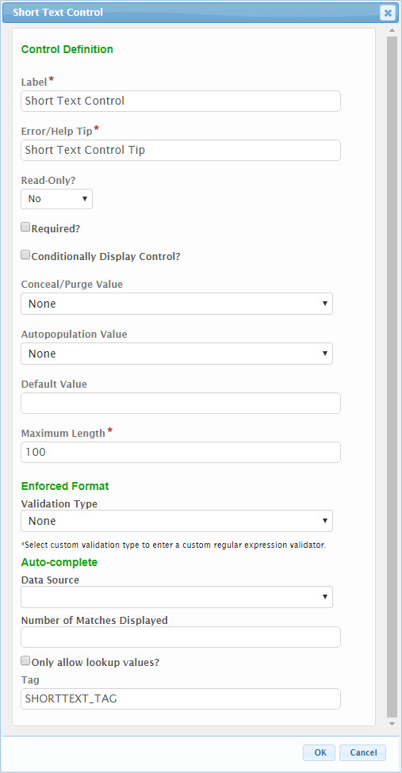
The following configuration properties are available for the Short Text control:
- Label: The label that will be presented to the submitter for the control.
- Error/Help Tip: The help tip that will be presented to the submitter when hovering their mouse over the help tip icon () for the control. This attribute will also be utilized to provide additional information to the submitter when an invalid value is available for the control.
- Read-Only?: If set to "Yes", the control will be displayed in a read-only mode. If set to "No", the control will be editable. If set to "If Prepopulated", the control will be displayed in read-only mode, if the control is pre-filled with data.
- Required?: Specifies whether the control is required to be entered by the submitter.
- Conditionally Display Control?: If the control will be allowed to display conditionally, during submission process, check the Conditionally Display Control checkbox. When checked, the Display Formula text field will be enabled for configuration. See the Conditional Display section of the Advanced Form Design Guide for details on this feature.
- Conceal/Purge Value: For sensitive information, control value selection can be set the conceal, conceal and purge, or none. If "None" is selected, data will display in standard ways. If "Conceal" is selected, data entered in this control will be concealed from most users. If "Conceal and Purge" is selected, data entered in this control will be concealed from most users and will be purged from the submission, once the submission is finalized. See the Conceal and Purge Data Point topic in the Advanced Form Design Guide for additional details on this feature.
- Autopopulation Value: When a value is selected in this attribute, information will automatically be populated in the control based the respective value found in the submitter’s user profile (e.g., user name, user email address, etc.).
- Default Value: If entered, the controls value will be defaulted to the value entered in this attribute.
- Maximum Length: The maximum number of characters that the submitter will be allowed to enter in the control.
- Enforcement Format
  - Validation Type: Specifies the type of value that will be entered in this field. This format will be validated to this selected format during data entry. Custom validations can be established, for situations where this is required, by using a standard validation format using Regular Expressions. Contact a system administrator if this is required.
  - If Validation Type equals “Number”, the following attributes will be enabled.
    - Decimal Places: Specifies the number of decimal places with will be enterable/displayed for the value.
    - Use 1000 Separator (,)?: If checked, a comma will be displayed to separate 1000’s (e.g., 1,343,200).
  - If Validation Type equals “Custom”, a Custom Regular Expression attribute will be enabled. See the Custom Validation topic in the Advanced Design Guide for more details on establishing these custom regular expressions.
- Auto-Complete: The auto-complete feature activates a suggestion dropdown based on text entered into the field. Note: this feature is only available with Dynamic Data Sources. See the Selection - Single Selection - Data Source topic in this guide for more details on establishing these data sources.
- Tag: The unique name assigned to the control to allow the control to be uniquely identified. This attribute is essential for facilitating the data importing and exporting processes. See the TAGging Fundamentals topic in the Integration Guide for additional details on tagging.

SSN
The SSN control is used to capture Social Security Numbers (SSN) and control display (or lack thereof) of the values in this field, as appropriate.
Control Properties in Submission Wizard
The following properties are available for display/data entry with this control in the Submission Wizard:
- Label: The label for the control will be displayed to the submitter.
- Error/Help Tip: The help tip that will be presented to the submitter when hovering their mouse over the help tip icon () for the control.
- Data Entry: The data entry area for the control. If configured, an auto-complete feature will assist data entry/selection. If some configurations, data entered will need to available in the list. Note: if Read-Only attribute is enabled, the field will be locked and data entry will not be allowed.
- Control Display: Control may not display depending on Display Formula value configuration.
- View Full SSN: If the user has the appropriate rights, they may be able to view the full SSN from view modes of this control. This can be accomplished by clicking on the eye icon (). Clicking on the eye icon () again will re-hide the value.
Control Properties in Form Design
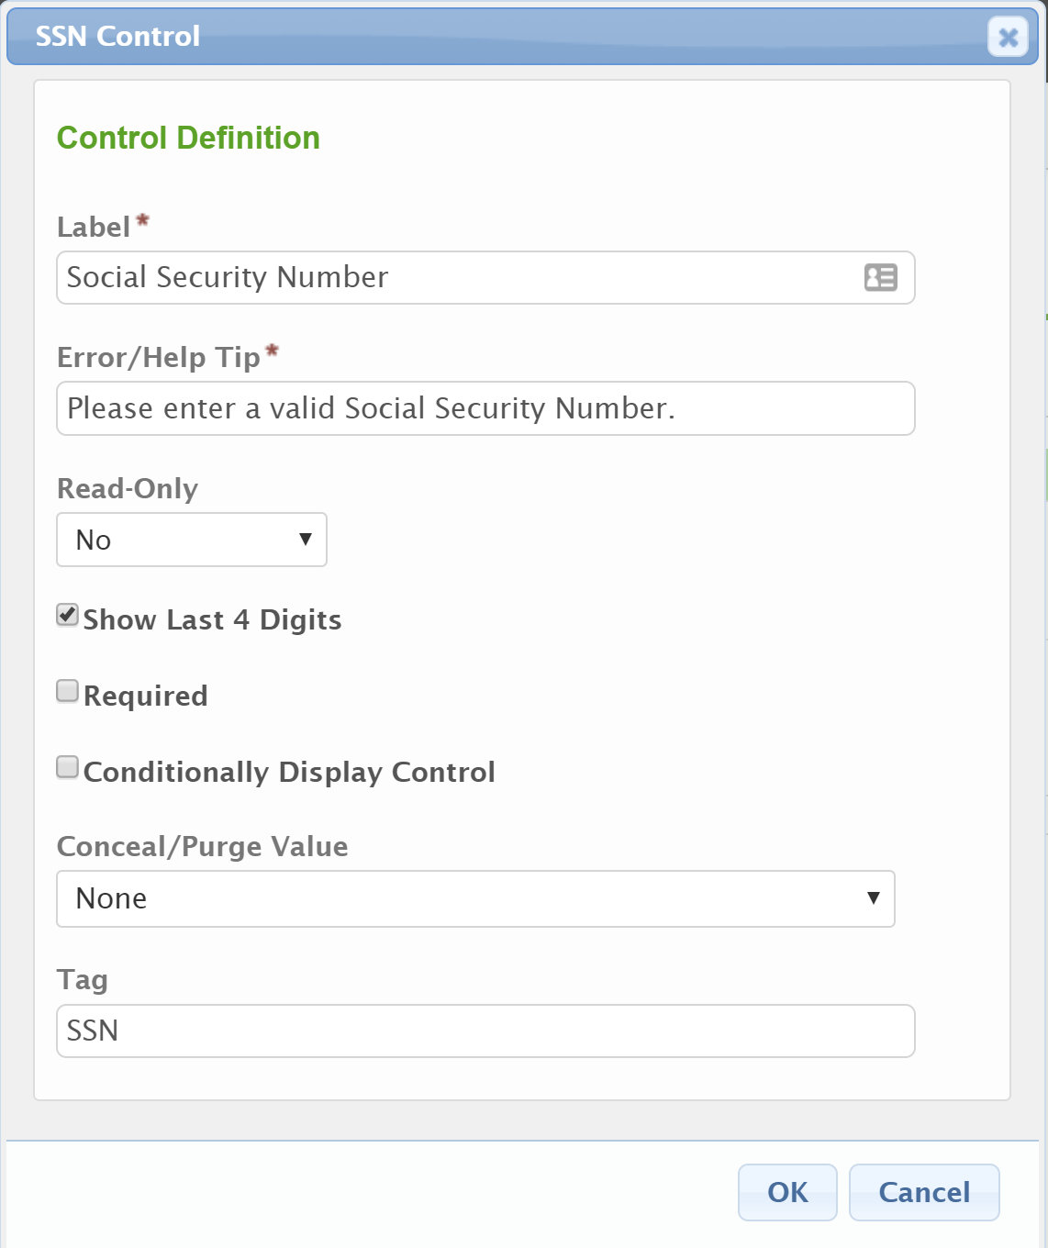
The following configuration properties are available for the Short Text control:
- Label: The label that will be presented to the submitter for the control.
- Error/Help Tip: The help tip that will be presented to the submitter when hovering their mouse over the help tip icon () for the control. This attribute will also be utilized to provide additional information to the submitter when an invalid value is available for the control.
- Read-Only: If set to "Yes", the control will be displayed in a read-only mode. If set to "No", the control will be editable. If set to "If Prepopulated", the control will be displayed in read-only mode, if the control is pre-filled with data.
- Show Last 4 Digits: If checked, the last four digits of the entered SSN will be displayed, the other digits will be obfuscated. If unchecked, all entered digits will be obfuscated.
- Required: Specifies whether the control is required to be entered by the submitter.
- Conditionally Display Control: If the control will be allowed to display conditionally, during submission process, check the Conditionally Display Control checkbox. When checked, the Display Formula text field will be enabled for configuration. See the Conditional Display section of the Advanced Form Design Guide for details on this feature.
- Conceal/Purge Value: For sensitive information, control value selection can be set the conceal, conceal and purge, or none. If "None" is selected, data will display in standard ways. If "Conceal" is selected, data entered in this control will be concealed from most users. If "Conceal and Purge" is selected, data entered in this control will be concealed from most users and will be purged from the submission, once the submission is finalized. See the Conceal and Purge Data Point topic in the Advanced Form Design Guide for additional details on this feature.
- Tag: The unique name assigned to the control to allow the control to be uniquely identified. This attribute is essential for facilitating the data importing and exporting processes. See the TAGging Fundamentals topic in the Integration Guide for additional details on tagging.

Formatted Controls
The Formatted controls allow a user to capture data of a particular format. These controls are described here. Formatted control types include the following:
- Date: Used to enforce an entered value is a valid date (e.g., 1/1/2012). This control provides a date picker utility for eased date selection.
- Email: Used to enforce an entered value is a valid email address (e.g., me@mydomain.org).
- Number: Used to enforce an entered value is numeric (e.g., 1001). This control provides up/down buttons for incrementing the numeric value up and down.
- Phone: Used to enforce an entered value adheres to standard phone number format (e.g., 555-555-5555 x555).
- Time: Used to enforce an entered value is a valid time (e.g., 12:00 am). This control provides a time picker utility for eased time selection.
- URL: Used to enforce an entered value adheres to standard URL format (e.g., https://www.mysite.org).

Date
The Date control is used to enforce an entered value is a valid date (e.g., 1/1/2012). This control provides a date picker utility for eased date selection.
Control Properties in Submission Wizard
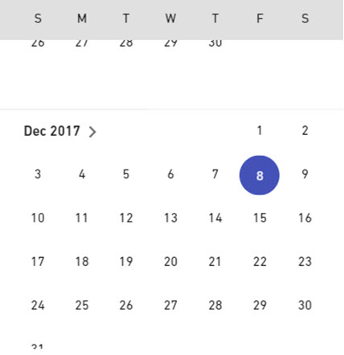
The following properties are available for display/data entry with this control in the Submission Wizard:
- Label: The label for the control will be displayed to the submitter.
- Error/Help Tip: The help tip that will be presented to the submitter when hovering their mouse over the help tip icon () for the control.
- Data Entry: The data entry area for the control. The value entered will need to be entered in a valid date format. Note: if Read-Only attribute is enabled, the field will be locked and data entry will not be allowed.
- Date Picker: The Date Picker icon can be clicked to present the user with the Date Picker utility. Note: if Read-Only attribute is enabled, the field will be locked and data entry will not be allowed.
  - Clicking a date value will enter the selected date in to the control and will close the Date Picker.
  - Clicking the < arrow will navigate to the previous month.
  - Clicking the > arrow will navigate to the next month.
  - Clicking the current month/year value at the top of the Date Picker will open the month selector.
  - Clicking Clear will clear any entered date in to the control and will close the Date Picker.
  - Clicking Done will close the Date Picker.
- Control Display: Control may not display depending on Display Formula value configuration.
Control Properties in Form Design
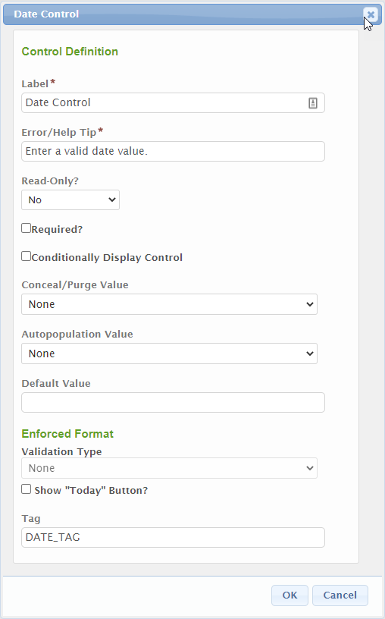
The following configuration properties are available for the control:
- Label: The label that will be presented to the submitter for the control.
- Error/Help Tip: The help tip that will be presented to the submitter when hovering their mouse over the help tip icon () for the control. This attribute will also be utilized to provide additional information to the submitter when an invalid value is available for the control.
- Read-Only?: If set to "Yes", the control will be displayed in a read-only mode. If set to "No", the control will be editable. If set to "If Prepopulated", the control will be displayed in read-only mode, if the control is pre-filled with data.
- Required?: Specifies whether the control is required to be entered by the submitter.
- Conditionally Display Control?: If the control will be allowed to display conditionally, during submission process, check the Conditionally Display Control checkbox. When checked, the Display Formula text field will be enabled for configuration. See the Conditional Display section of the Advanced Form Design Guide for details on this feature.
- Conceal/Purge Value: For sensitive information, control value selection can be set the conceal, conceal and purge, or none. If "None" is selected, data will display in standard ways. If "Conceal" is selected, data entered in this control will be concealed from most users. If "Conceal and Purge" is selected, data entered in this control will be concealed from most users and will be purged from the submission, once the submission is finalized. See the Conceal and Purge Data Point topic in the Advanced Form Design Guide for additional details on this feature.
- Autopopulation Value: When a value is selected in this attribute, information will automatically be populated in the control based the respective value found in the submitter’s user profile (e.g., user name, user email address, etc.).
- Default Value: If entered, the controls value will be defaulted to the value entered in this attribute.
- Enforcement Format - Validation Type: Specifies the type of value that will be entered in this field. This format will be validated to this selected format during data entry. This field is not editable.
- Show “Today” Button: Enables the “Today” button next to the control which will default the date to the current date.
- Tag: The unique name assigned to the control to allow the control to be uniquely identified. This attribute is essential for facilitating the data importing and exporting processes. See the TAGging Fundamentals topic in the Integration Guide for additional details on tagging.

Email
The Email control is used to enforce an entered value is a valid email address (e.g., me@mydomain.org).
Control Properties in Submission Wizard
The following properties are available for display/data entry with this control in the Submission Wizard:
- Label: The label for the control will be displayed to the submitter.
- Error/Help Tip: The help tip that will be presented to the submitter when hovering their mouse over the help tip icon () for the control.
- Data Entry: The data entry area for the control. The value entered will need to be entered in a valid email format. Note: if Read-Only attribute is enabled, the field will be locked and data entry will not be allowed.
- Control Display: Control may not display depending on Display Formula value configuration.
Control Properties in Form Design
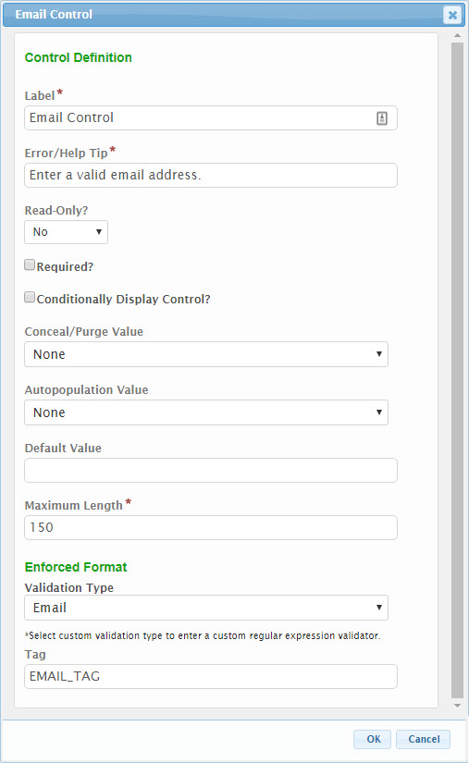
The following configuration properties are available for the control:
- Label: The label that will be presented to the submitter for the control.
- Error/Help Tip: The help tip that will be presented to the submitter when hovering their mouse over the help tip icon () for the control. This attribute will also be utilized to provide additional information to the submitter when an invalid value is available for the control.
- Read-Only?: If set to "Yes", the control will be displayed in a read-only mode. If set to "No", the control will be editable. If set to "If Prepopulated", the control will be displayed in read-only mode, if the control is pre-filled with data.
- Required?: Specifies whether the control is required to be entered by the submitter.
- Conditionally Display Control?: If the control will be allowed to display conditionally, during submission process, check the Conditionally Display Control checkbox. When checked, the Display Formula text field will be enabled for configuration. See the Conditional Display section of the Advanced Form Design Guide for details on this feature.
- Conceal/Purge Value: For sensitive information, control value selection can be set the conceal, conceal and purge, or none. If "None" is selected, data will display in standard ways. If "Conceal" is selected, data entered in this control will be concealed from most users. If "Conceal and Purge" is selected, data entered in this control will be concealed from most users and will be purged from the submission, once the submission is finalized. See the Conceal and Purge Data Point topic in the Advanced Form Design Guide for additional details on this feature.
- Autopopulation Value: When a value is selected in this attribute, information will automatically be populated in the control based the respective value found in the submitter’s user profile (e.g., user name, user email address, etc.).
- Default Value: If entered, the controls value will be defaulted to the value entered in this attribute.
- Maximum Length: The maximum number of characters that the submitter will be allowed to enter in the control.
- Enforcement Format - Validation Type: Specifies the type of value that will be entered in this field. This format will be validated to this selected format during data entry. This field is not editable.
- Tag: The unique name assigned to the control to allow the control to be uniquely identified. This attribute is essential for facilitating the data importing and exporting processes. See the TAGging Fundamentals topic in the Integration Guide for additional details on tagging.

Number
The Number control is used to enforce an entered value is numeric (e.g., 1001). This control provides up/down buttons for incrementing the numeric value up and down.
Control Properties in Submission Wizard
The following properties are available for display/data entry with this control in the Submission Wizard:
- Label: The label for the control will be displayed to the submitter.
- Error/Help Tip: The help tip that will be presented to the submitter when hovering their mouse over the help tip icon () for the control.
- Data Entry: The data entry area for the control. The value entered must be numeric. Note: if Read-Only attribute is enabled, the field will be locked and data entry will not be allowed.
- Control Display: Control may not display depending on Display Formula value configuration.

Control Properties in Form Design
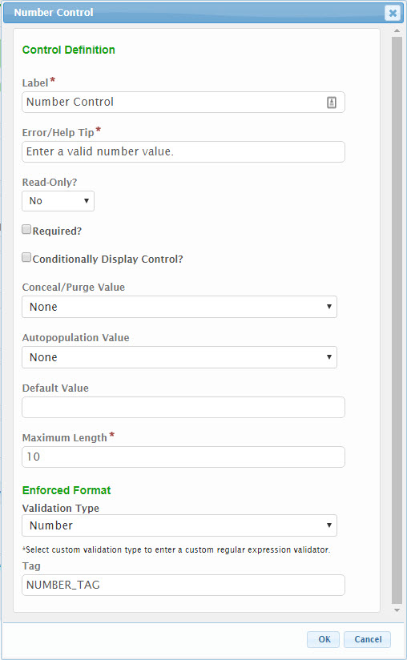
The following configuration properties are available for the control:
- Label: The label that will be presented to the submitter for the control.
- Error/Help Tip: The help tip that will be presented to the submitter when hovering their mouse over the help tip icon () for the control. This attribute will also be utilized to provide additional information to the submitter when an invalid value is available for the control.
- Read-Only?: If set to "Yes", the control will be displayed in a read-only mode. If set to "No", the control will be editable. If set to "If Prepopulated", the control will be displayed in read-only mode, if the control is pre-filled with data.
- Required?: Specifies whether the control is required to be entered by the submitter.
- Conditionally Display Control?: If the control will be allowed to display conditionally, during submission process, check the Conditionally Display Control checkbox. When checked, the Display Formula text field will be enabled for configuration. See the Conditional Display section of the Advanced Form Design Guide for details on this feature.
- Conceal/Purge Value: For sensitive information, control value selection can be set the conceal, conceal and purge, or none. If "None" is selected, data will display in standard ways. If "Conceal" is selected, data entered in this control will be concealed from most users. If "Conceal and Purge" is selected, data entered in this control will be concealed from most users and will be purged from the submission, once the submission is finalized. See the Conceal and Purge Data Point topic in the Advanced Form Design Guide for additional details on this feature.
- Read-Only?: If checked, the control will be presented for display purposes only. The user will not be able to change this value.
- Autopopulation Value: When a value is selected in this attribute, information will automatically be populated in the control based the respective value found in the submitter’s user profile (e.g., user name, user email address, etc.).
- Default Value: If entered, the controls value will be defaulted to the value entered in this attribute.
- Maximum Length: The maximum number of characters that the submitter will be allowed to enter in the control.
- Enforcement Format:
  - Between or Not Between: Allows form designer to specify a validation range for the number.
  - Validation Type: Specifies the type of value that will be entered in this field. This format will be validated to this selected format during data entry. This field is not editable.
  - Decimal Places: Specifies the number of decimal places with will be enterable/displayed for the value.
  - Use 1000 Separator (,)?: If checked, a comma will be displayed to separate 1000’s (e.g., 1,343,200).
- Tag: The unique name assigned to the control to allow the control to be uniquely identified. This attribute is essential for facilitating the data importing and exporting processes. See the TAGging Fundamentals topic in the Integration Guide for additional details on tagging.

Phone
The Phone control is used to enforce an entered value adheres to standard phone number format (e.g., 555-555-5555 x555).
Control Properties in Submission Wizard
The following properties are available for display/data entry with this control in the Submission Wizard:
- Label: The label for the control will be displayed to the submitter.
- Error/Help Tip: The help tip that will be presented to the submitter when hovering their mouse over the help tip icon () for the control.
- Data Entry: The data entry area for the control. The value entered must be a valid phone number. Note: if Read-Only attribute is enabled, the field will be locked and data entry will not be allowed.
- Control Display: Control may not display depending on Display Formula value configuration.
Control Properties in Form Design
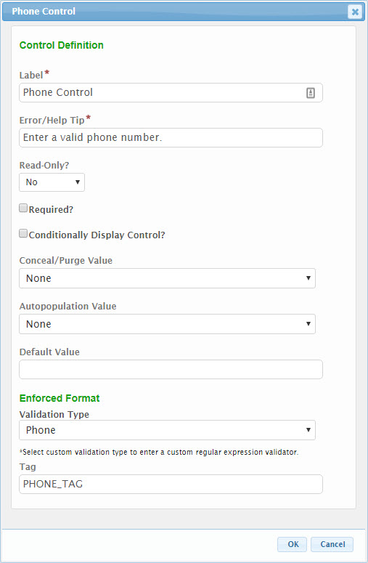
The following configuration properties are available for the control:
- Label: The label that will be presented to the submitter for the control.
- Error/Help Tip: The help tip that will be presented to the submitter when hovering their mouse over the help tip icon () for the control. This attribute will also be utilized to provide additional information to the submitter when an invalid value is available for the control.
- Read-Only?: If set to "Yes", the control will be displayed in a read-only mode. If set to "No", the control will be editable. If set to "If Prepopulated", the control will be displayed in read-only mode, if the control is pre-filled with data.
- Required?: Specifies whether the control is required to be entered by the submitter.
- Conditionally Display Control?: If the control will be allowed to display conditionally, during submission process, check the Conditionally Display Control checkbox. When checked, the Display Formula text field will be enabled for configuration. See the Conditional Display section of the Advanced Form Design Guide for details on this feature.
- Conceal/Purge Value: For sensitive information, control value selection can be set the conceal, conceal and purge, or none. If "None" is selected, data will display in standard ways. If "Conceal" is selected, data entered in this control will be concealed from most users. If "Conceal and Purge" is selected, data entered in this control will be concealed from most users and will be purged from the submission, once the submission is finalized. See the Conceal and Purge Data Point topic in the Advanced Form Design Guide for additional details on this feature.
- Autopopulation Value: When a value is selected in this attribute, information will automatically be populated in the control based the respective value found in the submitter’s user profile (e.g., user name, user email address, etc.).
- Default Value: If entered, the controls value will be defaulted to the value entered in this attribute.
- Enforcement Format - Validation Type: Specifies the type of value that will be entered in this field. This format will be validated to this selected format during data entry. This field is not editable.
- Tag: The unique name assigned to the control to allow the control to be uniquely identified. This attribute is essential for facilitating the data importing and exporting processes. See the TAGging Fundamentals topic in the Integration Guide for additional details on tagging.

Time
The Time control is used to enforce an entered value is a valid time (e.g., 12:00 am). This control provides a time picker utility for eased time selection.
Control Properties in Submission Wizard
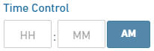
The following properties are available for display/data entry with this control in the Submission Wizard:
- Label: The label for the control will be displayed to the submitter.
- Error/Help Tip: The help tip that will be presented to the submitter when hovering their mouse over the help tip icon () for the control.
- Data Entry: The data entry area for the control. Note: if Read-Only attribute is enabled, the field will be locked and data entry will not be allowed.
  - Hours: The data entry area for the hours value of the control. The value entered must be a valid hour value (1-12). Clicking in this column and then using the up/down arrows on the keyboard will adjust the hour value from the current time.
  - Minutes: The data entry area for the minutes value of the control. The value entered must be a valid minute value (00-59). Clicking in this column and then using the up/down arrows on the keyboard will adjust the minute value from the current time.
  - AM/PM: The data entry area for the AM/PM value of the control. The value entered must be a valid AM/PM value (AM or PM). Clicking in this column will switch the values.
- Control Display: Control may not display depending on Display Formula value configuration.

Control Properties in Form Design
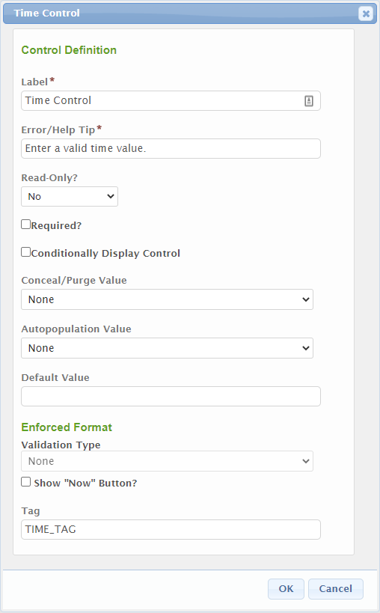
The following configuration properties are available for the control:
- Label: The label that will be presented to the submitter for the control.
- Error/Help Tip: The help tip that will be presented to the submitter when hovering their mouse over the help tip icon () for the control. This attribute will also be utilized to provide additional information to the submitter when an invalid value is available for the control.
- Read-Only?: If set to "Yes", the control will be displayed in a read-only mode. If set to "No", the control will be editable. If set to "If Prepopulated", the control will be displayed in read-only mode, if the control is pre-filled with data.
- Required?: Specifies whether the control is required to be entered by the submitter.
- Conditionally Display Control?: If the control will be allowed to display conditionally, during submission process, check the Conditionally Display Control checkbox. When checked, the Display Formula text field will be enabled for configuration. See the Conditional Display section of the Advanced Form Design Guide for details on this feature.
- Conceal/Purge Value: For sensitive information, control value selection can be set the conceal, conceal and purge, or none. If "None" is selected, data will display in standard ways. If "Conceal" is selected, data entered in this control will be concealed from most users. If "Conceal and Purge" is selected, data entered in this control will be concealed from most users and will be purged from the submission, once the submission is finalized. See the Conceal and Purge Data Point topic in the Advanced Form Design Guide for additional details on this feature.
- Autopopulation Value: When a value is selected in this attribute, information will automatically be populated in the control based the respective value found in the submitter’s user profile (e.g., user name, user email address, etc.).
- Default Value: If entered, the controls value will be defaulted to the value entered in this attribute.
- Enforcement Format - Validation Type: Specifies the type of value that will be entered in this field. This format will be validated to this selected format during data entry. This field is not editable.
- Show “Now” Button: Enables the “Now” button next to the control which will default the time to the current time.
- Tag: The unique name assigned to the control to allow the control to be uniquely identified. This attribute is essential for facilitating the data importing and exporting processes. See the TAGging Fundamentals topic in the Integration Guide for additional details on tagging.

URL
The URL control is used to enforce an entered value adheres to standard URL format (e.g., https://www.mysite.org).
Control Properties in Submission Wizard
The following properties are available for display/data entry with this control in the Submission Wizard:
- Label: The label for the control will be displayed to the submitter.
- Error/Help Tip: The help tip that will be presented to the submitter when hovering their mouse over the help tip icon () for the control.
- Data Entry: The data entry area for the control. The value entered must be a valid fully qualified URL address (e.g., https://www.myorg.org). Note: if Read-Only attribute is enabled, the field will be locked and data entry will not be allowed.
- Control Display: Control may not display depending on Display Formula value configuration.
Control Properties in Form Design
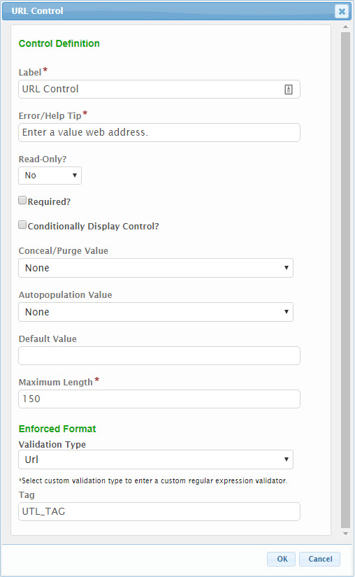
The following configuration properties are available for the control:
- Label: The label that will be presented to the submitter for the control.
- Error/Help Tip: The help tip that will be presented to the submitter when hovering their mouse over the help tip icon () for the control. This attribute will also be utilized to provide additional information to the submitter when an invalid value is available for the control.
- Read-Only?: If set to "Yes", the control will be displayed in a read-only mode. If set to "No", the control will be editable. If set to "If Prepopulated", the control will be displayed in read-only mode, if the control is pre-filled with data.
- Required?: Specifies whether the control is required to be entered by the submitter.
- Conditionally Display Control?: If the control will be allowed to display conditionally, during submission process, check the Conditionally Display Control checkbox. When checked, the Display Formula text field will be enabled for configuration. See the Conditional Display section of the Advanced Form Design Guide for details on this feature.
- Conceal/Purge Value: For sensitive information, control value selection can be set the conceal, conceal and purge, or none. If "None" is selected, data will display in standard ways. If "Conceal" is selected, data entered in this control will be concealed from most users. If "Conceal and Purge" is selected, data entered in this control will be concealed from most users and will be purged from the submission, once the submission is finalized. See the Conceal and Purge Data Point topic in the Advanced Form Design Guide for additional details on this feature.
- Autopopulation Value: When a value is selected in this attribute, information will automatically be populated in the control based the respective value found in the submitter’s user profile (e.g., user name, user email address, etc.).
- Default Value: If entered, the controls value will be defaulted to the value entered in this attribute.
- Maximum Length: The maximum number of characters that the submitter will be allowed to enter in the control.
- Enforcement Format - Validation Type: Specifies the type of value that will be entered in this field. This format will be validated to this selected format during data entry. This field is not editable.
- Tag: The unique name assigned to the control to allow the control to be uniquely identified. This attribute is essential for facilitating the data importing and exporting processes. See the TAGging Fundamentals topic in the Integration Guide for additional details on tagging.

Advanced Controls
The Advanced controls allow for support of the more advanced data capture capabilities. These controls are described here. Advanced control types include the following:
- Address: The Address control captures a standard address such as submitters address, work site.
- Attachment: The Attachment control allows for capture/upload of electronic document(s).
- Calculated: The Calculated control allows for calculated of a value based on a formula. The calculated value can be derived based on values found in other controls on the form.
- Contact: The Contact control allows for capture of detailed information for a contact person, including attributes such as a name, title, company, phone numbers, email, and address, etc.
- Hidden Text: The Hidden Text control allows for data to be included in a form, but hidden, when appropriate, for storing data used by the import/export processes, that may have no meaning to the submitter.
- Location: The Location control allows for the capture of a latitude and longitude for a particular spatial point/location. Users can search for a location by an address, entry of a latitude and longitude decimal value or use of a Google map to point to and identify a specific location.
- Message: The Message control presents messages to users based on submission properties, if desired. This includes informational messages, warnings and errors. Users are prevented from submitting forms with error messages presented.
- Name: The Name control captures a Name and Title value. This can be used to capture the name/title of an owner, operator or project manager.
- Tables: Table controls allow for the capture of a table of data from the submitter. The Table controls currently supported, include:
  - Advanced Table: The Advanced Table control allows for the capture and/or display of data in a highly formatted table structure. Users can interact with the table (e.g., adding/removing rows), if appropriate, and entered data can be controlled using a number of Simple and Formatted control types.
  - [Bulk Upload] Table: The [Bulk Upload] Table control allows the agency to provide a predefined spreadsheet template to the submitter for download, population, copy and upload back into the system. The Table control is intended to ease data entry for bulk datasets. Users will download a predefined spreadsheet template, populate this template with the appropriate data, and then copy the raw data from the populated spreadsheet and paste the data in to the table control on the form, where the system will capture the data and present it back to the user for review.

Address
The Address control is used to capture a standard address such as submitters address, work site.
Control Properties in Submission Wizard
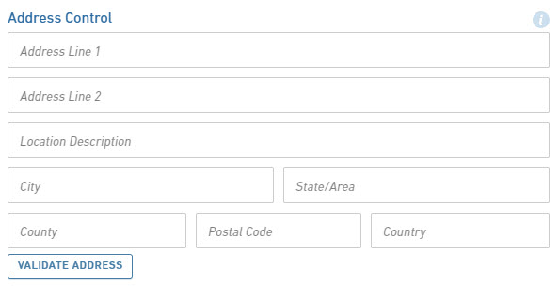
The following properties are available for display/data entry with this control in the Submission Wizard:
- Label: The label for the control will be displayed to the submitter.
- Error/Help Tip: The help tip that will be presented to the submitter when hovering their mouse over the help tip icon () for the control.
- Data Entry: The data entry area for the control. Note: if Read-Only attribute is enabled, the fields will be locked and data entry will not be allowed.
  - Address Line 1: The street address line for the address.
  - Address Line 2: The secondary address line for the address (e.g., BLDG #, APT #, STE #)
  - Location Description: A supplementary description for the address (e.g., 1/4 mile past mile post 214).
  - City: The city for the address.
  - State/Area: The state for the address.
  - County: The county the address resides within.
  - Postal Code: The postal code for the address.
  - Country: The country for the address.
- Validate Address: When clicked, the address entered will be verified against a domestic address service. If an improved address match is found, it will be presented for selection.
- Control Display: Control may not display depending on Display Formula value configuration.
Control Properties in Form Design
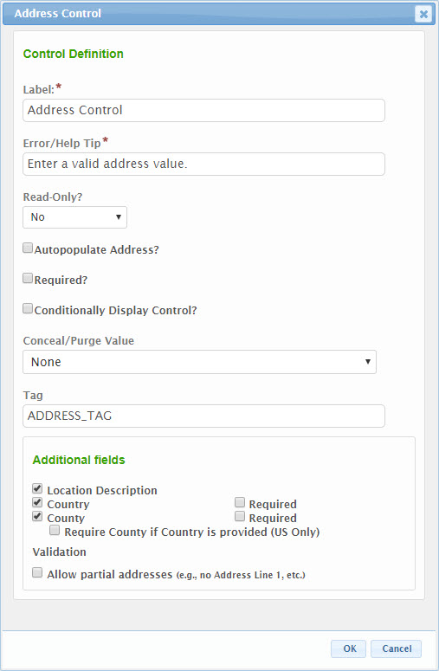
The following configuration properties are available for the control:
- Label: The label that will be presented to the submitter for the control.
- Error/Help Tip: The help tip that will be presented to the submitter when hovering their mouse over the help tip icon () for the control. This attribute will also be utilized to provide additional information to the submitter when an invalid value is available for the control.
- Read-Only?: If set to "Yes", the control will be displayed in a read-only mode. If set to "No", the control will be editable. If set to "If Prepopulated", the control will be displayed in read-only mode, if the control is pre-filled with data.
- Autopopulate Address?: If checked, the address will automatically be populated in the control based the address value found in the submitter’s user profile.
- Required?: Specifies whether the control is required to be entered by the submitter.
- Conditionally Display Control?: If the control will be allowed to display conditionally, during submission process, check the Conditionally Display Control checkbox. When checked, the Display Formula text field will be enabled for configuration. See the Conditional Display section of the Advanced Form Design Guide for details on this feature.
- Conceal/Purge Value: For sensitive information, control value selection can be set the conceal, conceal and purge, or none. If "None" is selected, data will display in standard ways. If "Conceal" is selected, data entered in this control will be concealed from most users. If "Conceal and Purge" is selected, data entered in this control will be concealed from most users and will be purged from the submission, once the submission is finalized. See the Conceal and Purge Data Point topic in the Advanced Form Design Guide for additional details on this feature.
- Tag: The unique name assigned to the control to allow the control to be uniquely identified. This attribute is essential for facilitating the data importing and exporting processes. See the TAGging Fundamentals topic in the Integration Guide for additional details on tagging.
- Additional Fields:
  - Location Description: If checked, the Location Description field will be enabled, allowing for entry of a location description (e.g., 1/4 beyond mile post 214)
  - Country: If checked, the Country field will be enabled.
  - Country Required: If checked, the Country field will be required.
  - County: If checked, the County field will be enabled.
  - County Required: If checked, the County field will be required.
  - Require County if Country is provided (US Only): If checked, the County field will be required if the Country field is populated (and equal to United States).
  - Validation:
    - Allow partial addresses: If checked, partial addresses will be accepted (e.g., city, state and zip code with no street address are accepted, etc.).

Attachment
The Attachment control allows for capture/upload of electronic document(s)/file(s). Attachments can be uploaded using the Choose File button and selecting the file or by dragging and dropping the electronic document on the "Drop files here to upload" area. An electronic document/file can be deleted by clicking the 'x' button to the right of the electronic document/file name.
Note: Large files can be accepted by the system. The max file size is configurable by a system administrator.
Control Properties in Submission Wizard
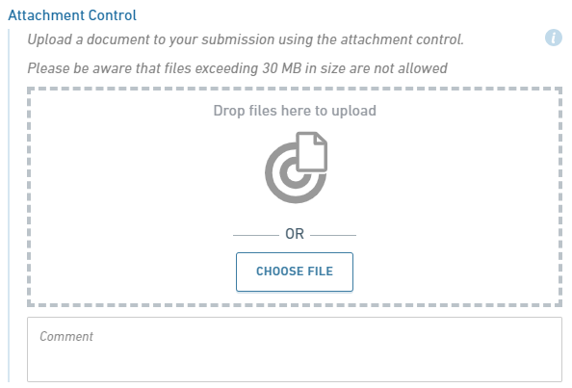
The following properties are available for display/data entry with this control in the Submission Wizard:
- Label: The label for the control will be displayed to the submitter.
- Error/Help Tip: The help tip that will be presented to the submitter when hovering their mouse over the help tip icon () for the control.
- Data Entry: The data entry area for the control. Files will be virus scanned on upload.
  - Drop files here to upload: Drag and drop electronic document files to this area to initiate an electronic document/file upload.
  - Choose File: Click this button to open the file browser and allow for selection of the electronic document/file.
Note: Any uploaded files will be scanned for viruses prior to being saved
  - File List: A list of all uploaded electronic documents/files.
  - Confidential: If configured to be enabled, the submitter will have the ability to mark an electronic document/file as confidential using this checkbox, in the case of sensitive information. Marking an electronic document/file as confidential will encrypt the information and limit access to who will be able to view the electronic document/file.
  - Justification: If the submitter marks the electronic document/file as confidential, they will be required to enter justification text.
  - Comment: An area for the submitter to provide additional comments on the electronic documents/files.
- Control Display: Control may not display depending on Display Formula value configuration.
Control Properties in Form Design
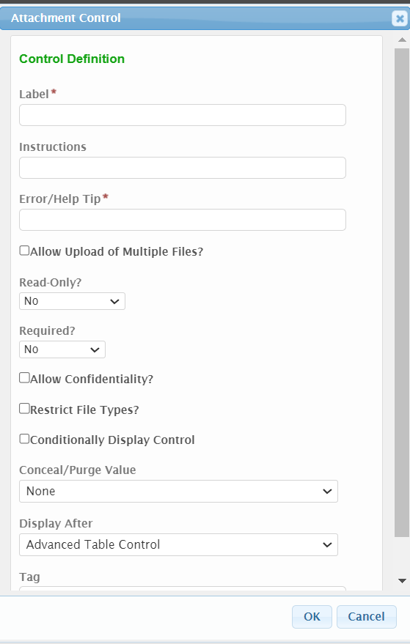
The following configuration properties are available for the control:
- Label: The label that will be presented to the submitter for the control.
- Instructions: Any pertinent instructions for the submitter with regards to the electronic document(s) for upload.
- Error/Help Tip: The help tip that will be presented to the submitter when hovering their mouse over the help tip icon () for the control. This attribute will also be utilized to provide additional information to the submitter when an invalid value is available for the control.
- Allow Upload of Multiple Files?: If checked, the system will allow multiple documents/files to be uploaded to this control.
- Read-Only?: If set to "Yes", the control will be displayed in a read-only mode. If set to "No", the control will be editable. If set to "If Prepopulated", the control will be displayed in read-only mode, if the control is pre-filled with data.
- Required?: Specifies whether the control is required to be entered by the submitter.
- Allow Confidentiality: If checked it allows the applicant to mark an attachment as confidential when going through the form.
- Restrict File Types?: Select/check the file types that will be accepted for this control in the Submission Wizard.
- Conditionally Display Control?: If the control will be allowed to display conditionally, during submission process, check the Conditionally Display Control checkbox. When checked, the Display Formula text field will be enabled for configuration. See the Conditional Display section of the Advanced Form Design Guide for details on this feature.
- Conceal/Purge Value: For sensitive information, control value selection can be set the conceal, conceal and purge, or none. If "None" is selected, data will display in standard ways. If "Conceal" is selected, data entered in this control will be concealed from most users. If "Conceal and Purge" is selected, data entered in this control will be concealed from most users and will be purged from the submission, once the submission is finalized. See the Conceal and Purge Data Point topic in the Advanced Form Design Guide for additional details on this feature.
- Tag: The unique name assigned to the control to allow the control to be uniquely identified. This attribute is essential for facilitating the data importing and exporting processes. See the TAGging Fundamentals topic in the Integration Guide for additional details on tagging.

Calculated
The Calculated control allows for calculated of a value based on a formula. The calculated value can be derived based on values found in other controls on the form.
Control Properties in Submission Wizard
The following properties are available for display/data entry with this control in the Submission Wizard:
- Label: The label for the control will be displayed to the submitter.
- Error/Help Tip: The help tip that will be presented to the submitter when hovering their mouse over the help tip icon () for the control.
- Data Display: The area will display the formulated value(s) for the control.
Control Properties in Form Design
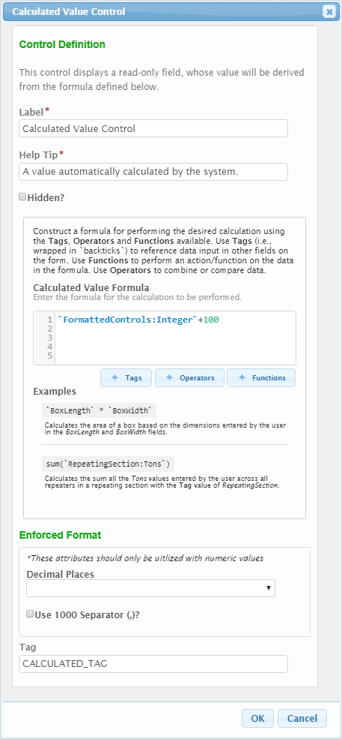
The following configuration properties are available for the control:
- Label: The label that will be presented to the submitter for the control.
- Help Tip: The help tip that will be presented to the submitter when hovering their mouse over the help tip icon () for the control. This attribute will also be utilized to provide additional information to the submitter when an invalid value is available for the control.
- Hidden?: If checked, the system will hide the display of this control from the submitter.
- Calculated Value Formula: The formula used to determine the value(s) that will be displayed in the form. See the Calculated Control section of the Advanced Form Design Guide for details on this feature.
- Enforced Format:
  - Decimal Places: Specifies the number of decimal places with will be enterable/displayed for the value.
  - Use 1000 Separator (,)?: If checked, a comma will be displayed to separate 1000’s (e.g., 1,343,200).
- Tag: The unique name assigned to the control to allow the control to be uniquely identified. This attribute is essential for facilitating the data importing and exporting processes. See the TAGging Fundamentals topic in the Integration Guide for additional details on tagging.

Contact
The Contact control allows for capture of detailed information for a contact person, including attributes such as a name, title, company, phone numbers, email, and address, etc.
Control Properties in Submission Wizard
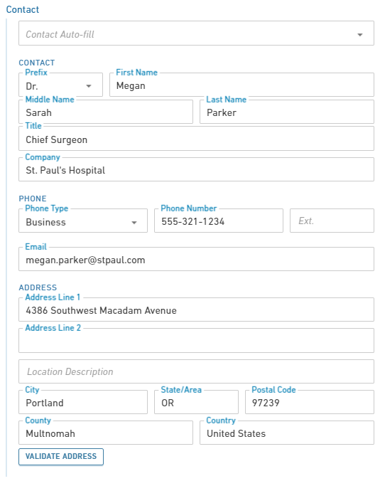
The following properties are available for display/data entry with this control in the Submission Wizard:
- Label: The label for the control will be displayed to the submitter.
- Error/Help Tip: The help tip that will be presented to the submitter when hovering their mouse over the help tip icon () for the control.
- Data Entry: The data entry area for the control. Note: if Read-Only attribute is enabled, the fields will be locked and data entry will not be allowed.
  - Contact Auto-Fill: Provides the ability for the user to auto-fill the contact control based on data entered in other areas of the form, or via auto-fill dataset. Note: this value is only available if configured to be enabled.
  - Contact
    - Prefix: The prefix for the contacts name (e.g., Dr., Ms., etc.).
    - First Name: The first name for the contact.
    - Last Name: The last name for the contact.
    - Title: The title of the contact.
    - Company Name: The company which the contact represents.
    - Email: The email address for the contact.
    - Phone: The phone number for the contact.
    - Ext.: The extension for the phone number for the contact.
    - Fax: The fax number for the contact.
  - Address:
    - Address Line 1: The street address line for the address.
    - Address Line 2: The secondary address line for the address (e.g., BLDG #, APT #, STE #).
    - Location Description: A supplementary description for the address (e.g., 1/4 mile past mile post 214).
    - City: The city for the address.
    - State/Area: The state for the address.
    - County: The county for the address, if applicable.
    - Postal Code: The postal code for the address.
    - Country: The country for the address.
- Validate Address: When clicked, the address entered will be verified against a domestic address service. If an improved address match is found, it will be presented for selection.
- Control Display: Control may not display depending on Display Formula value configuration.

Control Properties in Form Design
The following configuration properties are available for the control:
- Header: The label that will be presented to the submitter in the header of the control.
- Error/Help Tip: The help tip that will be presented to the submitter when hovering their mouse over the help tip icon () for the control. This attribute will also be utilized to provide additional information to the submitter when an invalid value is available for the control.
- Read-Only?: If set to "Yes", the control will be displayed in a read-only mode. If set to "No", the control will be editable. If set to "If Prepopulated", the control will be displayed in read-only mode, if the control is pre-filled with data.
- Autopopulate Contact and Address?: If checked, the contact and address fields will automatically be populated in the control based the information found in the submitter’s user profile.
- Conditionally Display Control?: If the control will be allowed to display conditionally, during submission process, check the Conditionally Display Control checkbox. When checked, the Display Formula text field will be enabled for configuration. See the Conditional Display section of the Advanced Form Design Guide for details on this feature.
- Conceal/Purge Value: For sensitive information, control value selection can be set the conceal, conceal and purge, or none. If "None" is selected, data will display in standard ways. If "Conceal" is selected, data entered in this control will be concealed from most users. If "Conceal and Purge" is selected, data entered in this control will be concealed from most users and will be purged from the submission, once the submission is finalized. See the Conceal and Purge Data Point topic in the Advanced Form Design Guide for additional details on this feature.
- Tag: The unique name assigned to the control to allow the control to be uniquely identified. This attribute is essential for facilitating the data importing and exporting processes. See the TAGging Fundamentals topic in the Integration Guide for additional details on tagging.
- Components:
  - Main Contact Info:
    - Contact Group Label: The label displayed above the Contact information area in the control. If left blank, no label will be displayed in this area.
    - Individual:
      - Display Individual Name: If checked, the individual First Name and Last Name fields will be displayed.
      - Individual Name Required: If checked, the individual First Name and Last Name fields will be required to be entered by the submitter.
      - Prefix: If checked, the Prefix field will be displayed.
      - Prefix Required: If checked, the Prefix field will be required to be entered by the submitter.
      - Middle Name: If checked, the Middle Name field will be displayed.
      - Middle Name Required: If checked, the Middle Name field will be required to be entered by the submitter.
    - Title:
      - Display Title: If checked, the Title field will be displayed.
      - Title Required: If checked, the Title field will be required to be entered by the submitter.
    - Organization/Company Name
      - Display Organization/Company Name: If checked, the Organization/Company Name field will be displayed.
      - Organization/Company Name Required: If checked, the Organization/Company Name field will be required to be entered by the submitter.
      - Organization/Company Name Custom Label: If a value is entered in this field, this will be the label presented for the Organization/Company Name field. If no value is provided, Organization Name will be displayed.
  - Phone
    - Display Phone: If checked, the Phone fields will be displayed.
    - At Least 1 Required: If checked, at least one phone number will be required to be provided by the submitter.
    - Phone Number Group Label: The label displayed above the Phones area in the control. If left blank, no label will be displayed in this area.
    - Multiple phone numbers allowed: If checked, multiple phone number can be provided by the submitter.
    - Allowed phone number types:
      - Main: If checked, the user will be allowed to enter a main phone number.
      - Business: If checked, the user will be allowed to enter a business phone number.
      - Home: If checked, the user will be allowed to enter a home phone number.
      - Mobile: If checked, the user will be allowed to enter a mobile phone number.
      - Other: If checked, the user will be allowed to enter an other type of phone number.
  - Fax:
    - Display Fax: If checked, the Fax field will be displayed.
    - Fax Required: If checked, the Fax field will be required to be entered by the submitter.
  - Email Address:
    - Display Email Address: If checked, the Email field will be displayed.
    - Email Address Required: If checked, the Email field will be required to be entered by the submitter.
  - Address:
    - Display Address: If checked, the address fields (e.g., Address Line 1, Address Line 2, City, State/Area, Postal Code) will be displayed.
    - Address Required: If checked, an address will be required to be entered by the submitter.
    - Address Group Label: The label displayed above the address information area in the control. If left blank, no label will be displayed in this area.
    - Location Description: If checked, the Location Description field will be enabled, allowing for entry of a location description (e.g., 1/4 beyond mile post 214)
    - Country: If checked, the Country field will be enabled.
    - Country Required: If checked, the Country field will be required.
    - County: If checked, the County field will be enabled.
    - County Required: If checked, the County field will be required.
    - Require County if Country is provided (US Only): If checked, the County field will be required if the Country field is populated (and equal to United States).
    - Validation:
      - Allow partial addresses: If checked, partial addresses will be accepted (e.g., city, state and zip code with no street address are accepted, etc.).

Hidden Text
The Hidden Text control allows for data to be included in a form, but hidden, when appropriate, for storing data used by the import/export processes, that may have no meaning to the submitter.
Control Properties in Submission Wizard
No properties are available for display/data entry with this control in the Submission Wizard as it is hidden from the submitters view.
Control Properties in Form Design
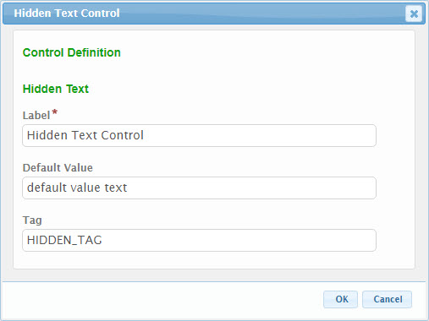
The following configuration properties are available for the control:
- Label: The label that will identify the control in the form designer.
- Default Value: A default value that should be assigned to the control, if appropriate.
- Tag: The unique name assigned to the control to allow the control to be uniquely identified. This attribute is essential for facilitating the data importing and exporting processes. See the TAGging Fundamentals topic in the Integration Guide for additional details on tagging.

Location
The Location control allows for the capture of a latitude and longitude for a particular spatial point/location. Users can search for a location by an address, entry of a latitude and longitude decimal value or use of a Google map to point to and identify a specific location.
Control Properties in Submission Wizard
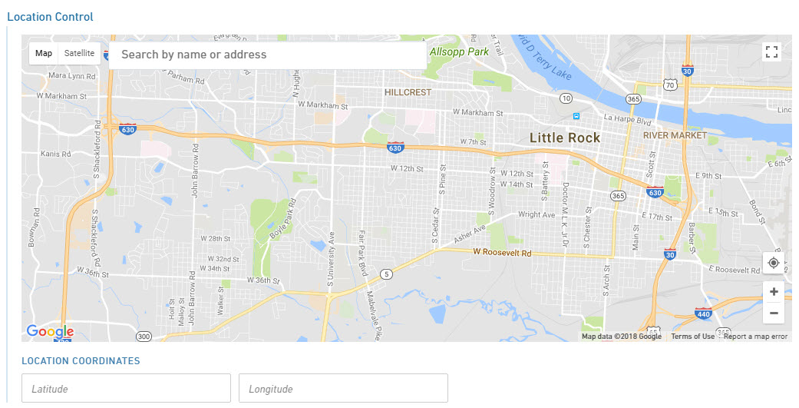
The latitude and longitude can be identified using one of the following methods:
- Address: A location can be identified by entering the physical address of the location (e.g., “919 Ala Moana Blvd., Honolulu, Hawaii 96814”) in the Search by name or address text field on the top of the map.
- Map: The map marker can be moved on the map to the appropriate location by clicking on the map and/or dragging the marker to the appropriate location. Use the zoom and pan controls on the bottom right to navigate the map. The closer you zoom in to a location, the more accurate the identified location.
- My Location: Some browsers have the ability to share the user’s exact location (when provided access to such information). When supported and authorized, the user can click on the my location button () to pinpoint their exact location on the map. Note: you will be required (when/if asked) to share your location to your browser for this feature to work properly.
- Direct Entry: In the search box, type your coordinates. Here are examples of formats that work:
  - Degrees, minutes, and seconds (DMS): 41°24'12.2"N 2°10'26.5"E
  - Degrees and decimal minutes (DMM): 41 24.2028, 2 10.4418
  - Decimal degrees (DD): 41.40338, 2.17403
  - Tips:
    - Use the degree symbol instead of "d".
    - Use periods as decimals, not commas. Incorrect: 41,40338, 2,17403. Correct: 41.40338, 2.17403.
    - List your latitude coordinates before longitude coordinates.
    - Check that the first number in your latitude coordinate is between -90 and 90.
    - Check that the first number in your longitude coordinate is between -180 and 180.
- Control Display: Control may not display depending on Display Formula value configuration.
Note: if Read-Only attribute is enabled, the fields will be locked and data entry will not be allowed.
Control Properties in Form Design
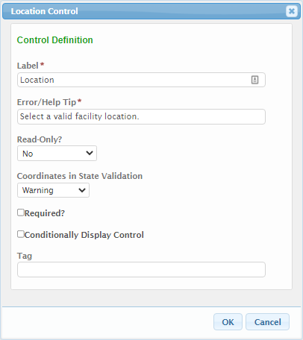
The following configuration properties are available for the control:
- Label: The label that will be presented to the submitter for the control.
- Error/Help Tip: The help tip that will be presented to the submitter when hovering their mouse over the help tip icon () for the control. This attribute will also be utilized to provide additional information to the submitter when an invalid value is available for the control.
- Read-Only?: If set to "Yes", the control will be displayed in a read-only mode. If set to "No", the control will be editable. If set to "If Prepopulated", the control will be displayed in read-only mode, if the control is pre-filled with data.
- Coordinated in State Validation: Specifies if location coordinates will be validated to be within the state. Validation options include:
  - No Validation: No validation will be performed.
  - Warning: The user will be warned (but not stopped) if the selected coordinates are outside of the state.
  - Error: The user will receive an error if the selected coordinates are outside of the state.
- Required?: Specifies whether the control is required to be entered by the submitter.
- Conditionally Display Control?: If the control will be allowed to display conditionally, during submission process, check the Conditionally Display Control checkbox. When checked, the Display Formula text field will be enabled for configuration. See the Conditional Display section of the Advanced Form Design Guide for details on this feature.
- Tag: The unique name assigned to the control to allow the control to be uniquely identified. This attribute is essential for facilitating the data importing and exporting processes. See the TAGging Fundamentals topic in the Integration Guide for additional details on tagging.

Message
The Message control presents messages to users based on submission properties, if desired. This includes informational messages, warnings and errors. Errors prevent the user from proceeding with submitting the form, while warnings and informational messages do not. A formula is used to determine whether the message control will be displayed.
Control Properties in Submission Wizard
The three display formats are presented here:
- Informational:
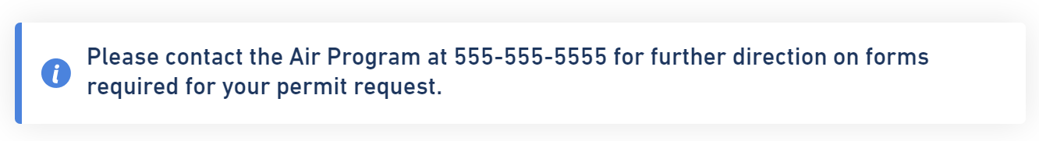
- Warning:
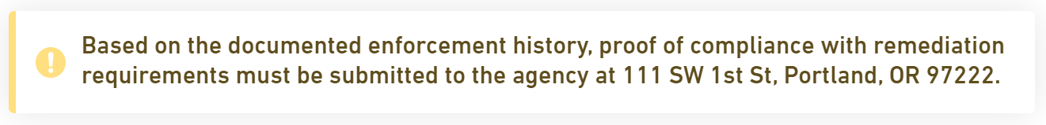
- Error:
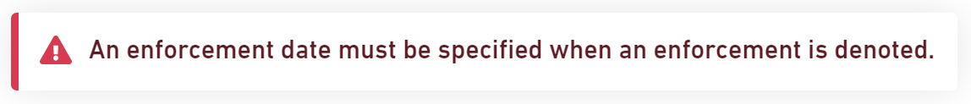
The following properties are available for display/data entry with this control in the Submission Wizard:
- Icon: An icon representing the type of message presented.
- Message Content: The custom message content presented to the user.
- Control Display: Control may not display depending on Display Formula value configuration.
Control Properties in Form Design
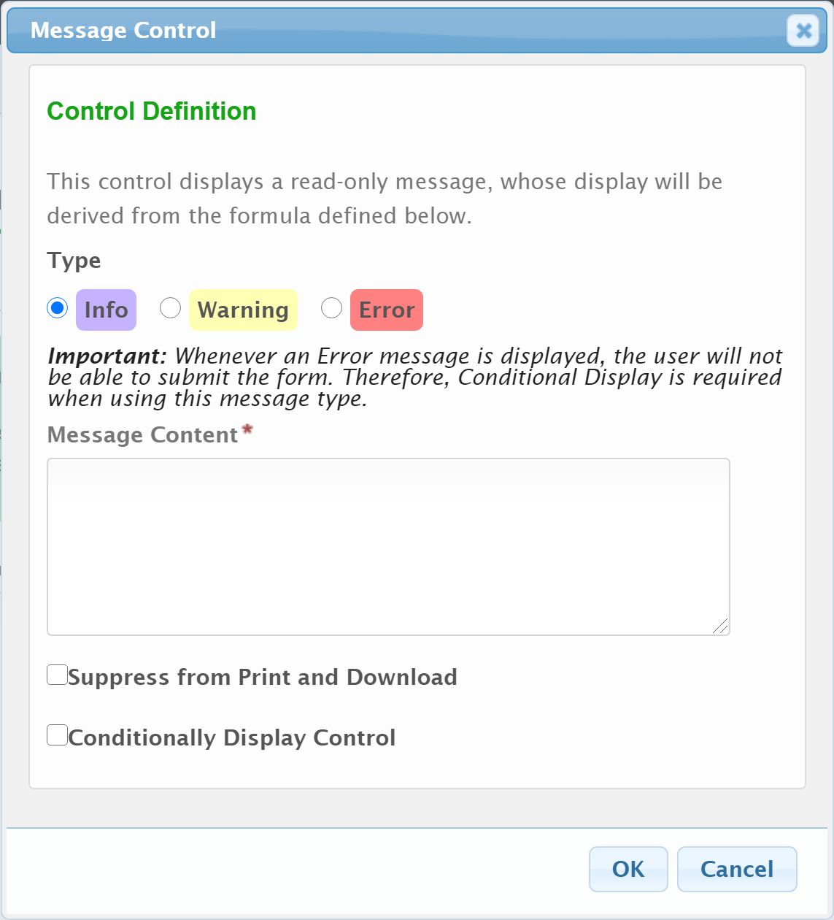
The following configuration properties are available for the control:
- Type: A selection of the control type. Options include:
  - Info: A informational message displayed to the user. Users can submit the form regardless of whether an informational message is displayed. When selected, the Conditionally Display Control option will be enabled.
  - Warning: A warning message displayed to the user, based on properties of a submission. Users can submit the form regardless of whether a warning message is displayed. When selected, the Conditionally Display Control option will be enabled.
  - Error: An error message to display to a user based on properties of a submission. Users are unable to submit the form is an error message is displayed. When selected, the Display Formula option will be enabled.
- Message Content: The message that will be displayed to the user.
- Suppress from Print and Download: If checked, the control will be suppressed from prints and downloads.
- Display Formula: The formula used to determine the value(s) that will be displayed in the form.

Name
The Name control captures a Name and Title value. This can be used to capture the name/title of an owner, operator or project manager.
Control Properties in Submission Wizard
The following properties are available for display/data entry with this control in the Submission Wizard:
- Label: The label for the control will be displayed to the submitter.
- Error/Help Tip: The help tip that will be presented to the submitter when hovering their mouse over the help tip icon () for the control.
- Data Entry: The data entry area for the control. Note: if Read-Only attribute is enabled, the fields will be locked and data entry will not be allowed.
  - Full Name: The full name for the person.
  - Title: The title of the person.
- Control Display: Control may not display depending on Display Formula value configuration.
Control Properties in Form Design
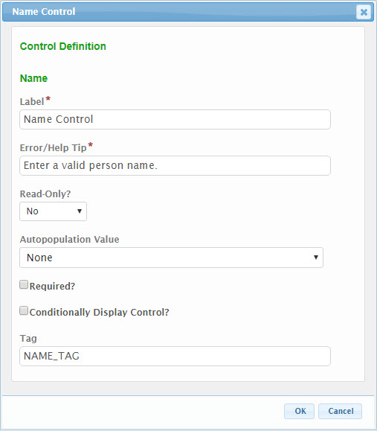
The following configuration properties are available for the control:
- Label: The label that will be presented to the submitter for the control.
- Error/Help Tip: The help tip that will be presented to the submitter when hovering their mouse over the help tip icon () for the control. This attribute will also be utilized to provide additional information to the submitter when an invalid value is available for the control.
- Read-Only?: If set to "Yes", the control will be displayed in a read-only mode. If set to "No", the control will be editable. If set to "If Prepopulated", the control will be displayed in read-only mode, if the control is pre-filled with data.
- Autopopulation Value: When a value is selected in this attribute, information will automatically be populated in the control based the respective value found in the submitter’s user profile (e.g., user name, user email address, etc.).
- Required?: Specifies whether the control is required to be entered by the submitter.
- Conditionally Display Control?: If the control will be allowed to display conditionally, during submission process, check the Conditionally Display Control checkbox. When checked, the Display Formula text field will be enabled for configuration. See the Conditional Display section of the Advanced Form Design Guide for details on this feature.
- Tag: The unique name assigned to the control to allow the control to be uniquely identified. This attribute is essential for facilitating the data importing and exporting processes. See the TAGging Fundamentals topic in the Integration Guide for additional details on tagging.

Tables
Table controls allow for the capture of a table of data from the submitter. This section will describe the available Table control options.

Advanced Table
The Advanced Table control allows for the capture and/or display of data in a highly formatted table structure. Users can interact with the table (e.g., adding/removing rows), if appropriate, and entered data can be controlled using a number of Simple and Formatted control types.
Control Properties in Submission Wizard
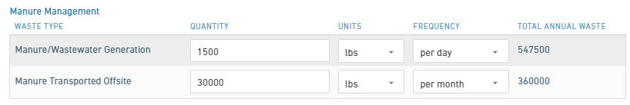
The following properties are available for display/data entry with this control in the Submission Wizard:
- Label: The label for the control will be displayed to the submitter. Note: this field can be omitted to suppress the table header label (i.e., if stacking tables).
- Error/Help Tip: The help tip that will be presented to the submitter when hovering their mouse over the help tip icon () for the control.
- Data Entry: The data entry area for the control. Note: if Read-Only attribute is enabled, the fields will be locked and data entry will not be allowed.
  - Column Label: The label for the column of data.
  - Column Values: The values for entry in a column. Each column’s control type and available values will be dependent upon the configuration for the table.
  - Add Row: When available, clicking the Add Row button will create a new row to the table.
  - Delete: When available, clicking the Delete 'x' button will delete the selected row from the table.
- Control Display: Control may not display depending on Display Formula value configuration.

Control Properties in Form Design 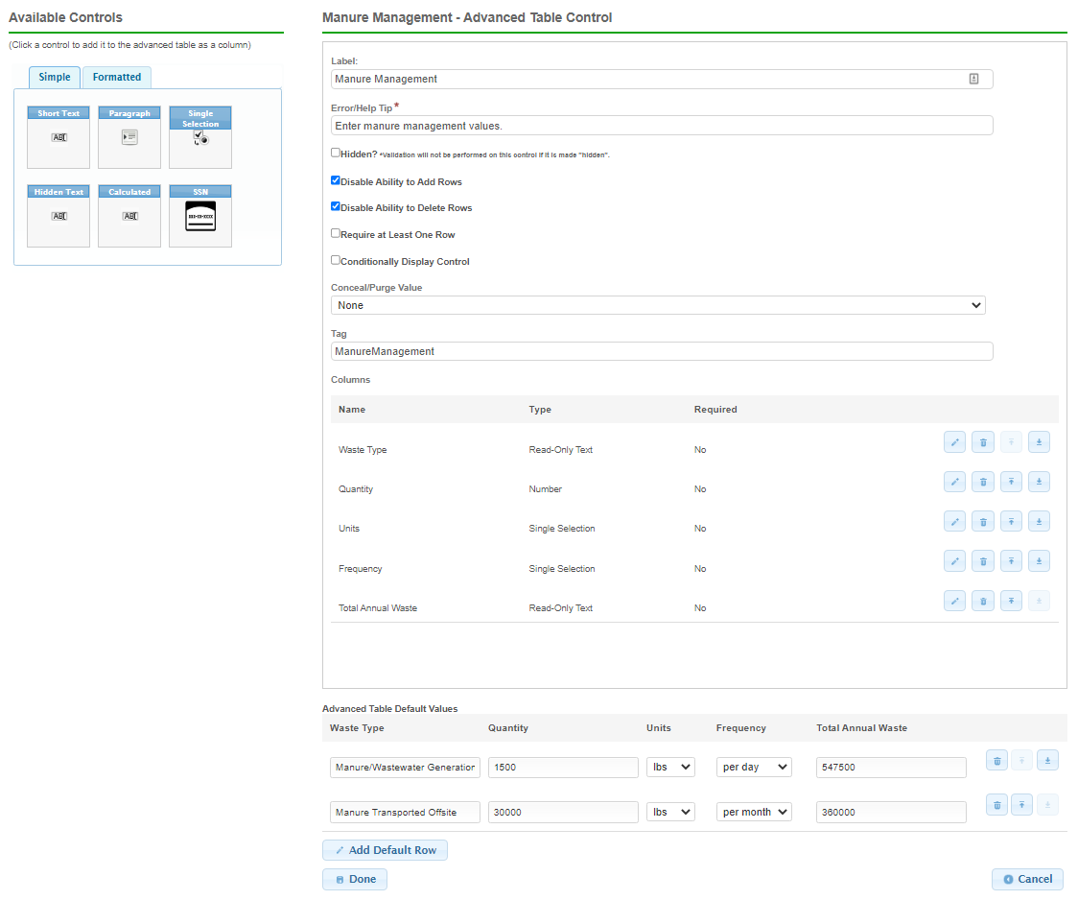
The following configuration properties are available for the control:
- Label: The label that will be presented to the submitter for the control.
- Error/Help Tip: The help tip that will be presented to the submitter when hovering their mouse over the help tip icon () for the control. This attribute will also be utilized to provide additional information to the submitter when an invalid value is available for the control.
- Hidden?: If checked, the system will hide the display of this control from the submitter.
- Disable Ability to Add Rows: If checked, the Add Row button will be hidden from the submitter to prevent rows from being added to the table. This can be helpful for locking down the table in situations where the table data is prepopulated or defaulted with data.
- Disable Ability to Remove Rows: If checked, the "x" button next to the data rows will be hidden from the submitter to prevent rows from being deleted from the table. This can be helpful for locking down the table in situations where the table data is prepopulated or defaulted with data.
- Require at Least One Row: If checked, the submitter will be required to provide at least one row of data in the table.
- Conditionally Display Control?: If the control will be allowed to display conditionally, during the submission process, check the Conditionally Display Control checkbox. When checked, the Display Formula text field will be enabled for configuration. See the Conditional Display section of the Advanced Form Design Guide for details on this feature.
- Conceal/Purge Value: For sensitive information, control value selection can be set the conceal, conceal and purge, or none. If "None" is selected, data will display in standard ways. If "Conceal" is selected, data entered in this control will be concealed from most users. If "Conceal and Purge" is selected, data entered in this control will be concealed from most users and will be purged from the submission, once the submission is finalized. See the Conceal and Purge Data Point topic in the Advanced Form Design Guide for additional details on this feature.
- Tag: The unique name assigned to the control to allow the control to be uniquely identified. This attribute is essential for facilitating the data importing and exporting processes. See the TAGging Fundamentals topic in the Integration Guide for additional details on tagging.
- Columns: This area will define the columns presented in the table.
  - To add new column, click on one of the available controls from left Available Controls pane which will add the Column to the Columns area. This will activate the control design dialog for the relevant control. The available controls are limited to those that are considered most appropriate for use in a table. See control type configuration properties in this topic, above, for the selected control types.
It is worth noting that one additional set of configuration options are available to support column footer calculations in a table. This includes:
  - Column Summary: This configuration option allows the column values to be aggregated using a mathematical function.
    - Show Column Summary?: If checked, a Summary Type dropdown will display.
    - Summary Type: Allows user to select type mathematic function (Average, Count, Max, Min, Sum) to perform for the column summary.
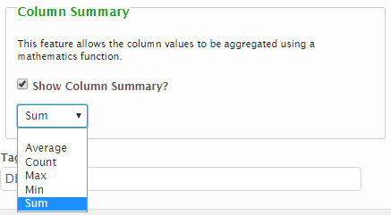
Note: To edit a column, click on the Edit icon () for the desired column.
Note: To remove a column, click on the Delete icon () for the desired column.
- Advanced Table Default Values: This area allows a designer to establish a default dataset in the table when desired. This can be handy if a finite set of data is captured where the tables data will be fairly static.
  - To add a new default row, click on the Add Default Row button. A row will be added and the values in this row can be adjusted as desired. Many rows can be added, if desired.
Note: To edit a column, adjust the row and column values, in place, as desired.
Note: To remove a column, click on the Delete icon () for the desired column.
  - To reorder columns, moving a column up one position, click on the Move Up icon () for the desired column.
  - To reorder columns, moving a column down one position, click on the Move Down icon () for the desired column.
  - If the Column Summary option was selected in columns setup, a gray summary row will be added to the bottom of the Advanced Table Default Values table display in the form design view. The summary row will indicate the type of mathematics function used for each column selected to display a column summary.
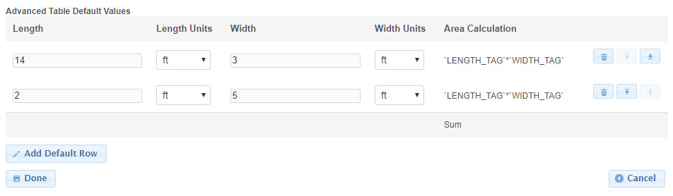
Note: The Calculated control can be included in the table as a Column to perform calculations or summarize data across a particular row.

Datagrid Control
The DataGrid control is a highly formatted table structure that allows users to capture, display, and interact with data. It is a powerful tool for a variety of tasks, such as budgeting, forecasting, and reporting.
The DataGrid control provides several features that make it easy to manage and analyze data, including:
- Import and export: Users can import hundreds of rows of data into the DataGrid control from a variety of sources and export the control values to Excel or other formats.
- Interactivity: Users can interact with the table by adding, removing, and editing rows. The DataGrid control also provides several control types for entered data.
- Validation: The DataGrid control's form-side validation allows users to see where there are errors in their dataset. A next error button allows the user to cycle through these errors, and a full-screen mode makes it easier to view the entire table at once.
- Summary rows: The DataGrid control allows users to summarize columns in a table. This includes the following options:
  - Count
  - Sum
  - Minimum
  - Maximum
  - Average
Summary rows can be added in the form configuration by clicking "Show column summary" within the control configuration of a number type control in a Datagrid.
Control Properties in Submission Wizard
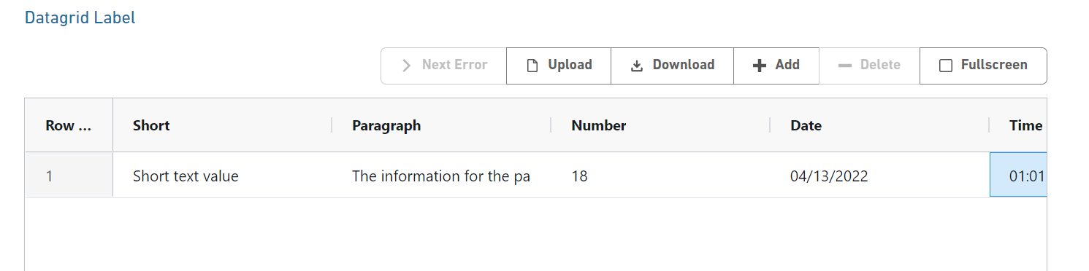
The following properties are available for display/data entry with this control in the Submission Wizard:
- Label: The label for the control will be displayed to the submitter. Note: this field can be omitted to suppress the table header label (i.e., if stacking tables).
- Error/Help Tip: The help tip that will be presented to the submitter when hovering their mouse over the help tip icon () for the control.
- Data Entry: The data entry area for the control. Note: if Read-Only attribute is enabled, the fields will be locked and data entry will not be allowed. (read-only fields will be displayed with a lock icon in the field’s bottom corner.
  - Column Label: The label for the column of data. A hamburger icon is present next to all column labels to allow the user to manipulate the column sizing.
  - Column Values: The values for entry in a column. Each column’s control type and available values will be dependent upon the configuration for the table.
  - Next Error: When available, clicking this button will take the user to the next column containing an error.
  - Download: Allows the user to download the Datagrid and all of its values in an xlsx format. Downloading the grid also allows the user to manipulate the data and add to it in excel if desired and then reupload the new data to the form.
  - Upload: Allows the user to upload a matching dataset to the Datagrid, overlapping all existing data in that control. For a dataset to match the column headers must match the grid control tags. Only excel file formats are accepted.
  - Add: When available, clicking the Add button will create a new row on the table consisting of the selected controls.
  - Delete: This button is available when a row is selected and will delete the entire row. Users can also right click on a row and select Remove row to delete the entire row.
  - Fullscreen: This allows suers to view and manipulate their data in a full screen mode. Users can do all standard grid functions except for uploading.
- Control Display: Control may not display depending on Display Formula value configuration.

Control Properties in Form Design
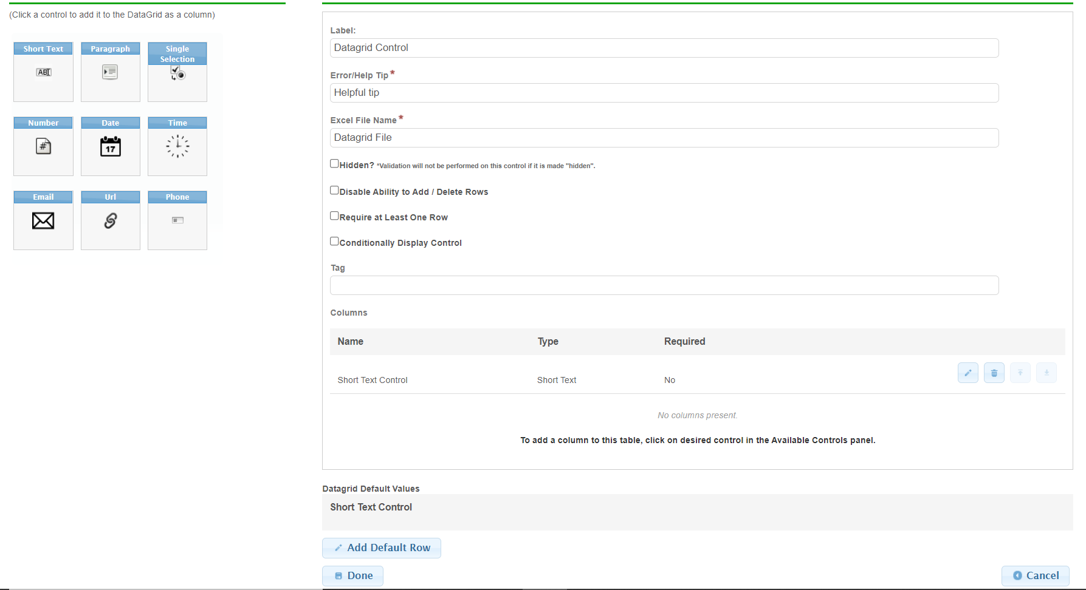
The following configuration properties are available for the control:
- Label: The label that will be presented to the submitter for the control.
- Error/Help Tip: The help tip that will be presented to the submitter when hovering their mouse over the help tip icon () for the control. This attribute will also be utilized to provide additional information to the submitter when an invalid value is available for the control.
- Hidden?: If checked, the system will hide the display of this control from the submitter.
- Disable Ability to Add / Delete Rows: If checked, the Add Row button will be hidden from the submitter to prevent rows from being added to the table. This can be helpful for locking down the table in situations where the tables data is prepopulated or defaulted with data.
- Require at Least One Row: If checked, the submitter will be required to provide at least one row of data in the table.
- Conditionally Display Control?: If the control will be allowed to display conditionally, during the submission process, check the Conditionally Display Control checkbox. When checked, the Display Formula text field will be enabled for configuration. See the Conditional Display section of the Advanced Form Design Guide for details on this feature.
- Conceal/Purge Value: For sensitive information, control value selection can be set the conceal, conceal and purge, or none. If "None" is selected, data will display in standard ways. If "Conceal" is selected, data entered in this control will be concealed from most users. If "Conceal and Purge" is selected, data entered in this control will be concealed from most users and will be purged from the submission, once the submission is finalized. See the Conceal and Purge Data Point topic in the Advanced Form Design Guide for additional details on this feature.
- Tag: The unique name assigned to the control to allow the control to be uniquely identified. This attribute is essential for facilitating the data importing and exporting processes. See the TAGging Fundamentals topic in the Integration Guide for additional details on tagging.
- Columns: This area will define the columns presented in the table.
  - To add a new column, click on one of the available controls from left Available Controls pane which will add the Column to the Columns area. This will activate the control design dialog for the relevant control. The available controls are limited to those that are considered most appropriate for use in a table. Below is a list of the available controls for the Datagrid:
      - Short Text
      - Paragraph
      - Single Selection
      - Number
      - Date
      - Time
      - Email
      - URL
      - Phone
      - Calculated Control
Note: To edit a column, click on the Edit icon () for the desired column. To remove a column, click on the Delete icon () for the desired column.
- Datagrid Default Values: This area allows a designer to establish a default dataset in the table, when desired. This can be handy if a finite set of data will be captured where the tables data will be fairly static.
  - To add a new default row, click on the Add Default Row button. A row will be added and the values in this row can be adjusted as desired. Many rows can be added, if desired.
Note: To edit a column, adjust the row and column values, in place, as desired. To remove a column, click on the Delete icon () for the desired column.
  - To reorder columns, moving a column up one position, click on the Move Up icon () for the desired column.
  - To reorder columns, moving a column down one position, click on the Move Down icon () for the desired column.

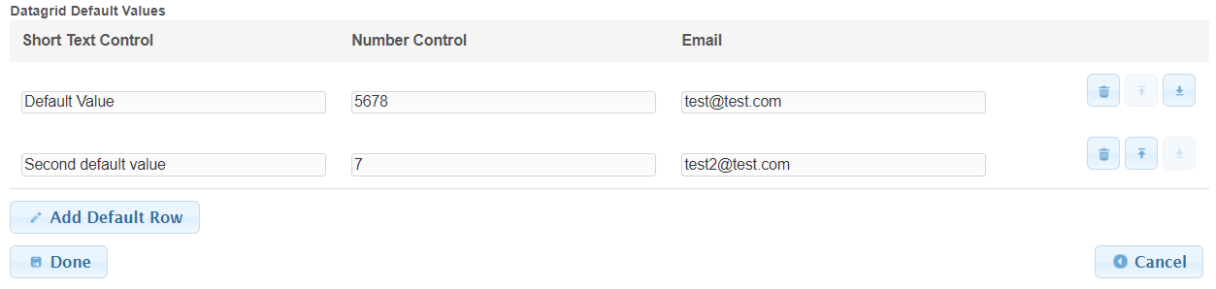

Bulk Upload Table
The [Bulk Upload] Table control allows the agency to provide a predefined spreadsheet template to the submitter for download, population, copy and upload back into the system. The Table control is intended to ease data entry for bulk datasets. Users will download a predefined spreadsheet template, populate this template with the appropriate data, and then copy the raw data from the populated spreadsheet and paste the data in to the table control on the form, where the system will capture the data and present it back to the user for review.
Control Properties in Submission Wizard - Pre Data Upload
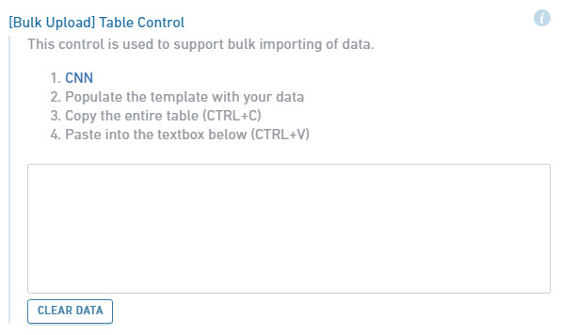

Control Properties in Submission Wizard - Post Data Upload
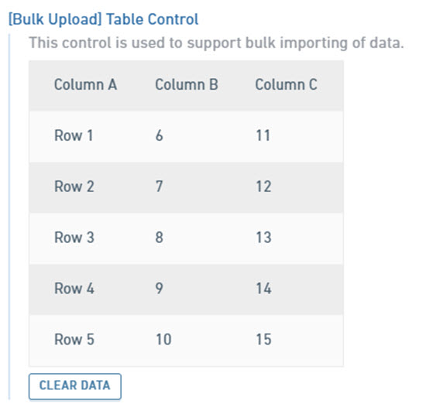
The following properties are available for display/data entry with this control in the Submission Wizard:
- Label: The label for the control will be displayed to the submitter.
- Error/Help Tip: The help tip that will be presented to the submitter when hovering their mouse over the help tip icon () for the control.
- Description Text: Descriptive instructions/text present to the submitter with regards to how to use the template, data population or the upload process.
- Link: The link for downloading the pre-defined spreadsheet template which will be used for data entry.
- Data Entry: The data entry area for the control.
  - Table Data: Data will be copied from the populated spreadsheet template and pasted in to this area for upload. Once the data is pasted in this area, it will be automatically displayed to the user for review/confirmation.
  - Clear Data: The Clear Data button can be clicked to clear the data in the Table Data area.
- Control Display: Control may not display depending on Display Formula value configuration.
Control Properties in Form Design
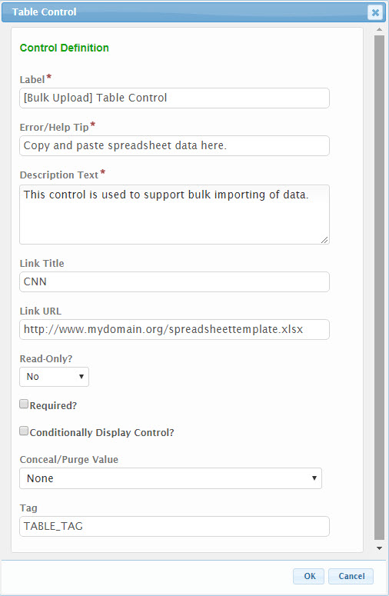
The following configuration properties are available for the control:
- Label: The label that will be presented to the submitter for the control.
- Error/Help Tip: The help tip that will be presented to the submitter when hovering their mouse over the help tip icon () for the control. This attribute will also be utilized to provide additional information to the submitter when an invalid value is available for the control.
- Description Text: Any descriptive instructions/text to present to the submitter with regards to how to use the template, data population or the upload process.
- Link Title: The text that will be displayed as the URL link to the spreadsheet template.
- Link URL: The fully qualified URL location (e.g., https://www.mydomain.org/SpreadsheetTemplate1.xlsx) of the spreadsheet template. Note: this template will need to be located in a publicly available location.
- Read-Only?: If set to "Yes", the control will be displayed in a read-only mode. If set to "No", the control will be editable. If set to "If Prepopulated", the control will be displayed in read-only mode, if the control is pre-filled with data.
- Required?: Specifies whether the control is required to be entered by the submitter.
- Conditionally Display Control?: If the control will be allowed to display conditionally, during submission process, check the Conditionally Display Control checkbox. When checked, the Display Formula text field will be enabled for configuration. See the Conditional Display section of the Advanced Form Design Guide for details on this feature.
- Tag: The unique name assigned to the control to allow the control to be uniquely identified. This attribute is essential for facilitating the data importing and exporting processes. See the TAGging Fundamentals topic in the Integration Guide for additional details on tagging.

