Windsor Solutions

Submission Processing Guide

Updated for Version 4.17
Revision Date: September 28, 2023.

This page intentionally left blank
Version Control

Version | Date | Author | Notes
4.6 | 5/10/2019 | Windsor Solutions | Initial version
4.6 | 6/7/2019 | Windsor Solutions | Updated to reflect terminology change from “Revising” to “Editing”.
4.7 | 6/7/2019 | Windsor Solutions | Versioned for v4.7.
4.8 | 1/31/2020 | Windsor Solutions | Refined to reflect changes implemented in v4.8 where the remaining Submission Details features were integrated in to the Submission Overview page.
4.9 | 7/27/2020 | Windsor Solutions | Updated to reflect 4.9. Updated content to reflect new Dashboard/Search functionality.
4.9 | 8/11/2020 | Windsor Solutions | Updated Dashboard Column Selector panel image.
4.10 | 9/4/2020 | Windsor Solutions | Updated to reflect 4.10.
4.11 | 1/29/2021 | Windsor Solutions | Updated to reflect 4.11. Added bulk reassignment steps description.
4.12 | 7/20/2021 | Windsor Solutions | Updated to reflect 4.12.
4.13 | 5/2/2022 | Windsor Solutions | Updated to reflect 4.13.
4.14 | 8/31/2022 | Windsor Solutions | Updated to reflect release 4.14.
4.16 | 5/11/2023 | Windsor Solutions | Updated to reflect 4.16.
4.17 | 6/28/2023 | Windsor Soltuions | Updated to reflect 4.17.

Contents
Introduction 1
Overview 2
Submission Processing 3
Search for and Select a Submission 4
Begin/Complete Review 7
Modify Status 7
Notations 8
Workflow 11
Submission Information 15
Record Internal Processing Data 15
Update Payment Processing Information 15
Email Submitter 16
Revising a Submission 17
Submitter Responding to Correction Requests 17
Processing a Revised Submission 19

Introduction
The submission processing area of the system provide internal users with the ability to process submissions in an efficient and streamlined manner. Internal staff have the ability to find, identify and select submissions. Once selected, staff can review a submission, edit submission properties, change submission status, complete workflow steps, add documents/attachments and collaborate with the submitter through notes and correction requests.
This guide helps educate processors on how to utilize the submission processing area of the system.

Overview
Submission processing is supported through the “submission overview” set of pages. These screens replace the legacy submission view and submission detail screens, and provide the user with a more interactive environment in which to process a submission and to collaborate with the submitter.
At the highest level, a submitter submits a form and then has the ability to see their submission by logging into their account and selecting the relevant submission from their history tab. Upon selection of a submission the user is presented with the submission overview screen set where they can see details of their submission along with the processing status of the submission. They may also respond to any correction requests, they can download their submission and they can share it with other account holders.
Once a submission is received by an agency, an authorized staff member has the ability to review the submission and to complete workflow tasks according to the workflow that was designed to support the form. As part of this overall review process an authorized staff member can annotate the submission and request that the submitter respond to any necessary correction requests. The creation of a correction request “locks” the submission and prevents the submitter from making any changes while the staffer is in the middle of their review. Once the staff member has defined all of their correction requests they are able to pass control back to the submitter by using the “Complete Review” button. The collaborative process essentially switches control between the reviewer (agency staff) and the submitter.
This document acts a guide to agencies in how to use the functionality.

Submission Processing
One or more submission processors may be assigned to a submission by virtue of workflow task assignments.
The workflow can be established to notify a staff member when their task is due. If this is the case the staff member will receive an email and the relevant submission will appear on their dashboard.
A submission processor may choose to tackle tasks based on the automatic ordering of the processing dashboard. Alternatively, they can search, filter or re-order within the dashboard to select submissions that they wish to work on.
Having selected a submission to process, a submission processor’s intent is to address the task that is assigned to them. This may require that the processor simply marks the required task(s) as complete, or it may require the review of details within the submission. While completing the assigned task the staff member is allowed to, among other things:
- Modify the status
- Create notes
- Create correction requests
- Create processing issues
- Resolve processing issues
- Complete workflow tasks
- Record internal data
- Update submission identification information
- Update payment processing information
- Assign submission responsible person
- Email submitter
- Revise a submission
- Processing a revised submission
Each of these are described in greater detail in the following sections.

Search for and Select a Submission
To search for and select a submission, the user will navigate to the Submission Dashboard, select the desired search criteria, and select the submission in question. This is described in more detail in the following sections.
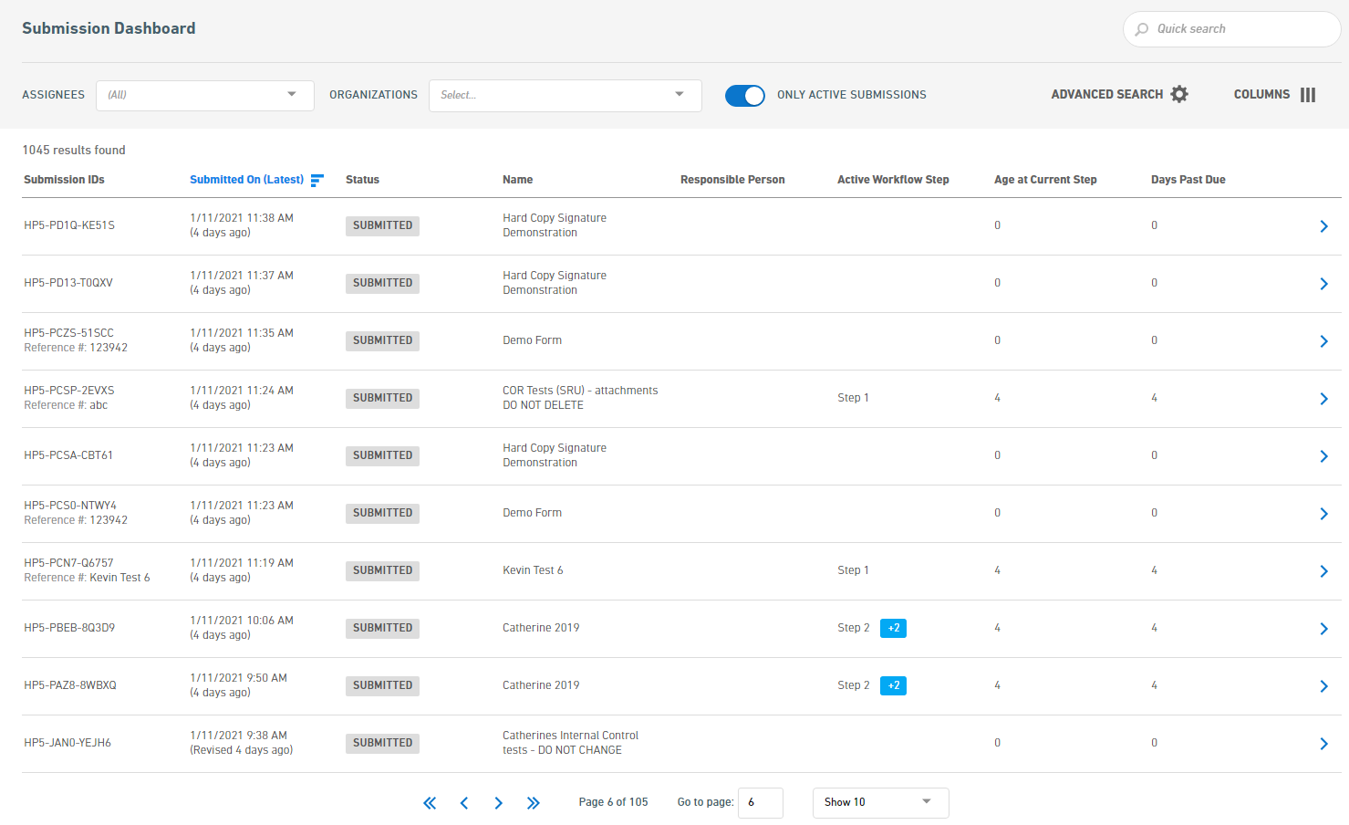

Search for Submissions
To search for a submission(s), first navigate to the Dashboard from the Dashboard link at the top of the nFORM application. Once on the Submission Dashboard, the user has many options for searching for selection. These are broken in to two general approaches: 1) Quick Search and 2) Advanced Search.

Quick Search
The quick search is used to find submissions based on a generic quick search field which searches most submission attributes (e.g., Submission Numbers, form name, submission description, etc.) in addition to a few key attributes (e.g., Assignees, Organizations and Only Active Submissions). The search is refreshed in real time as soon as an attribute is changed.
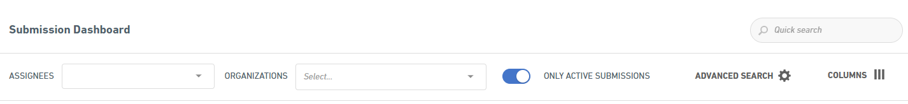
For example, if the user is looking for all active submissions assigned to them, they would simply select their username in the Assignee field and ensure the Only Active Submission filter is activated.
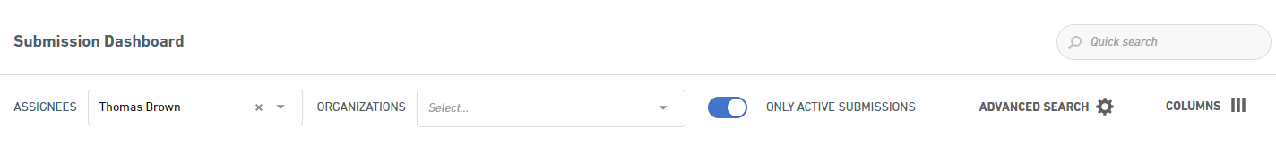

Advanced Search
To perform a more targeted and advanced search, the Advanced Search capabilities can be utilized by clicking upon the Advanced Search option.
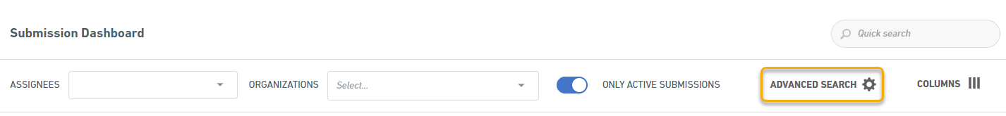
Activating the Advanced Search will present the Advanced Search dialog where specific criteria can be selected and utilized. This Advanced Search provides many search options for use, including the Assignees, Organizations and Only Active Submission attributes that are available in the Quick Search approach.
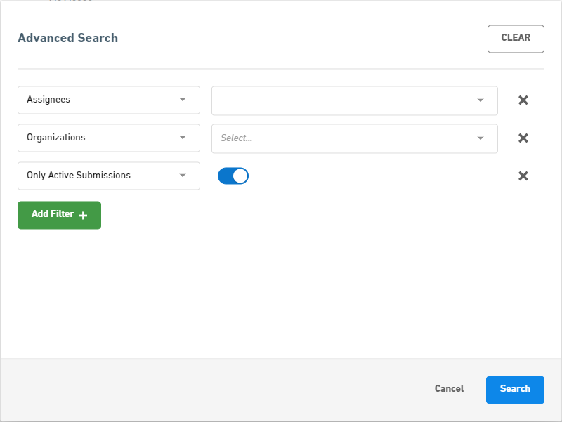
To add new search attributes, click upon the Add Filter + button and then click upon the icon for the desired search criteria. Once added, the cooresponding search value can be entered/selected.
Click the button to run the search.

Submission Selection
Select a submission by clicking on the button for the submission in question.
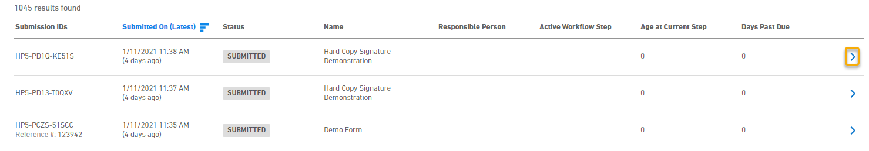

Search Result Column Selection
To aid in the searching process, the system provides users with the ability to select the column that will be displayed in the search results area. This selection is opened by clicking upon the Columns area.
Once selected the user can activate or deactivate the desired display columns.
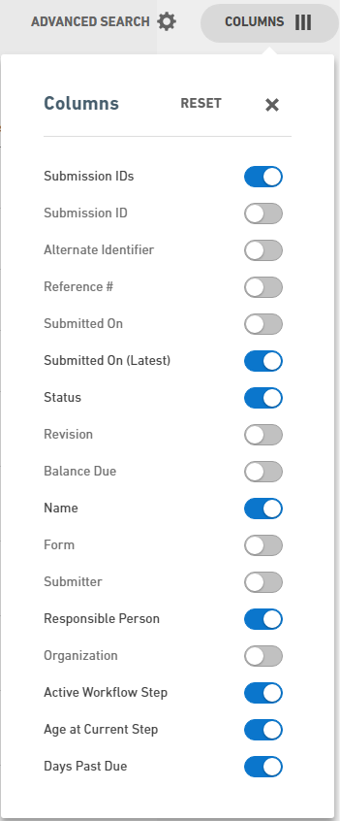
Note: based on an agency’s configuration, some columns options presented here may not be available in your installation.

Begin/Complete Review
To facilitate the review process, begin and complete review states are available for the form.
Selecting Begin Review will enable a processing lock on the form to prevent the submitter from revising the form during the review process and signify that the form is being reviewed. Note: the form will automatically be placed in the review state when a correction request is added.
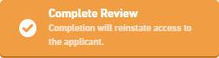
Selecting the Complete Review button will stop the review process and disable the processing lock from the form. The processor will be asked if the submitter should be notified of the unlock and any correction requests.
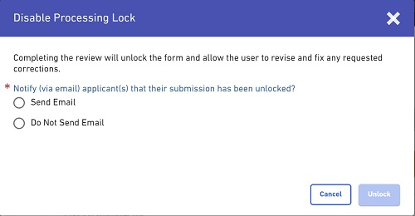

Modify Status
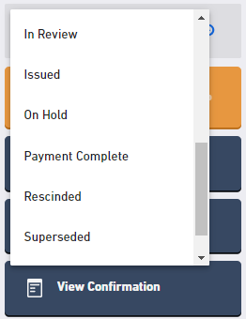
Modifying status is a simple but powerful task that is achieved by selecting the wrench icon in the status panel and selecting the appropriate state.
Note that several states result in specific actions. For instance selecting a final status will lock the submission down to both submitter and staff.

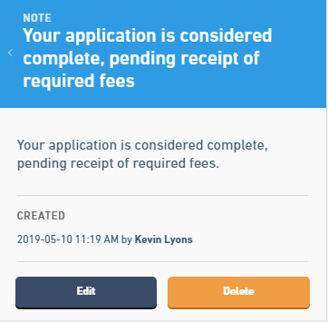
Notations

Create Note
A submission processor can add notes to a submission at any time during processing and these can be assigned at the form, section or control level within the submission.
Notes are for informational purposes only and do not indicate an error or issue.
When processing a submission, notes can be added from the Summary screen or within the View Form page. To add a note from the Summary screen, find the Notes & Issues section of the summary and click the “Add New” button found top right of that section, then select “Create Note” from the resulting drop down menu. To add a note from the Form View screen, either click the “Add Notation” button at the top of the screen, or to the right of the relevant section/control header, and then click “Create Note” from the resulting drop down menu.
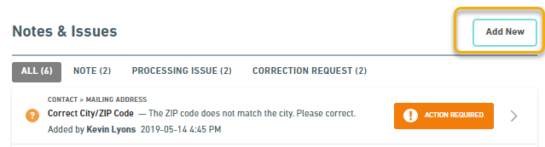
A note can be specified for display to the submitter (and internal staff), or for internal viewing only. Additionally, attachments (e.g., final permit, public notice template, etc.) can be added to a note.

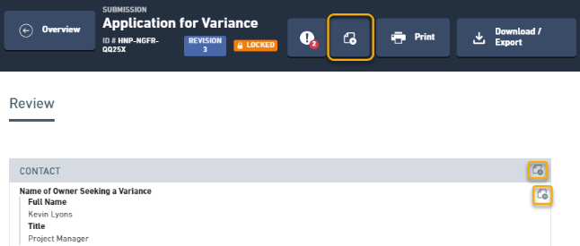
Notes provide a means for communicating with the submitter or other internal staff on topics of relevance to the submission. Submitters cannot respond to notes as they are intended for informational purposes (versus bidirectional communication). Notes that are created transcend submissions so they remain visible as revisions are established.

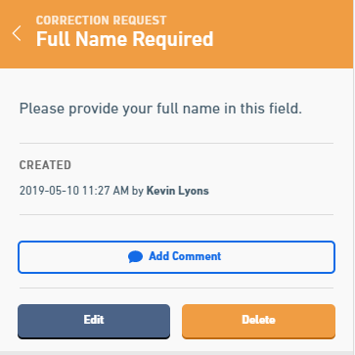
Create Correction Request
When a staff member finds a discrepancy that must be addressed, they can create a correction request on the submission. This can be created at the form, section or control level.

When processing a submission, correction requests can be added from the Summary screen or within the View Form page. To add a correction request from the Summary screen, find the Notes & Issues section of the summary and click the “Add New” button found top right of that section, then select “Create Correction Request” from the resulting drop down menu. To add a correction requests from the Form View screen, either click the “Add Notation” button at the top of the screen, or to the right of the relevant section/control header, and then click “Create Correction Request” from the resulting drop down menu.

If the processor has not yet clicked on the Begin Review button, when the first correction request is created, the submission will be locked to prevent the user from starting a revision while the staff member is working in the submission. Additional correction requests can be established by the submission processor as they see fit.
Once the processor has identified and created all the correction requests that they wish, they can complete their review and unlock the submission to allow the submitter to address each correction request via a revised submission. To complete the review and unlock the submission, the submission processor uses the Complete Review button.
At this point, the processor will have the ability to specify whether an email should be sent to the submitter indicating that the submission is unlocked. If there are correction requests, they will be noted in the email.

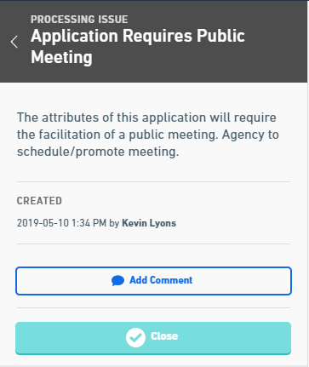
Create Processing Issue
When a staff member needs to investigate, share or address a processing issue (e.g., review submitter financial status, confirm correct ownership, validate submitter, etc.), they can create a processing issue.
When processing a submission, processing issues can be added from the Summary screen or within the View Form page. To add a processing issue from the Summary screen, find the Notes & Issues section of the summary and click the “Add New” button found top right of that section, then select “Create Processing Issue” from the resulting drop down menu. To add a processing issue from the Form View screen, either click the “Add Notation” button at the top of the screen, or to the right of the relevant section/control header, and then click “Create Processing Issue” from the resulting drop down menu.
Processing issues have a simple opened/closed status and are only visible to internal staff members. Processing issues can be assigned at the form, section or control level.

Additional processing issues can be established by the submission processor as they see fit.

Resolve Processing Issue
To denote that a processing issue is resolved the following steps can be followed.
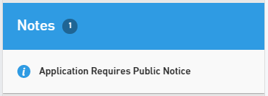
Select the processing issue in question.
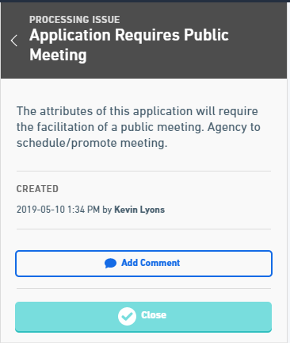

Select the Add Comment button to enter a comment. Select the Close button to mark the processing issue as resolved.

Workflow

Complete Workflow Tasks
Workflow tasks are displayed at a summary level within the Summary portion of the Submission Overview screens and also within a dedicated processing screen.
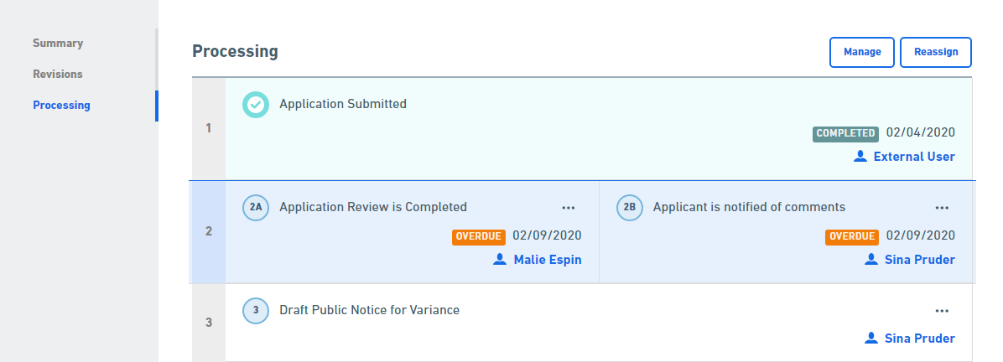
To complete workflow tasks the user will click on a step number, or alternatively can select the “…” ellipsis and select “Mark Complete” option for the step in question.

Reassign Staff (in Bulk)
For instances where assigned staff need to be adjusted, the system provides the ability to reassign tasks in bulk fashion. The Responsible Person and Processing Step Assignments for a submission can be reassigned to different individuals or roles.
To reassign the Responsible Person and Processing Steps for the submission, perform the following steps:
- Open the Submission Overview form using the steps described in the View a Submission topic, if not already open.
- Navigate to the Processing area of the Overview screen which displays the currently active processing steps, including name, due date and assigned staff.
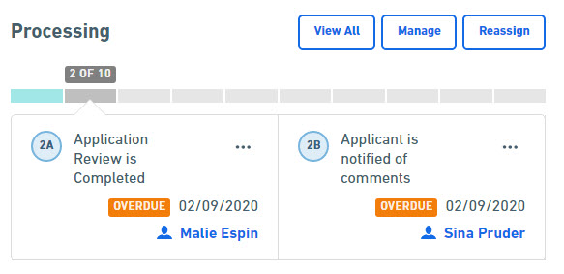
Note: A user can click on the "Processing" link on the left navigation panel to view all processing steps for this submission.
- Click on the Reassign button to open the Bulk Reassign screen.
- The Bulk Reassign screen will be displayed to facilitate the bulk reassignments.
- Individual Assignments:
  - To reassign individual processing steps, remain on the Individual Assignments tab and select users to assign to individual steps.
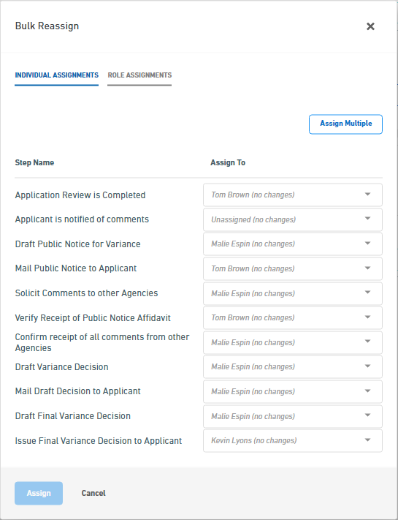
  - Select the submission processor to reassign to step(s), as desired, and click the Assign button to initiate the reassignment process.
  - All users assignments will be updated based on the selected step-user mappings.
- Bulk Role Assignments:
  - To reassign steps, in bulk, by role, select the Role Assignments tab.
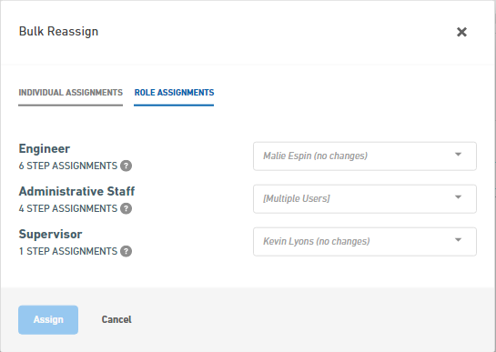
  - Select the submission processor to reassign to role(s), as desired, and click the Assign button to initiate the reassignment process.
  - All user assignments will be updated based on the selected role-user mappings.
- Select the submission processor to reassign to each role(s) and click the Assign button to initiate the reassignment process.
- All users’ assignments will be updated based on the selected role-user mappings for the Responsible Person attribute as well as all Steps.

Adjust Workflow Tasks
In some circumstances, the workflow tasks associated with a submission must be adjusted. This is possible by manipulating the workflow steps within the workflow designer and is accessed by selecting the “Manage” button shown at the top right of the Processing section.
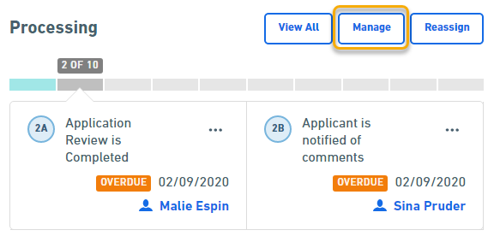
Upon selection, the user is taken to the processing step designer where the workflow steps can be customized for the submission. Once the user has finished adjusting workflow steps, selecting the “Done” button will return the user to the originating submission.

Submission Information

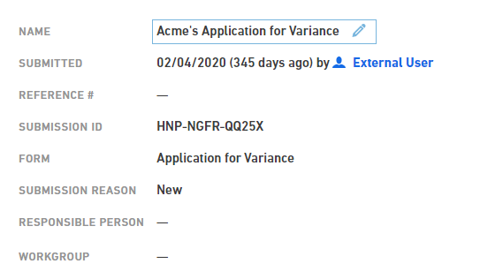
Update Submission Information
High-level submission information (e.g., Reference #, Description, Responsible Person, etc.) can be edited/refined by clicking on the relevant submission attributes value field in the top section of the Summary screen and editing the attribute, inline.

Assign Submission Responsible Person
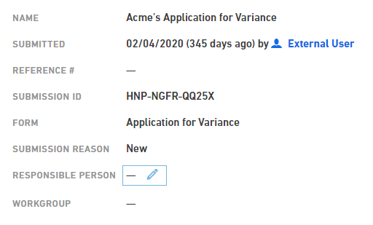
The submission’s responsible person (e.g., permit writer, etc.) can be assigned/changed. This is achieved by selecting the manage button within the processing screen and selecting the new responsible person from the Responsible Person (note: this is the default label for this field) field in the Submission Identification area of the submission details page. Windsor is in the process of bringing this functionality into the main submission overview screen as the processing details screen is retired.

Record Internal Processing Data
Some forms and workflow processes support the ability for the processer to capture additional pre-configured data points. If this is the case for a submission, the data elements will be displayed on the Summary Screen in a specific Internal Data section. Addition or modification of the data is completed simply by clicking on the relevant internal data attributes value field and editing the attribute, inline.
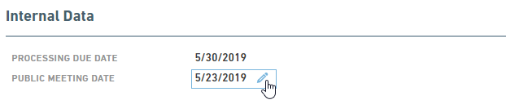

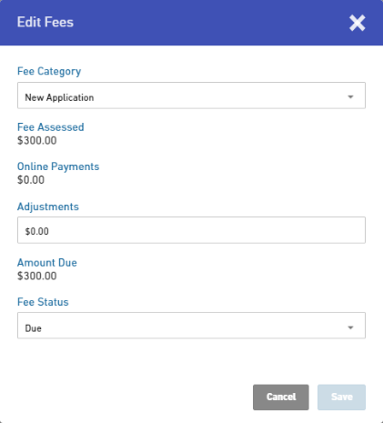
Update Payment Processing Information
Payment processing information can be edited/refined. This is achieved by selecting the edit icon () within the Fees area of the Summary screen. The Edit Fees dialog will be presented.
From the Edit Fees dialog, the user can adjust the Fee Category, manually enter a payment (negative value) or adjustment (negative value equates to a downward adjustment and positive value equates to an upward adjustment) in the Adjustments field and the Fee Status can be adjustment.

Email Submitter
An email can be sent to the submitter, including correction requests or notes. This is achieved by clicking on the Submitter’s name within the Submission Information at the top of the Summary screen. The Email External User dialog will be displayed. From this dialog, the user can select the correction requests and notes to include in the email by checking the checkbox to the left of the item. Clicking the Email User button will open the users native email client, including any selected items.
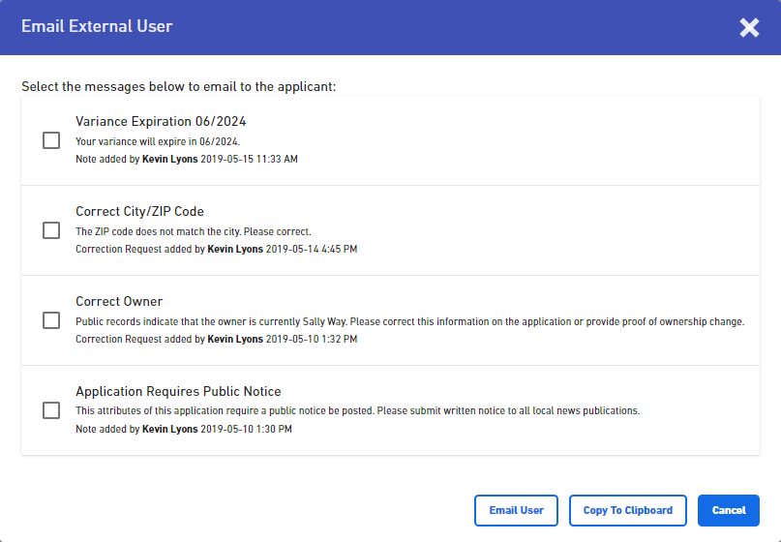
Note: total length of items that can be included in email may be limited based on your selected email client. Additionally, use of special characters in notes may cause issues when including them in emails.

Revising a Submission

Submitter Responding to Correction Requests
If there are outstanding correction requests when the submission processor complete their review, the system can email the submitter to ask them to revise the submission and to address the correction requests.
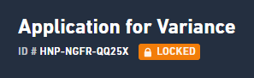
If a submitter visits their submission whilst it is under review, the submission will be locked for the submitter and they will have access in read only. The submitter will see the following indication that their submission is locked.
However, when informed that a revision is necessary the submitter will navigate to their submission where they can review the status of the submission processing and can see any correction requests or notes exposed to them.
To correct and respond to a correction request, the user must select the Revise Submission button to create a new revision of the submission for editing.

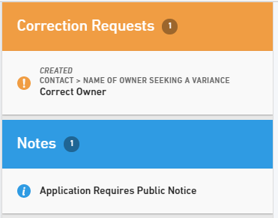
Once the revision is established, the user view (e.g., title and context) and select any created correction requests and/or notes.

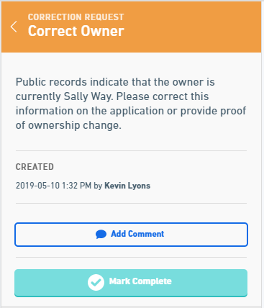

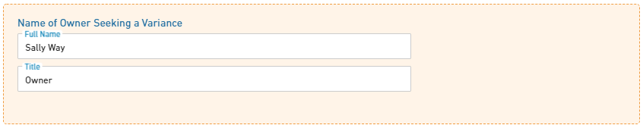
By selecting a correction request or note, the details of the selected item as well as the associated section/control are presented and highlighted. For correction requests, correct the information on the form.

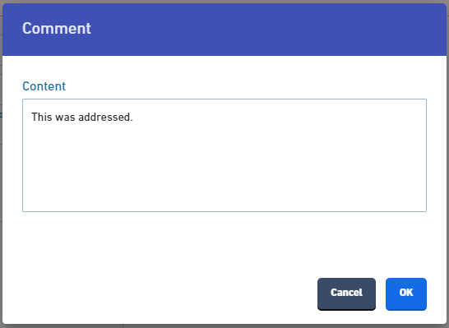
Once corrected, select the Add Comment button (optional) and enter a response.
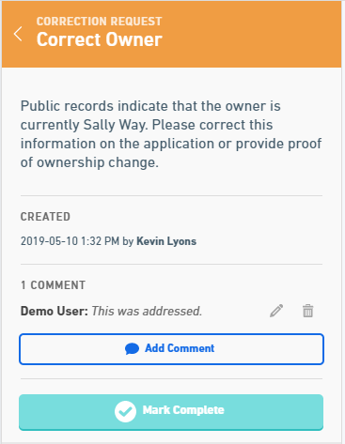

Select the Mark Complete button to denote that the issue was addressed.

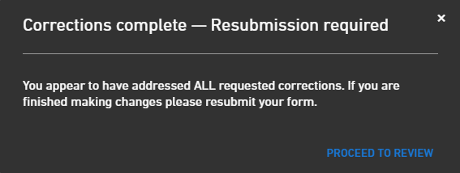
In order to resubmit, the user must address (and mark complete) ALL correction requests, they must then review the submission (if this is an included step), then complete the certify and submit step. When all correction requests are addressed and marked as complete, the system will notify the user that the revision must be resubmitted. Select Proceed to Review (if this is an included step) to navigate to the review page to review and resubmit the form. Review the submission data and resubmit the form (select the Submit Form button).

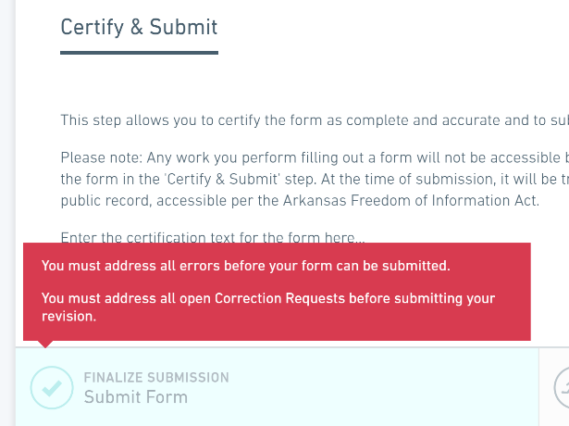
If a submitter tries to submit a revised/edited submission without having addressed (and marked complete) ALL correction requests they will be prevented from submitting and will be presented with an error message.

Processing a Revised Submission
Having received a revised submission the agency staff assigned will once again select the submission from their list of assigned submissions within their personal processing dashboard.

Compare Submissions
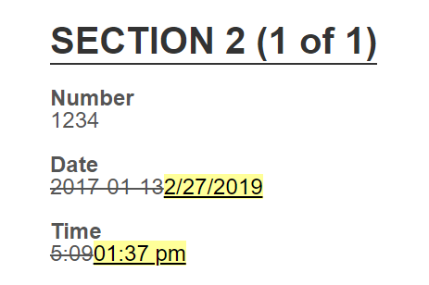
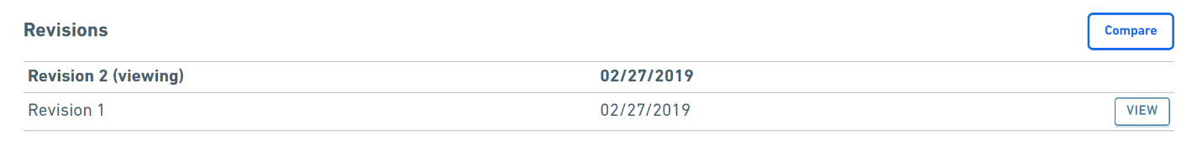
One of the first tasks staff may undertake is to compare the revisions. This is achieved by selecting revisions from the left hand menu and then selecting which submission versions to compare.

The comparison allows the reviewer to quickly see what has changed and it can help them more efficiently complete their review.

Process Correction Request Adjustments
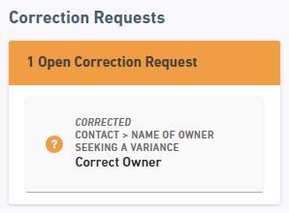
For each correction request that was addressed within the revised submission the staff submission processor must acknowledge that the correction request is satisfactory, or they must reject the corrections as unsatisfactory. This process continues until the submission processor is comfortable that the submission details are satisfactory or another round of corrections is necessary. This process is completed by selecting each corrected correction request in turn and making a determination.

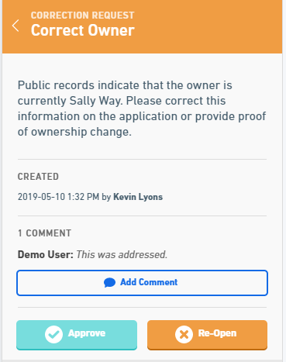
Once a correction request is selected the reviewer will be automatically taken to the location in the submission pertaining to that specific correction request. Here the reviewer can see what steps the submitter took to address the request and can easily make a determination. The processor can also add comments and can then select Approve or Re-Open.
If Re-Open is selected then the reviewer is provided a warning that they are about to re-open a correction request and that this will place the submission into a review / revision cycle once more.
If however the correction has been appropriately taken care of then the processor can approve the request and move on by clicking the Approve button.

Other Processing
The processing staff may wish to perform other tasks such as creating new notations, completing workflow tasks, updating submission information, or recording internal processing data. These tasks can be accomplished using the same steps as is described in the Submission Processing section.

