Windsor Solutions

System Requirements

Updated for Version 4.17
Revision Date: September 28, 2023

THIS PAGE INTENTIONALLY LEFT BLANK

Contents
Version Control v
Overview 1
Infrastructure 1
Deployment Requirements 1
Minimum Requirements 1
Recommended Hardware/Software 2

THIS PAGE INTENTIONALLY LEFT BLANK

Version Control

Version | Author | Date | Comments
2.1.1a | Windsor Solutions | 06/20/2013
3.3.1 | Windsor Solutions | 08/24/2015 | Adjusted minimum software/hardware requirements to meet current recommendations.
4.2/4.3 | Windsor Solutions | 12/19/2017 | Adjusted to reflect release 4.2/4.3.
4.4 | Windsor Solutions | 1/12/2018 | Adjusted to adjust some settings.
4.5 | Windsor Solutions | 6/28/2018 | Adjusted to reflect v4.5.
4.6 | Windsor Solutions | 12/4/2018 | Adjusted to reflect v4.6.
4.7 | Windsor Solutions | 5/30/2019 | Updated to reflect v4.7.
4.8 | Windsor Solutions | 1/29/2020 | Updated to reflect v4.8.
4.9 | Windsor Solutions | 7/27/2020 | Updated to reflect v4.9.
4.10 | Windsor Solutions | 9/4/2020 | Updated to reflect v4.10.
4.11 | Windsor Solutions | 2/2/2021 | Updated to reflect v4.11.
4.11 | Windsor Solutions | 4/21/2021 | Updated minimum DB requirements.
4.12 | Windsor Solutions | 7/20/2021 | Updated to reflect v4.12.
4.13 | Windsor Solutions | 5/2/2022 | Updated to reflect v4.13.
4.14 | Windsor Solutions | 8/31/2022 | Updated to reflect release 4.14.
4.15 | Windsor Solutions | 12/19/2022 | Updated to reflect release 4.15.
4.16 | Windsor Solutions | 5/11/2023 | Updated to reflect release 4.16.
4.17 | Windsor Solutions | 6/28/2023 | Updated to reflect release 4.17.

THIS PAGE INTENTIONALLY LEFT BLANK

Overview
This document is intended for administrative staff, as a reference of the technical environment which supports the nFORM system. This document can be used as a reference of the technologies utilized and how they support the system and how they interact. It also details the environmental prerequisites to support an on-premises implementation.

Infrastructure
The primary goal of the nFORM application is to provide agencies with a scalable and reliable form management platform capable of adapting to the changing needs and requirements of each program.
The recommended agency infrastructure will be comprised of both test and production environments, hosted in an environment consisting of a web and database server. Distribution of the application infrastructure across multiple tiers, along with enterprise development practices, will assure the necessary system availability and minimize the system maintenance.
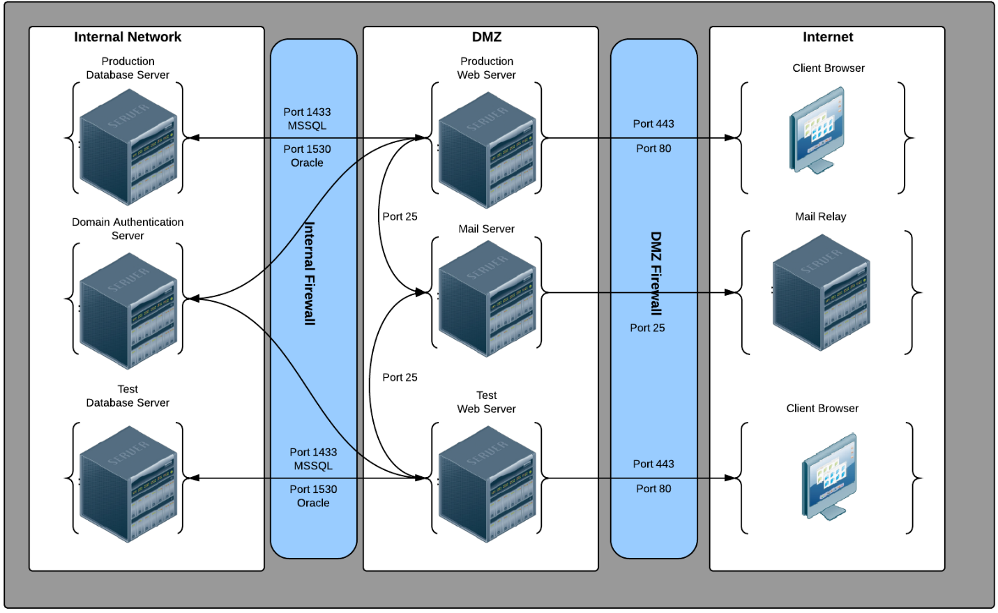

Deployment Requirements
To support the procurement process and to identify the physical hardware required to run the nFORM application, Windsor has developed the following hardware requirements based on load and data storage requirements. Note that Windsor also recommends the establishment of both TEST and PRODUCTION environments.
Note: Windsor recommends a separate servers for hosting the Application and Database systems.

Minimum Requirements
The system has the following minimal hardware/software requirements, based on anticipated concurrent users:
Concurrent Users | 0-50 | 50-200 | 200-500 | 500+
Application | Hardware:  4 Logical Cores @ 2.2GHz+  16GB RAM  200GB of Application and Document Storage  Software:  Windows Server 2012 R2/2016  IIS 7.5/8/9/10 | Hardware:  6 Logical Cores @ 2.5GHz+  16GB RAM  1000GB of Application and Document Storage  Software:  Windows Server 2012 R2/2016  IIS 7.5/8/9/10 | Hardware:  8 Logical Cores @ 3.0GHz+  32GB RAM  1000GB of Application and Document Storage  Software:  Windows Server 2012 R2/2016  IIS 7.5/8/9/10 | TBD
Database | Hardware: 4 Logical Cores @ 2.2GHz+  16GB RAM  300GB of Database Storage  Software:  Windows Server 2012 R2/2016  Microsoft SQL Standard 2019 | Hardware: 6 Logical Cores @ 2.5GHz+  32GB RAM  1000GB of Database Storage  Software:  Windows Server 2012 R2/2016  Microsoft SQL Standard 2019 | Hardware: 8 Logical Cores @ 3.0GHz+  32GB RAM  1000GB of Database Storage  Software:  Windows Server 2012 R2/2016  Microsoft SQL Standard 2019 | TBD

Recommended Hardware/Software
Windsor recommends the following minimal hardware/software, based on anticipated concurrent users:
Concurrent Users | 0-50 | 50-200 | 200-500 | 500+
Application | Hardware:  4 Logical Cores @ 2.5GHz+  16GB RAM  300GB of Application and Document Storage  Software:  Windows Server 2012 R2/2016  IIS 7.5/8/9/10 | Hardware:  8 Logical Cores @ 2.5GHz+  20GB RAM  1000GB of Application and Document Storage  Software:  Windows Server 2012 R2/2016  IIS 7.5/8/9/10 | Hardware:  16 Logical Cores @ 3.0GHz+  32GB RAM  1000GB of Application and Document Storage  Software:  Windows Server 2012 R2/2016  IIS 7.5/8/9/10 | TBD
Database | Hardware: 4 Logical Cores @ 2.2GHz+  16GB RAM  300GB of Database Storage  Software:  Windows Server 2012 R2/2016  Microsoft SQL Standard 2019 | Hardware: 6 Logical Cores @ 2.5GHz+  32GB RAM  1000GB of Database Storage  Software:  Windows Server 2012 R2/2016  Microsoft SQL Standard 2019 | Hardware: 8 Logical Cores @ 3.0GHz+  32GB RAM  1000GB of Database Storage  Software:  Windows Server 2012 R2/2016  Microsoft SQL Standard 2019 | TBD

A separate server is not technically required, but recommended.
In situations where 500 or more concurrent users are anticipated, additional analysis will be required to determine the most appropriate server configurations/architecture.
In situations where 500 or more concurrent users are anticipated, additional analysis will be required to determine the most appropriate server configurations/architecture.

